Youth Affairs Council Victoria

Annual Report

2020-2021
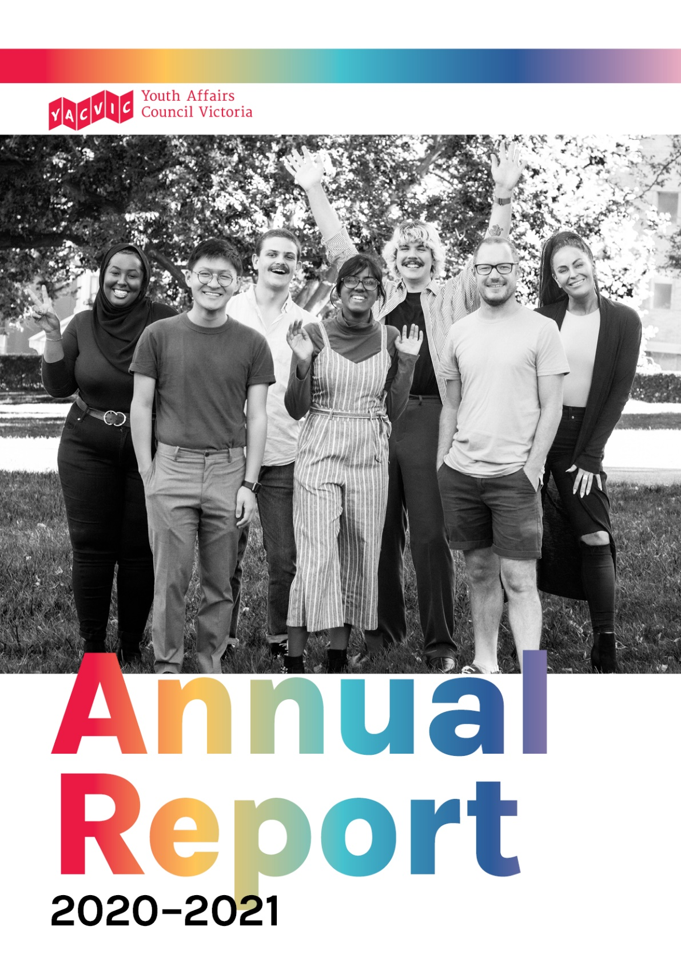

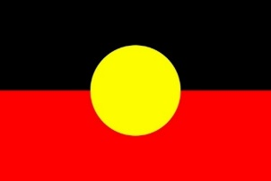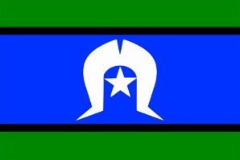
YACVic works across the entire state of Victoria. YACVic’s head office is based on the lands of the Kulin Nation in Naarm (Melbourne). We also have offices based on the lands of the Gunditjmara Nation in Warrnambool, and on the lands of the Wemba Wemba and Wadi Wadi Nations in Swan Hill.
YACVic gives our deepest respect to Aboriginal and Torres Strait Islander Elders past and present for their wisdom, strength, support and leadership.
We acknowledge all Aboriginal and Torres Strait Islander people in Victoria, and stand in solidarity to pay respect to the ongoing culture and continued history of all Aboriginal and Torres Strait Islander nations.

Youth Affairs Council Victoria (YACVic) is the peak body and leading advocate for young people aged 12–25, and youth workers in Victoria.
Our vision is that the rights of young people in Victoria are respected, and they are active, visible and valued in their communities.
We lead policy responses to issues affecting young people, represent the youth sector to government, resource high quality youth work practice, research and advocate on youth issues. We value our members and prioritise their needs.
We provide additional targeted advocacy through our key services, YACVic Rural and Youth Disability Advocacy Service (YDAS), and proudly auspice and support our partner agency, Koorie Youth Council (KYC).
Wurundjeri Country Level 2, 235 Queen Street,Melbourne, Victoria, 3000
www.yacvic.org.au, info@yacvic.org.au
November 2021

Chairpersons’ Report
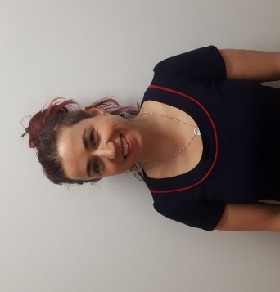

12 months on from our last Annual Report and we are all still dealing with a world of upheaval and uncertainty. COVID has exposed and exacerbated inequities that divide and stratify our communities, particularly for our members and the people we serve. Young people, overrepresented in casual and part time work, have been among the hardest hit by job losses. Engagement in education, hobbies and other supports that enhance wellbeing have been significantly impacted. They’ve missed important milestones, been ignored in COVID messaging, and demonized in the media for not getting a vaccine they’ve been ineligible for.

Youth workers have completely and continually reimagined the way they connect with young people and with each other. They’ve developed new engagement tools, renegotiated funding, and advocated for the needs and rights of young people in new and confusing spaces while managing their own isolation challenges; remote learning, caring for families, and more.

But such a seismic shift, this break in the business-as-usual train, has also offered a chance to drive transformational change. We have seen businesses pivot, families recalibrate and politicians acting out of type. When necessary, we are brave and we take opportunities to challenge more than just what is obvious or immediate. Throughout history, young people have driven social change, and often been labelled as idealistic, or insolent for doing so. We are proud that YACVic, our members and young people across Victoria have used these challenges as opportunities to come together, to challenge the status quo and push for a more inclusive, fairer future.

We want to thank the YACVic staff for their tireless dedication to young people and the youth sector. YACVic has achieved so much in the face of many challenges. We also want to thank our fellow Directors for their continued time and energy.

We fervently hope next year we don’t mention the C word in our report! Until then, we celebrate YACVic as an organisation challenging inequities and supporting all young people to flourish.

Tasha Ritchie & Kerrie Loveless,

YACVic Co-Chairs

Board of Governance
- Kerrie Loveless, Chairperson
- Natasha Ritchie, Deputy Chairperson
- Peter Glynn, Treasurer
- Becc Brooker
- Katerina Dandanis
- Kareem El-Ansary
- Tim Harte
- Tessa Jenkins
- Alexandra Neill
- Georgina Oxley
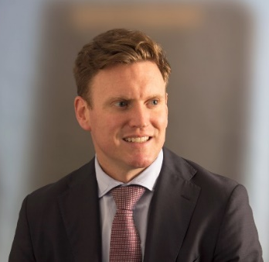
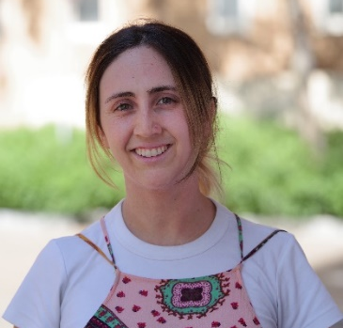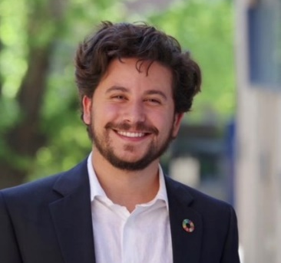
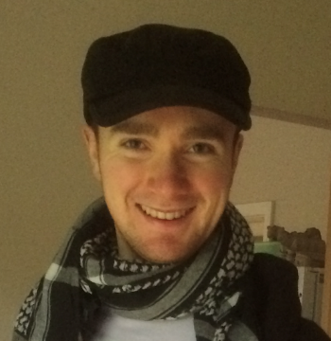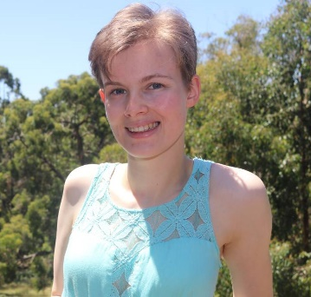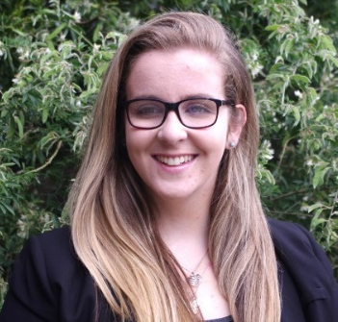

CEO’s Report

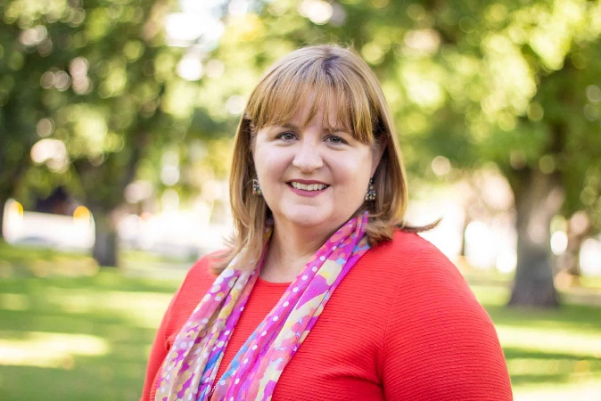
2020-2021, like the year before, has been a time of great challenge for young people in Victoria, and for everyone who works in the youth sector. Young people continue to be disproportionately slammed by disruption to education, job losses, social isolation and mental health issues, at the same time as many are toiling as frontline essential workers and waiting to be eligible for vaccination.

I want to thank and commend every young person who continues to face these challenges, and all the parents, carers, teachers, youth workers and others who are collectively supporting and nurturing Victoria’s young people through this very tough time. I also want to thank our stakeholders and funders, in particular the Victorian Government, for the step-up in their support.

As the peak body for young people and the youth sector, and with YDAS, KYC and YACVic Rural focused specifically on young people who often face marginalisation at the best of times, YACVic has felt a deeper-than-usual responsibility to keep young people and youth issues front and centre with policy makers and media, to gather and share relevant expert information, and to help the sector connect and cooperate. I feel, and I hope our stakeholders do too, that we have succeeded in that to the best of our ability (and resources).

This has included key COVID-related activities such as our COVID-19 Recovery Plan for Young People (p 16), YDAS’s COVID-19 resources (p 19) and Youth Working Group recommendations, and KYC’s hugely popular online Yarning Circles (p 35). At the same time, we have continued with a huge program of policy advice, including to the Royal Commissions on Mental Health (p 15) and Disability (p 18); work to promote youth participation in decision making right across state / local government and the social sector (p 22); and capacity building and connection for youth workers and other youth specialists.

Throughout the disruption and uncertainty, there have been some silver linings, in particular the increased collaboration and generosity across the social sector, the greater acceptance of flexible working and personal lives for many, and the boost in attention by policy makers and media to the issues of young people, many of which existed before the pandemic. I hope very much that these remain as a legacy of this time in history.

Finally, and very importantly, I want to acknowledge the extraordinary efforts of YACVic’s staff, who have truly worked above and beyond this year, in most cases while also dealing with their own personal challenges related to COVID-19 and life in general, and the YACVic Board, who have continued to provide much-appreciated support and direction to our team in this uncertain and historic time.

Katherine Ellis, CEO

60 Years of Fearless Advocacy

Back in 1960 YACVic was founded by a small group of passionate thinkers, innovators and activists in youth sector organisations who banded together to fight for young people and youth workers. In 2020-21, that spirit has never been more important.

Thank you to you, our members, supporters and funders for your ongoing collaboration and support of YACVic. Shout-out to our partner agencies who have grown and been instrumental to our work over the years: Youth Disability Advocacy Service, Koorie Youth Council, Victorian Student Representative Council, Centre for Multicultural Youth (CMY) and Commission for Children & Young People.

You can watch our 60 year anniversary video here.

1960 Associated Youth Committee of the National Fitness Council is renamed as Youth Council of Victoria (YCV).
1965-66 Youth Council Conference held in Warrnambool to de-centralise the Youth Council.
1973 The Australian Parliament lowers the minimum voting age to 18 years.
1979-80 Restructure to become Youth Affairs Council of Victoria (YACVic), establishing YACVic as the key non-government organisation for Youth Affairs in Victoria.
1984 State-wide Youth Affairs Conference in Marysville raises concerns about rural workers. A young women’s subcommittee is established.
1987 Support and development of the Ethnic Youth Issues Network (now CMY).
1999 Direct Government funding of YACVic ends, and staff employment ceases on 31 August.
2000 YACVic’s Are You Listening to Us? Report calls for the establishment of a Children and Young People’s Commission in Victoria.
1995 Some regions in Victoria record 30% youth unemployment. The Parliamentary Inquiry into Youth Homelessness finds a 100% increase in homeless young people from 1991-94.
1996 Victoria University begins the first BA of Youth Studies in Victoria.
1992 Kennett Government cuts youth sector funding
1993 YACVic recognised as the peak body for Youth Affairs in Victoria by Minister Vin Heffernan.
2001 Establishment of the Policy Advisory Group, Youth Reference Group, and Victorian Secondary Students Network.
2003 Ro Allen is appointed Chairperson of YACVic, and Georgie Ferrari is appointed CEO. The Victorian Secondary Students Network becomes Victorian Student Representative Council (VicSRC).
2005 Victorian Indigenous Youth Advisory Council becomes an auspiced partner of YACVic. The Youth Disability Advocacy Service (YDAS) is established, in partnership with Youthlaw and the Disability Discrimination Legal Service.
2015 Establishment of YACVic Rural locations in the Southern Mallee and Great South Coast
2016 Victorian Government launches Building Stronger Youth Engagement in Victoria policy
2013 Victorian Indigenous Youth Advisory Council becomes the Koorie Youth Council (KYC).
2013 YACVic launches YERP youth participation resource.
2014 KYC runs the first Koorie Youth Summit
2007 Launch of the Code of Ethical Practice: A First Step for the Victorian Youth Sector
2010 Launch of Health Equal Youth (HEY) Grants
2012 First ever National Youth Disability Conference hosted by YDAS
2019 YDAS launches Emerging Young Leaders & Together Programs. KYC’s ground-breaking Ngaga-Dji report receives the Voltaire Award for 2019
2020 COVID-19 global pandemic hits. VicSRC becomes independent from YACVic. YACVic and the Victorian Government commence consultations for the new Victorian Youth Strategy.
2021 Young people are put front and centre in recommendations from Royal Commission into Victoria’s Mental Health System. YACVic delivers resources and training to ensure young people’s active participation in bushfire recovery.

Where We’ve Been

2020-2021

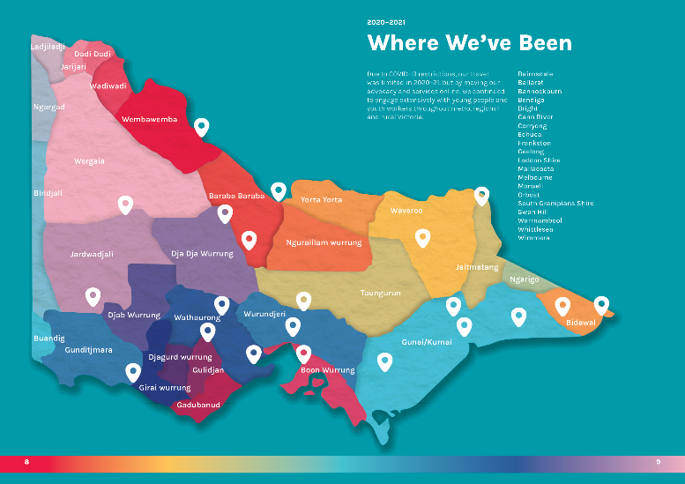
Due to COVID-19 restrictions, our travel was limited in 2020–21, but we also engaged extensively online with young people living throughout metro, regional and rural Victoria.
- Bairnsdale
- Ballarat
- Bannockburn
- Bendigo
- Bright
- Cann River
- Corryong
- Echuca
- Frankston
- Geelong
- Loddon Shire
- Mallacoota
- Melbourne
- Morwell
- Orbost
- South Grampians Shire
- Swan Hill
- Warrnambool
- Whittlesea
- Wimmera

Organisational Members

2020-2021

- Afro-Australian Student Organisation
- Alcohol and Drug Foundation
- Alpine Shire Council
- Anglicare Victoria
- Ardoch Youth Foundation
- Association for Children with a Disability
- Australian African Association Inc
- Australian Catholic University - Youth Work
- Australian Centre for Rural Entrepreneurship
- Australian Red Cross - Victorian Division
- Banyule City Council
- Banyule Nillumbik LLEN
- Bass Coast Shire Council
- Baw Baw LLEN
- Bayside City Council Youth Services
- Bayside Glen Eira Kingston LLEN
- Benalla Rural City Council
- Beyond the Bell Great South Coast
- BGT
- Blue Light Victoria
- Boroondara City Council
- Brimbank Youth Services
- The Bridge Youth Service
- Brophy Family & Youth Services Inc
- Campaspe Cohuna LLEN
- Campaspe Shire Council
- Capital City LLEN
- Catholic Care Melbourne
- Centacare Ballarat
- Central Grampians LLEN
- Central Ranges LLEN
- Centre for Adolescent Health
- Centre for Excellence in Child and Family
- Welfare
- The Centre for Continuing Education
- Centre for Excellence in Rural Sexual Health
- Centre for Multicultural Youth
- City of Ballarat
- City of Casey
- City of Darebin
- City of Greater Bendigo
- City of Greater Dandenong
- City of Greater Geelong
- City of Greater Shepparton
- City of Kingston
- City of Melbourne
- City of Monash Youth Servcies
- City of Port Phillip
- City of Stonnington Middle Years and Youth
- Services Unit
- City of Whittlesea
- City of Yarra Youth Services
- Colac Area Health
- Concern Australia
- Corangamite Shire Council
- The Drum Youth Service
- East Gippsland Shire Council
- Family Access Network Inc.
- The Foundation for Young Australians
- Frankston Mornington Penninsula LLEN
- Fusion Australia
- Future Connect
- Gardner and Blanchard Trading
- Gateway LLEN
- Geelong Region LLEN
- Gippsland East LLEN
- Girl Guides Victoria
- Glenelg and Southern Grampians LLEN
- Glenelg Shire Council
- Golden Plains Shire Council
- Goldfields LLEN
- Goulburn Murray LLEN
- Grampians Community Health
- Headspace Albury Wodonga
- Headspace National
- Hepburn Shire Council
- Highlands LLEN
- Hobsons Bay City Council
- Hume City Council Youth Services
- Hume Whittlesea LLEN
- Inner Eastern LLEN
- Inner Northen LLEN
- Innovation Youth Centre
- Job Watch Inc.
- Junction Support Services Inc
- Kids Under Cover
- Knox City Council Youth Services
- Les Twentyman Foundation
- Live4Life
- Macedon Ranges Shire Council
- Mansfield Shire Council
- Maribyrnong & Moonee Valley LLEN
- Maribyrnong City Council
- Maroondah City Council
- Maxme
- Melbourne City Mission
- Mental Health Victoria
- Merri Health
- Mildura Rural City Council
- Mission Australia
- MOIRA
- Moira Shire Council
- Moonee Valley City Council
- Moorabool Shire Council
- Moreland City Council
- Mount Alexander Shire Council
- Murray Mallee LLEN
- Murrindindi Shire Council
- My Place Youth Facility
- NE Tracks LLEN
- NESAY Inc
- Nillumbik Shire Council
- North Central LLEN
- North East LLEN
- Northen Mallee LLEN
- Outer Eastern LLEN
- Primary Care Connect
- The Salvation Army
- Save the Children
- Scouts Victoria
- South East LLEN
- South Gippsland Bass Coast LLEN
- South Gippsland Shire Council
- South West LLEN
- Squash & Racquetball Victoria
- State Library of Victoria
- Strathbogie Shire Council
- Students for Sensible Drug Policy Australia
- SYN Media
- TAFE Gippsland
- The Push
- The Youth Junction Inc.
- Tomorrow Today Education Foundation
- UN Youth Australia
- UN Youth Victoria Inc
- UnitingCare
- VCOSS
- VicHealth
- VicSRC
- Victoria University - Youth Studies
- Victorian Local Governance Association (VLGA)
- Volunteering Victoria
- WAYSS
- Wellington Shire Council
- Western Bulldogs Community Foundation
- Whereto Research
- Whitehorse City Council
- Whitelion Youth Agency
- Wimmera Southern Mallee LLEN
- Wodonga City Council
- Women’s Health Goulburn North East
- WynBay LLEN
- Wyndham City Youth Services
- Yarra Ranges Council
- YMCA Victoria
- Youth Action
- Youth Affairs Council Western Australia
- (YACWA)
- Youth Affairs Network of Queensland (YANQ)
- Youth Coalition of the ACT
- Youth Live4Life Inc
- Youth Network of Tasmania (YNOT)
- Youth Research Centre
- Youthlaw
- YSAS Pty Ltd
- YWCA Australia

Heartfelt Thanks to Our Partners

2020-2021

One of the genuine silver linings of the COVID-19 pandemic has been the partnerships that have blossomed and flourished as we have supported and advocated for Victoria’s young people.
We have continued to appreciate a strong and productive relationship with the Victorian Government, in particular with Youth Minister Hon. Ros Spence MP, and the Office for Youth (OfY), which provides our core funding, and also support for YACVic Rural, and the Marram Nganyin Aboriginal Youth Mentoring Program run jointly by YACVic and KYC.
Other key partnerships include the Office for Disability, which funds YDAS, including supplementary support this year in recognition of the impact of COVID-19 on disabled young people, and the First Peoples—State Relations Group (formerly Aboriginal Victoria) which continues to provide important backing and support to KYC.
These partnerships are genuinely two-way, as YACVic, YDAS and KYC facilitate representation by young people and the youth sector in a variety of government advisory groups, working groups, enquiries and consultations, so that policy reform and strategy development are informed by lived experience and include groups that often face marginalisation. This year we were also deeply immersed in collaboration with OfY to run consultations across the state to inform the new Victorian Youth Strategy.
We have a great partnership with VicHealth, and it has been a delight to support their genuine commitment to youth participation and a major youth focus in their work. This partnership has become a model for emerging engagement with other organisations and institutions, such as Bushfire Recovery Victoria, Department of Education and Training, and the Inspector-General for Emergency Management (focused on young people’s agency in bushfire recovery, p 21), and the Commission for Children and Young People.
YACVic brought together the Working for Victoria Coalition, comprising eight organisations (YSAS, Whitelion, Brophy, CMY, CFECFW, LLENs, PCC and YACVic), to collectively secure a grant from Department of Jobs, Precincts and Regions’ Working for Victoria Fund for extra capacity in the youth sector. The coalition has been highly successful, and has also led to information sharing, peer support and collaboration on other projects.
We are also grateful to the Lord Mayor’s Charitable Foundation, which has contributed much needed multi-year support to increase capacity in YDAS’ individual advocacy team; RSPCA Victoria which partnered with us to deliver a Rural Young Activators program focused on animal welfare in bushfire affected areas; CYDA, which auspiced us to secure NDIA funding and partnered for YDAS’ Young Leaders Program; and FRRR which has funded our Deadly Yarning and Learning Project with Aboriginal young people in the Southern Mallee.
Finally, we would like to thank all our members, who partner with us in so many ways—in peer networks, to develop policy submissions, to deliver events to the sector. YACVic is only as strong and effective as the many intersecting part of the youth sector, and we are fortunate to be able to draw from and contribute to a wonderful network of partnership.

Where YACVic Represents You

2020-2021

Youth Justice
- Smart Justice 4 Young People Coalition
- Victoria Police Youth Portfolio Reference Group
- Victorian Government Public Intoxication Reforms: Diversity and Inclusions Advisory Group

Mental Health
- Mental Health Reform Victoria co-design and implementation of Hospital Outreach Postsuicidal after Engagement (HOPE) model
- VicHealth Mental Wellbeing COVID-19 Working Group
- Victorian Women’s Mental Health Alliance
- School Mental Health Reform Reference Group: Department of Health
- Human Services and Health Partnership Implementation Committee (HSHPIC)

Employment & Economy
- Youth Employment Project Steering Committee: WEstjustice
- Victorian Chamber of Commerce & Industry
- ‘Victoria Summit’ Reference Group & ‘Future of Work’ Working Group
- Expert Advisory Group for Macklin Review of Skills for Victoria’s Growing Economy
- Central Ranges Local Learning Network (LLEN) Board

Disability
- DHHS Coronavirus Disability Taskforce
- DHHS Accessible COVID-19 Communications Advisory Group
- Disability Act Review Advisory Group
- Disability Education COVID-19 Advisory Group
- Disability Stakeholder Reference Group (Department of Education and Training)
- VCOSS Empowered Lives Advisory Committee

Policy
- National Peak Bodies Bushfire Recovery Forum
- Australian Youth Affairs Coalition (AYAC) Board
- DET Training and Practice Advisory Group for Child Information Sharing Scheme
- State/Territory Youth Peaks Coalition
- Consultations for new Australian Youth Policy Framework
- Consultations for new Victorian Youth Strategy
- 2020 Australian Youth Development Index (AYDI) Expert Group
- Victorian Government COVID-19 and Youth (20-29) Engagement and Communications Working Group
- VicHealth’s Local Government Partnership: Expert Partner
- Improve Your Play Advisory Committee: Alannah and Madeline Foundation
- Australian Coalition for Inclusive Education

Social Sector
- VCOSS Peaks and Statewide Organisations Group
- Leadership in Volunteering: Volunteering Victoria Special Interest Group
- Inclusive Volunteering: Volunteering Victoria Special Interest Group
- Consumer Participation Practice Network
- Lived Experience Engagement Network – Sane
- Outcomes Practice and Evidence Network –Centre for Excellence in Child and Family Welfare
- VCOSS DET-CSO Governance Group
- 7News Young Achievers Awards Judging Panel
- Victorian Peaks Coalition on LGBTIQ+ investment ‘Embracing Equality’

Strategic Goal 1: A Robust Policy Environment

Policy Overview

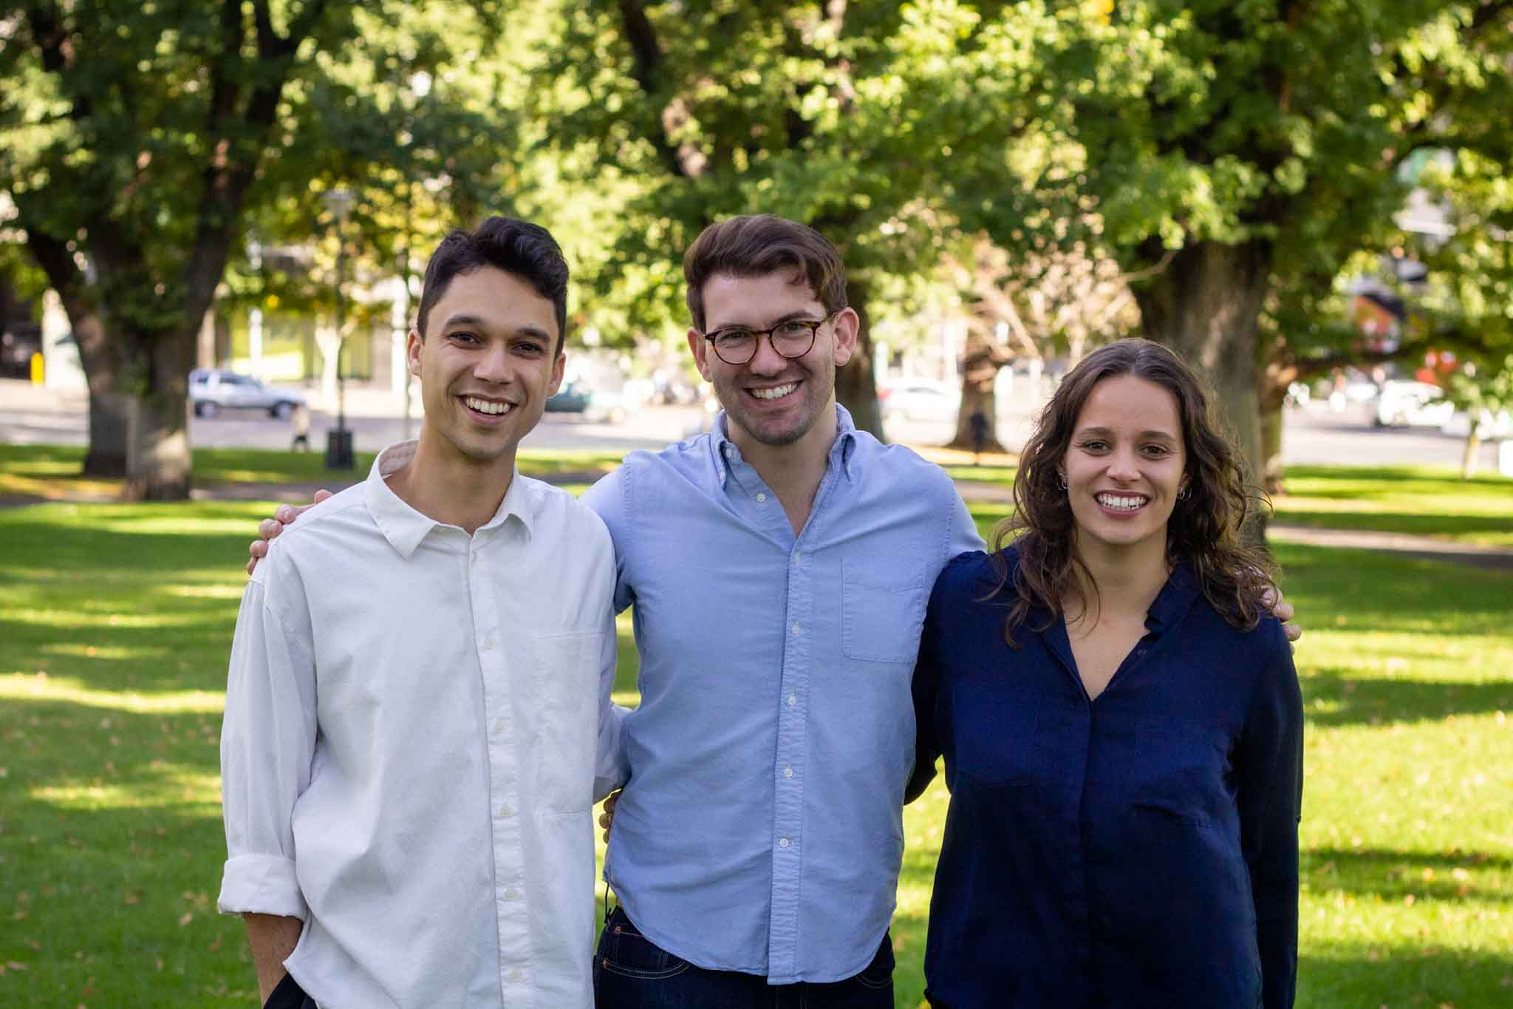
Young people took centre stage this year as we focused our attention on policy and advocacy that prioritised a strong recovery for young people from now into the future.
Following on from the surveys and consultations we’d hosted previously, we released the COVID-19 Recovery Plan for Young People (p 16), which provided a roadmap of key policy recommendations that would ensure young people would not be left behind as the country tried to recover from a generation defining pandemic. We supported young people to advocate on the issues most important to them, delivering an online webinar that provided them with the information and tools they need to meet with their local MP.
We also worked with young people to analyse the final report from the Royal Commission into Victoria’s Mental Health System (p 15). In addition, we have worked closely with young people to write articles for Parity, a magazine which examines homelessness from personal, local, social and global perspectives, published nationally by the Council to Homeless Persons.

Key Stats
- 9 submissions, reports and research publications
- 65 meetings with Members of the Victorian Parliament
- 185 young people engaged on the Victorian Youth Strategy
- 36 LGBTIQA+ young people engaged on the LGBTIQA+ strategy submission
- 20 young people engaged in COVID-19 recovery plan

Strategic Goal 1: A Robust Policy Environment

Mental Health Royal Commission

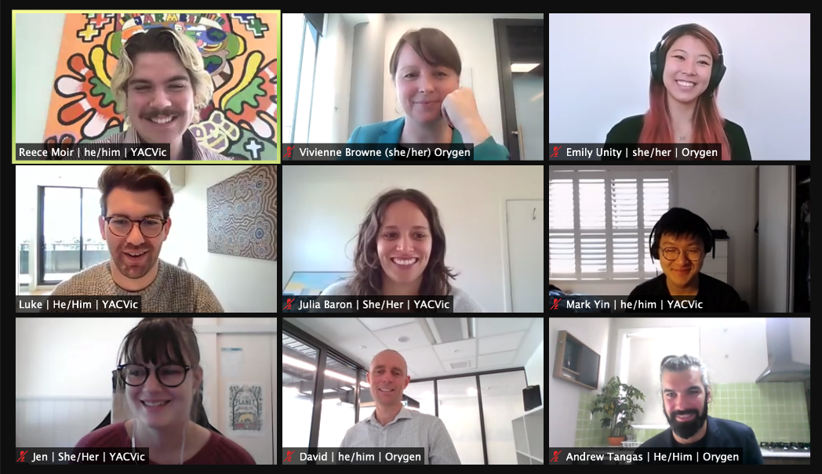
The final report from the Royal Commission into Victoria’s Mental Health System was released in March 2021, laying down a once-in-a-generation roadmap for reform.
Young people have been leaders in calling for a new mental health system and YACVic has supported hundreds of young people to connect and share their experiences and ideas for a better mental health system.
YACVic’s submission to the Royal Commission focused on the lived experiences of young people in rural and regional Victoria. Pleasingly, the Victorian Government has committed to investing in rural and regional Victoria as a priority.
We are hopeful that the implementation of the recommendations will meet the vision of young people and create a new future where young people are supported and have access to the best quality mental health care whenever and wherever it is needed.
Since the release of the final report, YACVic’s Policy Team has completed a detailed analysis of the recommendations and how they impact the youth sector alongside three young people. We supported them to bring their lived experience to illuminate themes in the final report that were important to them. This analysis is available on the YACVic website and was presented to 500 members of the Youth Mental Health Community of Practice that YACVic co-convenes with Orygen.
YACVic will continue doing research, policy and advocacy work to ensure the implementation of the Royal Commission’s recommendations over the next decade meaningfully centres young people and lived experience.

COVID-19 Recovery Plan for Young People

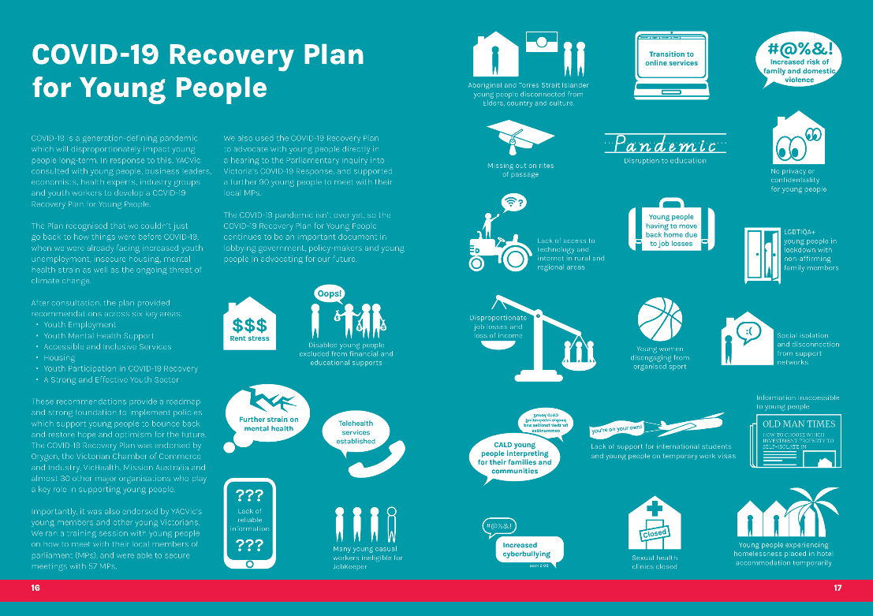
COVID-19 is a generation-defining pandemic which will disproportionately impact young people long-term. In response to this, YACVic consulted with young people, business leaders, economists, health experts, industry groups and youth workers to develop a COVID-19 Recovery Plan for Young People.
The Plan recognised that we couldn’t just go back to how things were before COVID-19, when we were already facing increased youth unemployment, insecure housing, mental health strain as well as the ongoing threat of climate change.
After consultation, the plan provided recommendations across six key areas:
- Youth Employment
- Youth Mental Health Support
- Accessible and Inclusive Services
- Housing
- Youth Participation in COVID-19 Recovery
- A Strong and Effective Youth Sector
These recommendations provide a roadmap and strong foundation to implement policies which support young people to bounce back and restore hope and optimism for the future. The COVID-19 Recovery Plan was endorsed by Orygen, the Victorian Chamber of Commerce and Industry, VicHealth, Mission Australia and almost 30 other major organisations who play a key role in supporting young people.
Importantly, it was also endorsed by YACVic’s young members and other young Victorians. We ran a training session with young people on how to meet with their local members of parliament (MPs), and were able to secure meetings with 57 MPs.
We also used the COVID-19 Recovery Plan to advocate with young people directly in a hearing to the Parliamentary Inquiry into Victoria’s COVID-19 Response, and supported a further 90 young people to meet with their local MPs.
The COVID-19 pandemic isn’t over yet, so the COVID-19 Recovery Plan for Young People continues to be an important document in lobbying government, policy-makers and young people in advocating for our future.

Infographic reads that young people have been affected by the COVID-19 pandemic in the following ways:
- Rent stress
- Disabled young people excluded from financial and educational supports
- Further strain on mental health
- Telehealth services established
- Lack of reliable information
- Many young casual workers ineligible for JobKeeper
- Aboriginal and Torres Strait Islander young people disconnected from Elders, country and culture
- Transition to online services
- Increased risk of family and domestic violence
- Missing out on rites of passage
- Disruption to education
- No privacy or confidentiality for young people (at home)
- Lack of access to technology and internet in rural and regional areas
- Young people having to move back home due to job losses
- LGBTIQA+ young people in lockdown with non-affirming family members
- Disproportionate job losses and loss of income
- Young women disengaging from organised sport
- Social isolation and disconnection from support workers
- CALD young people interpreting for their families and communities
- Lack of support for international students and young people on temporary work visas
- Information inaccessible to young people
- Increased cyberbullying
- Sexual health clinics closed
- Young people experiencing homelessness placed in hotel accommodation temporarily

Strategic Goal 1: A Robust Policy Environment

Disability Royal Commission

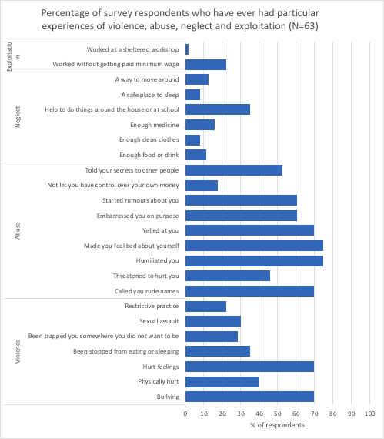
YDAS is working with YACVic’s support to elevate disabled young people’s voices to the Royal Commission into Violence, Abuse, Neglect and Exploitation of People with Disability. The Royal Commission is a landmark opportunity to investigate disabled people’s negative experiences and enact systemic and structural changes to better protect disabled people from violence, abuse, neglect and exploitation. YDAS recognise that disabled young people have a set of unique experiences and recommendations that are vital to the work of the Royal Commission.
YDAS co-ordinated a working group of five disabled young people to shape and deliver cutting edge and co-produced research about the experiences and recommendations of disabled young people. This is one of the first times that disabled young people have been meaningfully involved in the production of research about their own community.
YDAS supported the youth working group to develop a survey for young people, as well as to design and deliver 10 themed group conversations about topics like transport, employment, justice and medical mistreatment. Over 80 disabled young people have contributed their stories and ideas through the survey and the working group spoke with 43 disabled young people in the group conversations.
Over the next few months, the YDAS and YACVic policy teams will continue to support the working group to collect stories and data that emphasise the lived experiences of disabled young people and create recommendations and momentum for positive change. Part of this project will be delving into six years of case files from YDAS’s individual advocacy service, which will provide a unique and hugely valuable insight into the experiences of disabled young people in Victoria. YDAS and the working group will identify specific recommendations for the Royal Commission to galvanise government action so that disabled young people are better protected from violence, abuse, neglect and exploitation.

Strategic Goal 1: A Robust Policy Environment

YDAS COVID-19 Working Group

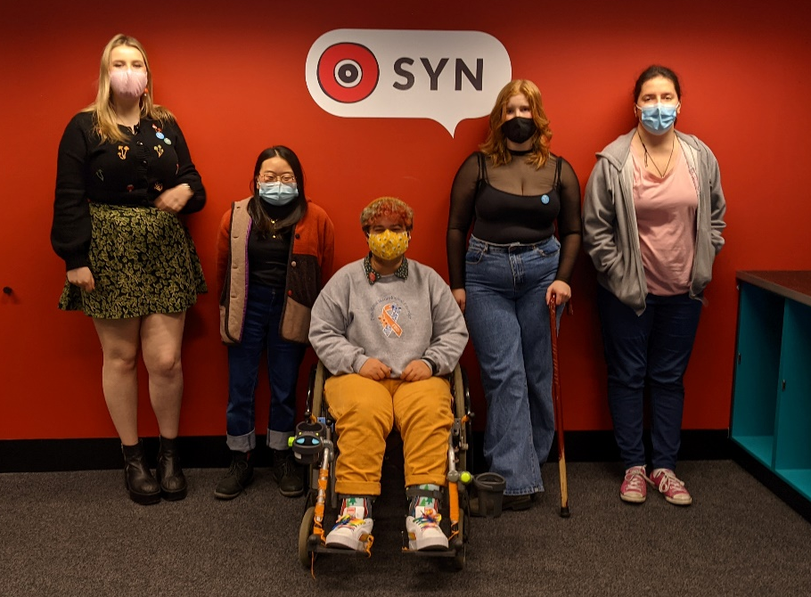
Disabled young people have been significantly impacted by the COVID-19 pandemic, yet they have been largely overlooked. That’s why YDAS formed a COVID-19 Working Group to put disabled young people at the forefront of Victoria’s pandemic response and recovery.
Our COVID-19 Working Group brought together eight disabled young people from around Victoria.
“I loved our meetings and the friendships we formed. We all had a level of understanding of each other through our shared lived experiences.” – Emma, Working Group Member
The COVID-19 Working Group has influenced government policy and shaped approaches for many government departments, universities, and youth and disability organisations.
The working group challenges assumptions and gives disabled young people the opportunity to educate decision-makers about what they need and how it can be done.
Disabled young people have been able to shape the pandemic response, making it more accurate, responsive, accessible and inclusive. The COVID-19 Working Group have created a research report on the experiences of disabled young people and their recommendations for recovery.
They also led a project to elevate the experiences of disabled young people during the pandemic. Over 20 disabled young people created artworks, music, stories, and videos, which received a great response on social media.
During the project, the working group members produced a podcast, interviewing leaders in the disability community about disability pride, education, healthcare, and the media.
“I love our podcast. It invites people in, it is spoken in our own voices, and I think the conversations we had are really important to have immortalised.” – Mia, COVID-19 Working Group Member
The COVID-19 Working Group members hope that the lessons learnt will carry on beyond the existence of the group.
“We hope to see disabled young people be given power in systemic and meaningful ways that mean working groups like this don’t need to exist, because our community will already be influencing decision making from the top.” – Is, Working Group Facilitator
Thank you to the members of our COVID-19 Working Group in 2020 and 2021: Cindy, Mac, Emma, Mia, Lee, William, Cate, and Tim.

Strategic Goal 2: Meaningful Youth Participation

Youth Participation Overview
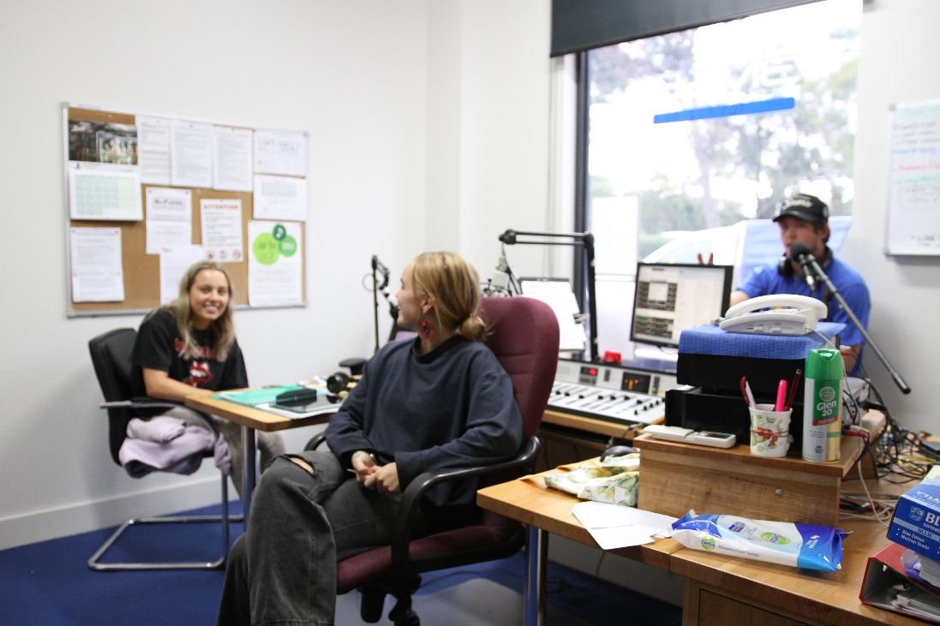
YACVic has stayed constant on the inclusion and empowerment of young people this year, despite the many challenges thrown up by COVID constraints. We adapted to lockdowns and changing restrictions, developing platforms and partnerships to promote young people’s voices. As well as large-scale engagements for the Victorian Government’s Youth Strategy forums, we have run various working groups, focus groups and co-design workshops this year. These have included the COVID-19 Recovery Plan for Young People, the consultation we ran for Volunteering Victoria and the Department of Environment, Land, Water and Planning (DELWP) as well as the codesign workshops we led for the Department of Justice and Community Safety (DJCS). Read more about these projects on page 25.
Through our partnership with VicHealth, we have supported various opportunities for young people which included the formation of their first Youth Expert Panel as well as recruiting and supporting a Youth Future Steering Committee. We also developed and led a brand new Regional Sport Victoria (RSV) Youth Advisory Council.
Our Young Member Alerts and Young Huddles have been regular platforms to connect our young members to ongoing opportunities and events. This has been led by young staff across the organisation, and has ensured young people a welcoming and safe space to connect.
Internally, we have trained up young people to understand the recruitment process at YACVic and empower them to contribute fully and equally on interview panels. Young people have told us that they find the insight of being on the ‘other side’ of the table invaluable to their own growth, and we recruit staff with confidence that they can connect authentically with young people.
Like many others across the sector, we really noticed ‘Zoom fatigue’ among young people through our networks this year. While online connection does have advantages, in particular providing a more accessible and autonomous space for some participants, it also has real challenges. We have learnt an enormous amount about what works, and how to make online activities engaging, which we will take forward to continue to create more accessible and equitable spaces for all young people.

Key Stats
- >200 Youth Participation opportunities
- 277 workers trained across 26 training sessions
- 95% of participants ‘satisfied’ or ‘extremely satisfied’ with training
- 7 Young Peer Facilitators + 1 Lead Facilitator hired
- 10 YPPN meetings with 371 members

Strategic Goal 2: Meaningful Youth Participation

Activators and Bushfire Recovery

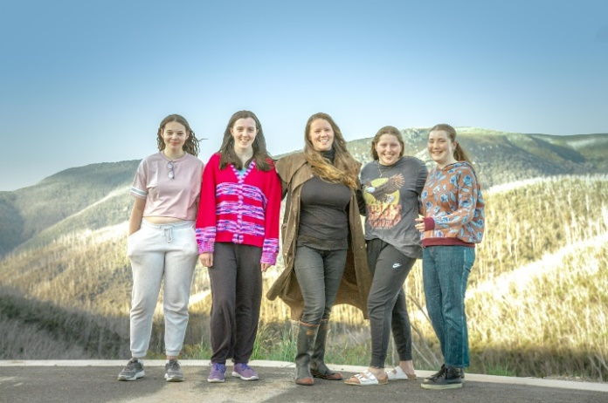

In early 2020, YACVic Rural developed a response to the devastating 2019-20 bushfires that devastated communities across much of Eastern Victoria. YACVic developed disaster recovery protocols to assist communities and local governments to maximise youth participation in the recovery response. We developed a sponsorship with RSPCA Victoria to refocus the Activators program for young people to lead animal welfare projects across affected areas. Sixteen young people participated in the program and led local projects as a response.
In July 2020 we commenced a large-scale project in partnership with the Department of Education and Training (DET) and Bushfire Recovery Victoria (BRV) to capture the views and experiences of young people across the LGAs of Towong, Alpine and East Gippsland. Our consultation process covered three topics:
- Their experience of bushfires and the emergency response
- Jobs, skills and education opportunities that could be developed as part of the recovery and rebuilding effort
- Examining opportunities for youth participation in disaster preparedness and recovery in local communities
Despite the constraints imposed by COVID-19, over 100 young people participated in our face to face and online workshops, as well as responding to our survey about their experiences. We provided advocacy, leadership and decision-making training to young people across the three LGAs. This work was complemented by the delivery of training for local Community Recovery Committees on ChildSafe Standards, the Code of Ethical Practice, and Youth Participation to assist local communities in including young people in recovery-based initiatives. Final reports and new resources designed to support this work will be delivered to BRV and DET later in 2021. The success of this project led to the Inspector General for Emergency Management requesting YACVic to consult with young people as part of the independent Inquiry into the 2019-20 Victoria Fire Season.
It is clear that, even now, 18 months on from the fires, many communities and individuals are only at the beginning of the recovery journey. The road ahead must include young people as part of this recovery and developing future disaster responses. YACVic Rural will continue to work with communities in the disaster, preparation management, and recovery spaces.

Strategic Goal 2: Meaningful Youth Participation

Youth Voices In Consultation

Participation, Policy and Rural
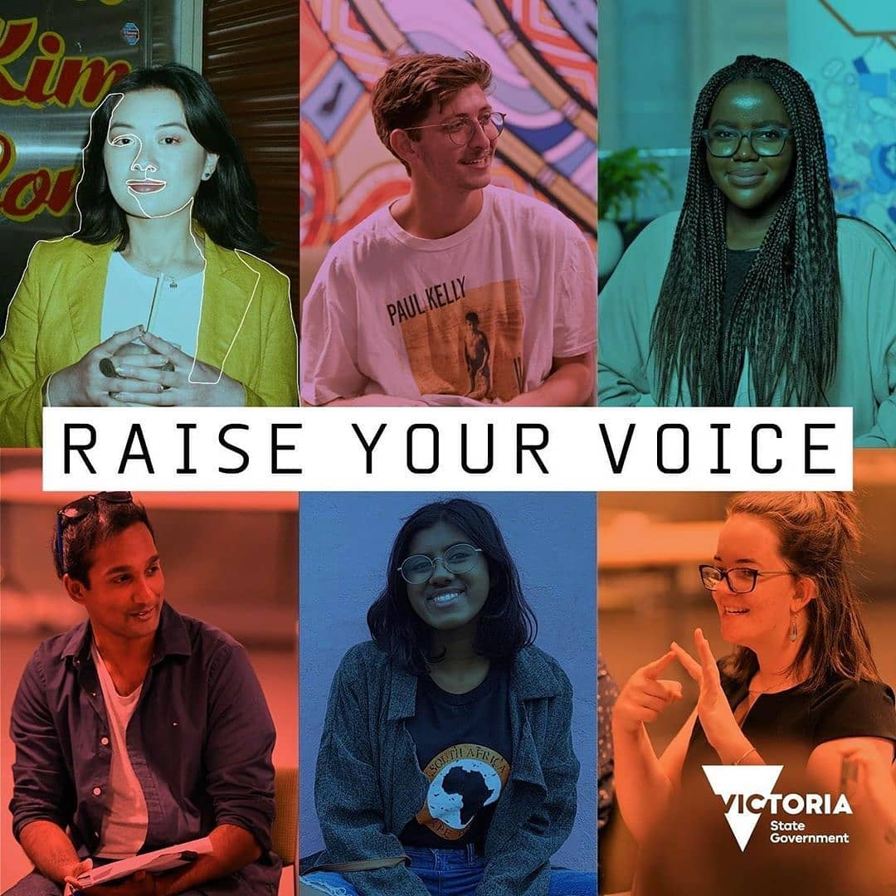
It has been a busy year for youth consultations at YACVic as we worked on many key projects for the Victorian Government and other partners to hear and highlight the voice of young people.

Between October to December 2020, YACVic delivered a series of consultations targeting young people and the broader community to have input into the new whole-of-Government Youth Strategy. Twenty consultations were delivered across Victoria for young people to develop recommendations on what policies they would like to see implemented by the Victorian Government to make Victoria a better place for all young people. These recommendations were then included in a report which was provided to the Office for Youth to give direct feedback into the development of the new Youth Strategy.

Key to the process of engaging with young people was the development and delivery of these consultations by YACVic’s Young Peer Facilitators. They worked in partnership with the Policy and Advocacy team and the Office for Youth to develop consultations that were engaging and gave young people from across Victoria the opportunity to have their voices heard directly by Government.

YACVic has also played a significant role working in Partnership with Bushfire Recovery Victoria and the Department of Education to develop resources in engaging young people meaningfully on disaster recovery. Similar work also took place for the Inspector General of Emergency Management (IGEM) on how to include young people in emergency responses. Led by a working group of young people, we have empowered young people to present at state-wide and national forums (p 20).

Additionally, we have advocated and created a platform for young people to have their say on other key issues, including the Mental Health Royal Commission (p 15), our COVID-19 Recovery Plan for Young People (p 16-17), the Disability Royal Commission (p 18), and other submissions on youth homelessness, gambling harm, youth justice, transport and more.

As YACVic’s work and impact continues to grow, we will continue to centre the voices and lived experience of young people and ensure they are recognised as experts in their own lives.

Strategic Goal 2: Meaningful Youth Participation

YDAS Young Leaders Program
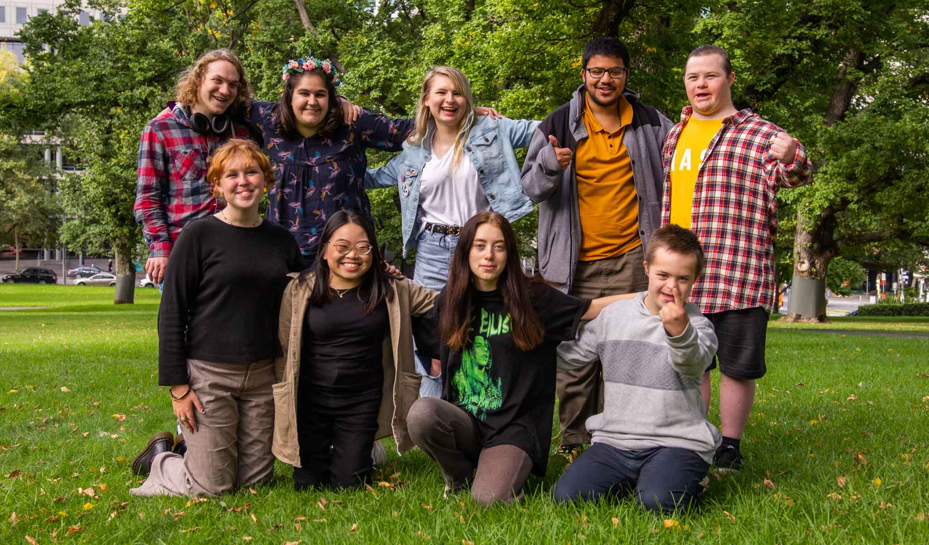
The YDAS Young Leaders program used to be called the Emerging Young Leaders Program, but this year we ditched ‘Emerging’ in its name. We also co-created a new workshop program for disabled young people aged between 20 – 25, in addition to our existing workshop program for disabled young people aged between 14 – 20. The program staff Haley, Kelsey and Simon, alongside YDAS staff Is, Jade and Nat worked on and with:
- 6 groups of workshops
- 66 young leader graduates from across Victoria
These young leaders have gone on to do many great things, so here’s some highlights:
- 31 stories of graduates who got jobs or paid engagements.
- 21 stories of getting into study or training, including TAFE, University or short courses.
- 7 people nominated for or winning awards.
- 23 instances of people joining boards, committees, advisory groups and other organised groups of influence.
- 20 stories of volunteering or taking a leadership role in their communities, including school captains and action groups in the United Nations.
- 21 personal milestones, like getting their driver’s license, buying a car or applying for their first job.
- 72 stories of advocating for their own rights, the rights of their family and friends, or for their community. This Included advocating for disability access and inclusion, LGBTIQA+ rights, bushfire recovery and equitable access to education or workplaces. The leaders advocated at local, state and federal levels of government, and multiple instances of advocating to the United Nations.

Strategic Goal 3: A Strong Youth Sector

Youth Sector Capacity Building
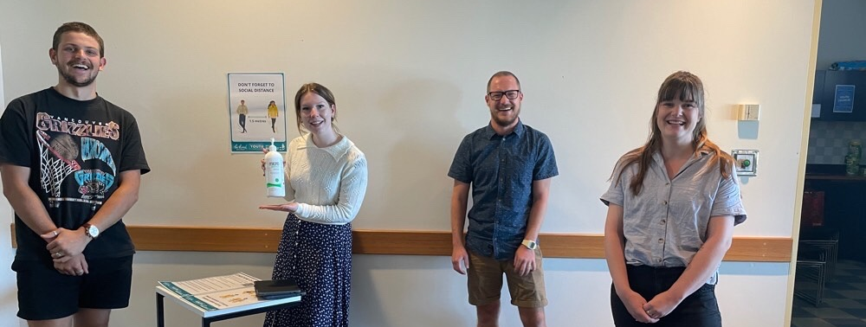
We have worked on some very interesting new youth sector capacity development projects this year, which has seen us support organisations in a variety of ways to better connect with young people.
Our long-term partnership with VicHealth went from strength to strength as we continued to provide advice and guidance on their youth engagement activities (p 20).
We were pleased to support Volunteering Victoria to connect with young people on the subject of Engaging and Supporting Young Volunteers for the Department of Environment, Land, Water and Planning (DELWP). We recruited the young participants and led a consultation for a guide that will be created for environmental volunteering organisations.
We partnered with the City of Whittlesea youth team on the Victorian Responsible Gambling Foundation (VRGF) funded Gambling Harm Awareness project that supported a group of young people to co-design a youth-focussed campaign to engage, educate and empower local young people. Our role was to support the team to work with young people, running youth participation training for the staff team and designing and leading workshops for the young co-designers.
The Child Safety team at Department of Justice and Community Safety (DJCS) approached us in August 2020 for support to connect with young people and gather feedback on their draft youth strategy. We brought the Commission for Children and Young People (CCYP) into the project too, and two members of their Youth Council worked with YACVic’s Young Peer Facilitators to plan and lead the workshops. The team of five young facilitators worked closely with the DJCS team to run three workshops with eight young people with lived experience of the youth justice system, to reflect on the youth strategy and make recommendations for DJCS to engage and work more closely with young people.
We also continued to provide training workshops and webinars on a variety of topics, in particular Youth Participation, and the Code of Ethical Conduct in Youth Work.

Strategic Goal 3: A Strong Youth Sector

Young Peer Facilitators
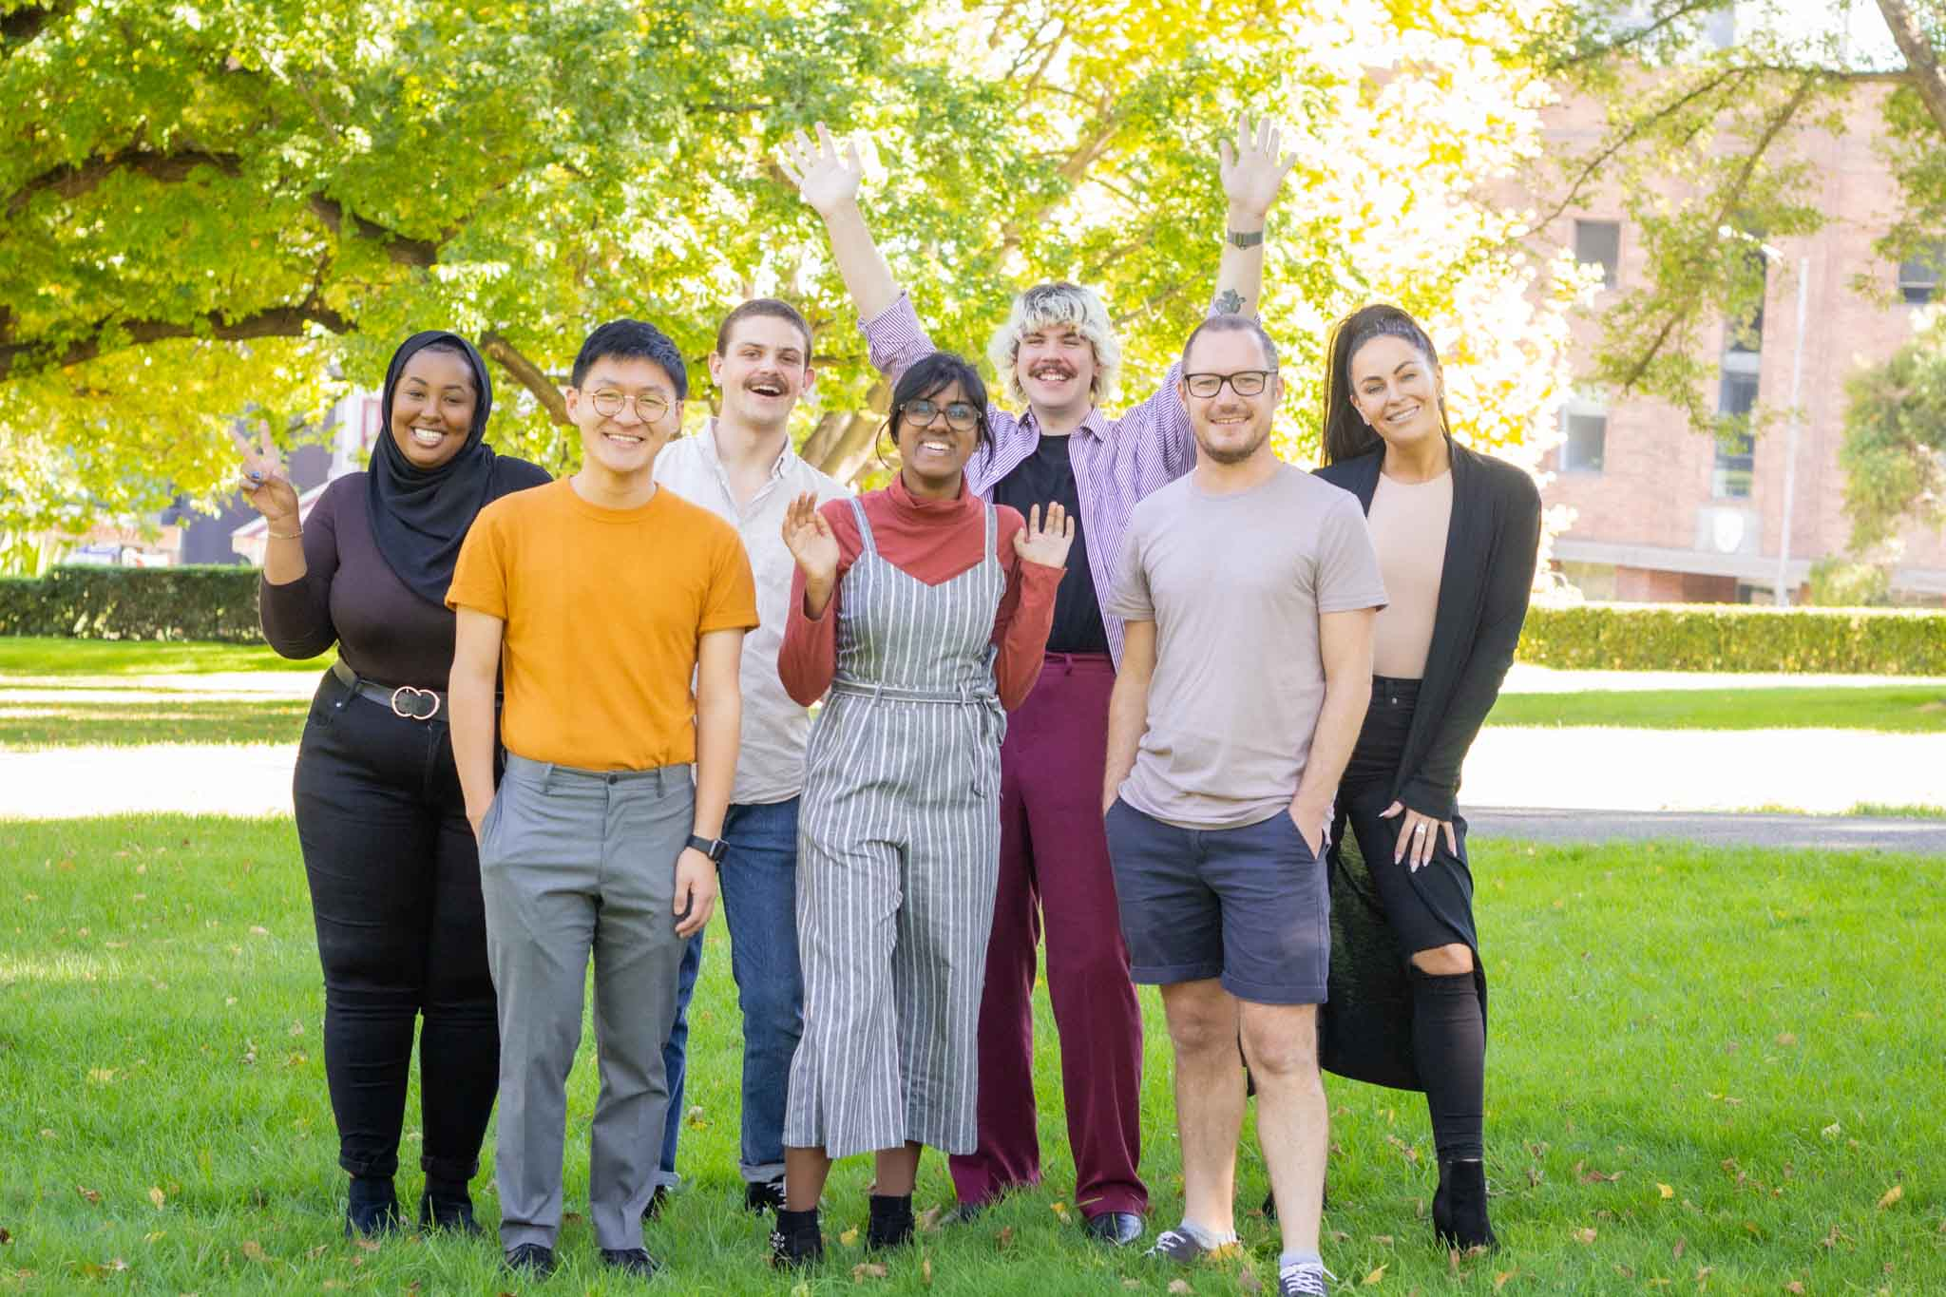
This has been a challenging year, but one undeniably positive outcome has been the Working for Victoria (WfV) funding that we received to employ people who had been impacted by the pandemic (p 27).
Through WfV funding, we were able to employ seven Young Peer Facilitators to embed within YACVic to work on training workshops and consultations. This allowed us to fully live our youth participation strategy of placing young people at the centre of conversations both with and about young people. The Young Peer Facilitators worked across multiple projects, with the various teams at YACVic, as well as with our members and partners across the sector.
The seven young people employed to these roles as casual staff were from across Victoria with a variety of lived experience. They were supported by a young Lead Facilitator who ran peer supervision and worked on allocating roles and projects that ranged from leading youth and community consultations for the Victorian Government Youth Strategy Forums to running Advocacy Training for young people and Code of Ethical Practice Training for people working with young people.
The Peer Facilitators helped us to create brand new workshops including an advanced Youth Participation 201 training to build on the already established Youth Participation 101 Training we have been running for years. Members of the group also created Youth-Led Meetings Training for young people which brings aspects of our Yerp.org.au website to life for young people and builds confidence in young people to organise and lead their own meetings.

Strategic Goal 3: A Strong Youth Sector

Bringing the Sector Together
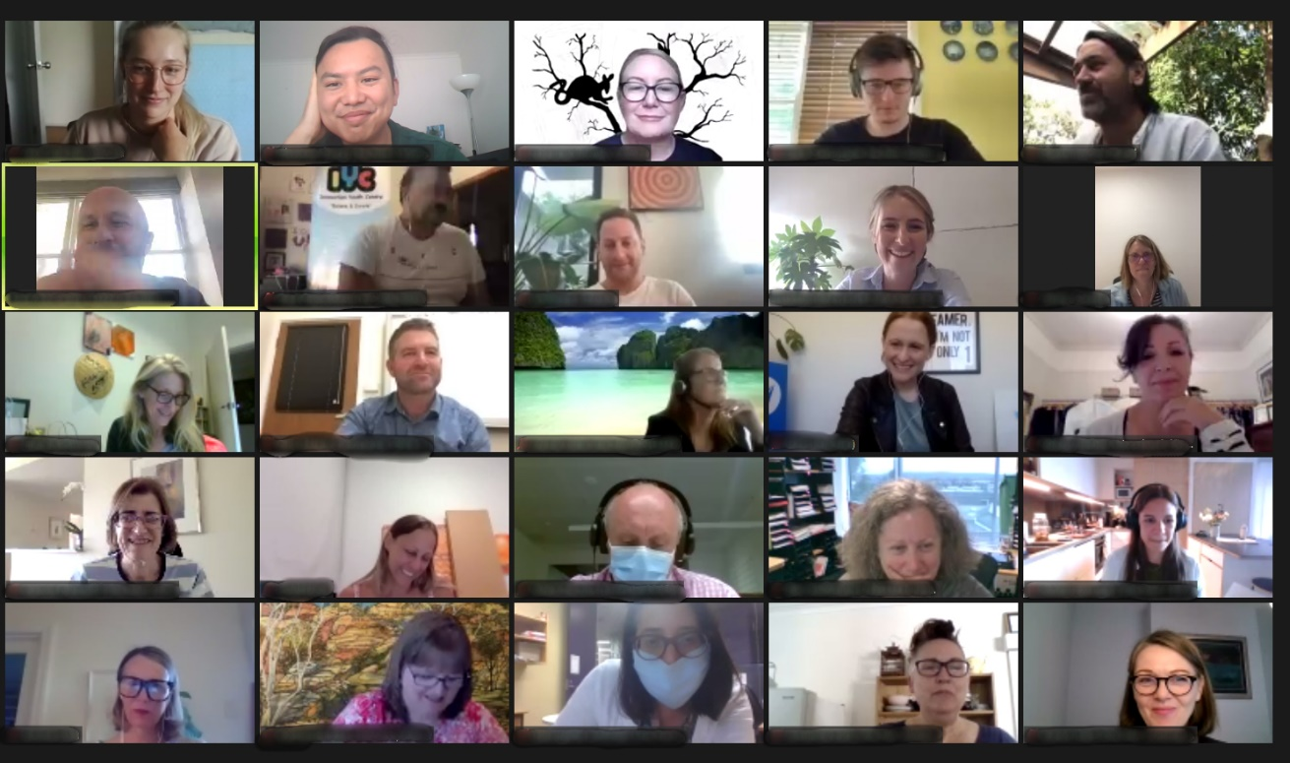
YACVic takes our role as a convenor for the youth sector very seriously. We have long brought together groups such as the Youth Participation Practice Network (YPPN) and KYC’s Koorie Youth Participation Network, and in the past year strengthened our Community of Practice in Youth Mental Health in partnership with Orygen, and built up our involvement in Smart Justice 4 Young People.
When COVID-19 hit in March 2020, it became obvious that there was an even greater need to bring our members and other stakeholders together, to understand the multitude of ways that young people were being affected, to share information and ideas in relation to the fast moving crisis, and as time went on, create opportunities to engage collectively on key issues and facilitate peer support. So we also created the Youth Sector Leaders Huddle that met fortnightly at first and continues now monthly, and Rural Huddles and Metro Huddles for workers on the front lines, and Youth Huddles to create a space for young people to connect.
While online meetings will never feel the same as face-to-face, the Zoom format did have some advantages, making it easy for people to include these gatherings in their busy days, removing venue and catering issues, and very importantly, improving access and inclusion options for people with disability and those living in rural and regional areas. The level of sharing, collaboration, and connection that has evolved across the Victorian youth sector means this is one adaptation from COVID-19 that we will definitely continue into the future.

Strategic Goal 3: A Strong Youth Sector

Working for Victoria Fund
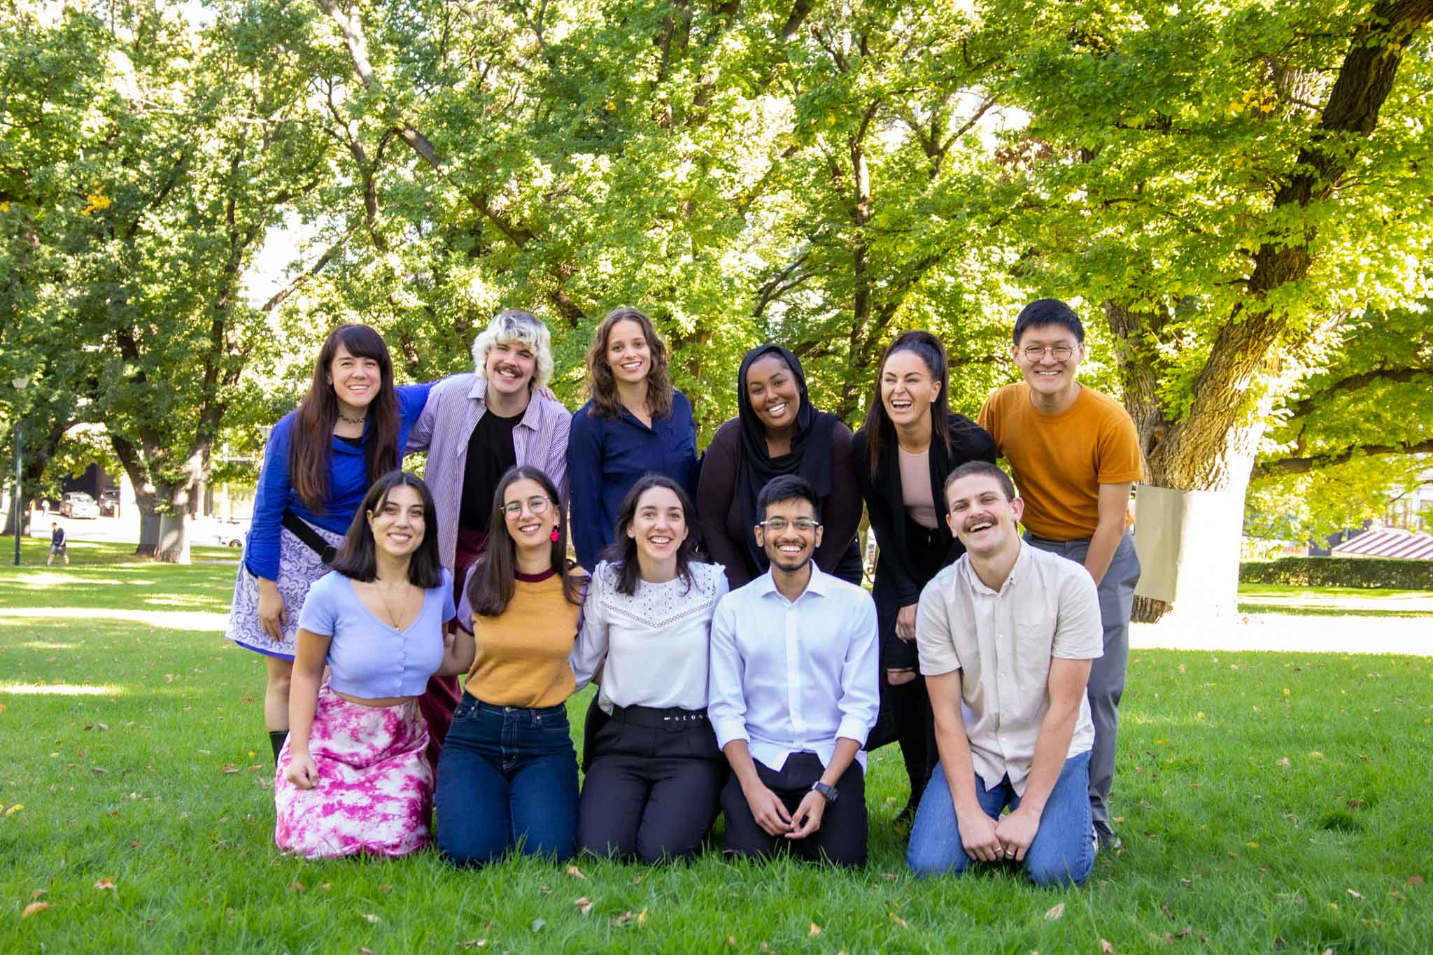
A coalition of youth services led by YACVic secured $6.97 million from the Working for Victoria Fund in the Department of Jobs, Precincts and Regions (DJPR) to create new jobs to help address the impact of COVID-19 on the lives of young Victorians.
Members of the coalition include YACVic, Youth Support Advocacy Service (YSAS), Centre for Multicultural Youth (CMY), Centre for Excellence in Child and Family Welfare (CFECFW), Brophy Family & Youth Services, Whitelion Youth Agency, Primary Care Connect, and the Victorian Local Learning and Employment Networks (VicLLENs). YACVic also played a convening and support role to manage implementation of the project and enhance collaboration between the Coalition Partners and DJPR.
The WfV Project has created employment pathways for the youth sector and increased the employment outcomes of WfV employees who participated in the project and, by doing so, helped address youth unemployment and the surge in demand for young people seeking support services.
The roles created include 46 Youth Outreach Workers, as well a variety of roles to support and strengthen the youth sector during the COVID-19 crisis and recovery.
The WfV-funded staff have provided extra capacity for the members of the Youth Sector Coalition to provide additional services for young people in Victoria, and to amplify young people’s voices to policymakers. This extra capacity has been crucial for the Coalition, as COVID-19 has brought surging demand for the youth sector amid uncertainty and disruption, with more services being delivered online and in-person.

Strategic Goal 4: Social Justice

Rural Overview
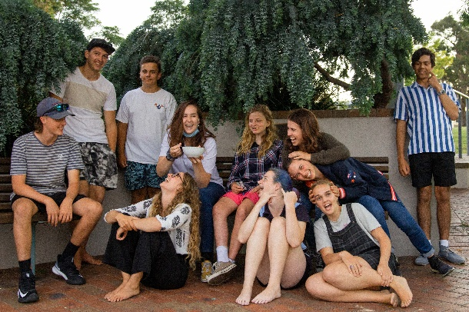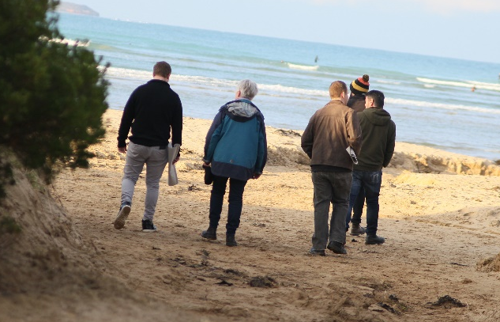
YACVic Rural continues to strengthen our engagement, focused on ensuring that the unique needs of young people and youth workers across rural and regional Victoria are recognised and addressed.
We delivered the Rural Youth Awards online for the first time, and congratulate again: Janelle Graham from Shepparton (Young Person Leading Change), Ken Innes from Mildura (Youth Worker Making a Difference), the Keeping In Touch Project (KIT) Project from Bendigo (Outstanding Youth Project), the Youth Advisory Board (YAB), Central Highlands LLEN (Young People’s Choice Award) and Pauline Neil (YACVic Rural Hall of Fame).
We continued to develop innovative content for communities which included a community of practice to support Aboriginal young people in the Southern Mallee improve peer-based responses to youth mental health. With twelve organisations across the Great South Coast, we established the Regional Partnership Youth Working Group which collaborates to prioritise local issues that impact young people and the youth sector.
The YACVic Rural team has also continued to build capacity in rural and regional areas, delivering Rural Huddles for workers; 26 workshops and presentations to young people on advocacy, leadership, participation, mental health, media skills, and a vast array of local issues; and assisting Youth Live 4 Life and Beyond the Bell with securing funding.

Key Stats
- 277 participants across 26 training sessions
- 525 young people engaged in YACVic Rural Activities
- 26 workshops and presentations delivered to 215 young people
- 104 workers participating in rural sector huddles
- 16 Young Activators developed projects to support bushfire recovery in their local communities
- 78 people attended the Rural Youth Awards with 40 separate applications

Strategic Goal 4: Social Justice

HEY Grants Round 10

Healthy Equal Youth
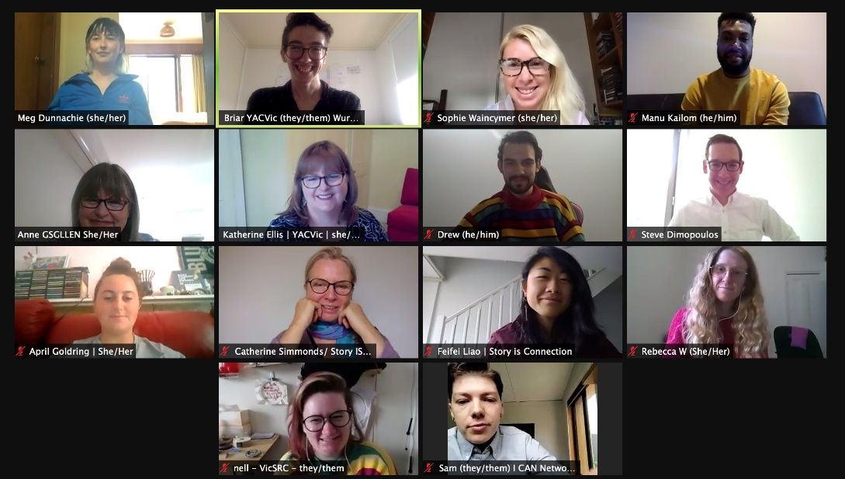
This year, HEY (Healthy Equal Youth), which YACVic oversees on behalf of and in partnership with the Victorian Government, went from strength to strength. The HEY Partners came together more often and created resources to deal with the pandemic (p. 30), and we were very pleased to receive confirmation in the May 2021 budget that newer HEY partners will receive ongoing funding.
The annual HEY Day was a collaboration with La Trobe University, to launch the Victorian Summary Report of their Writing Themselves In 4 research on the lives of LGBTIQA+ young people. The launch included presentations by a panel of peer educators, including young people, exploring the issues underpinning the often shocking data.
At the HEY Day, Steven Dimopoulos MP, Parliamentary Secretary for Mental Health, announced the successful 2021 HEY Grant recipients and talked with them on a Zoom call. YACVic promotes and administers the grants with a working group of LGBTIQA+ young people who provide invaluable input as part of the selection process.
This year we initiated an information session to assist organisations and individuals considering applying for the grants, and received 47 applications requesting $428,235, which equates to more than four times the amount of funds available. There was an increase in applications addressing deficits in LGBTIQA+ sexual health education; utilising peer-based approaches to project development including resources focused on mental health and sex education; and for Arts based projects. Eleven grants were funded in this round, and for the first time, two Aboriginal organisations received grants.

Strategic Goal 4: Social Justice

Breaking the Isolation of LGBTIQA+ Communities

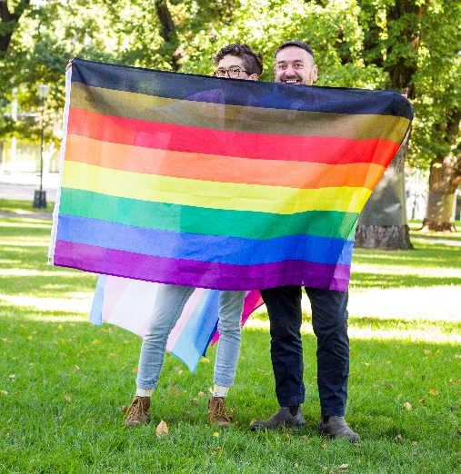
At the beginning of the pandemic, YACVic initiated fortnightly online meetings designed to break the isolation experienced by HEY workers during lockdown. The meetings became an important supportive lifeline for HEY workers—many of whom are isolated geographically and working as sole workers—in their ability to continue to support LGBTIQA+ young people across Victoria. These meetings continued on a monthly basis into 2021, where they have remained a mechanism for peer support, information-sharing, and stronger partnerships across the state
When Melbourne entered Stage 4 lockdown in August 2020, the HEY Partners identified a gap in COVID-19 communications. Many LGBTIQA+ specific services were overwhelmed with demand, and mainstream services were uninformed about appropriate care for LGBTIQA+ community members. Although LGBTIQA+ young people continued to support each other, heteronormative government guidelines around family violence and compassionate care left LGBTIQA+ young people unsure of if they were breaking the law if they had to leave their 5km radius, even if it was for safety or mental health reasons.
The HEY Partners worked together to create resources targeted to LGBTIQA+ communities. The resource, ‘COVID-19 Resources for LGBTIQA+ young people and carers’, was posted on Instagram and on the YACVic blog. This resource gave the Department of Health a starting point to create material specifically targeted to LGBTIQA+ Victorians, listing affirming mental health providers and even testing venues with the Rainbow Tick. The DHS resource is currently available at www.coronavirus.vic.gov.au/information-lgbtiq-communities.

Strategic Goal 4: Social Justice

Marram Nganyin

Marram Nganyin Project staff from both KYC and YACVic have continued to support five local Aboriginal Community Controlled Organisations (ACCO) to deliver strong and culturally safe mentoring programs on the ground in their communities. This has included online meetings in a Community of Practice, to support the work and share initiatives.
A key feature of this year’s work has been a strengths-based review of the project. Young project participants and workers across all five ACCOS were consulted in the development of the review and also provided feedback as key informants to the review. The key findings are now informing the development of the model for the next two years of project implementation.
This year our team also supported the development of new Aboriginal Youth Engagement Grants offered by the Victorian Government, including providing expert input into the application guidelines, assessment criteria and promotional materials. We provided two online information sessions attended by 38 prospective applicants across 26 organisations, which featured presentations by young people on best practice in Aboriginal Youth Participation. We also supported three Aboriginal young people to participate in the selection process, including reviewing and scoring applications and sitting on the selection panel. Six grants were provided from more than 35 applications, and our team will continue to include and involve these organisations in a range of opportunities, networks, and activities during their project delivery phase

Program Locations
- Wyndham Aboriginal Wellness Foundation
- Heywood Winda-Mara
- Bairnsdale Gippsland and East Gippsland Aboriginal Co-Operative
- Shepparton Rumbalara
- Swan Hill Mallee District Aboriginal Services

Strategic Goal 4: Social Justice

Youth Disability Advocacy Service (YDAS)
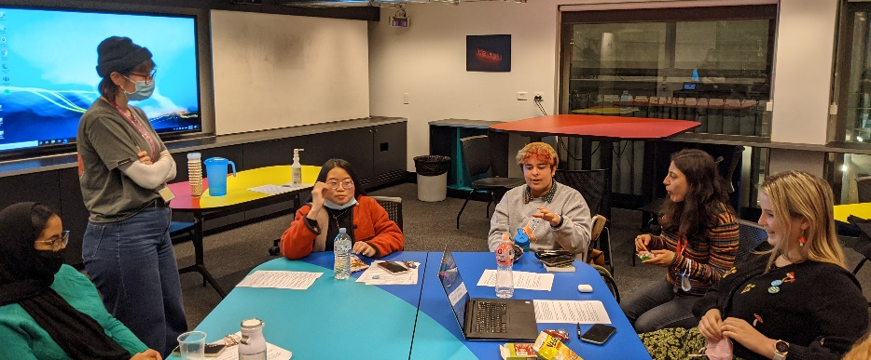
Disabled young people met the adversity of this past year with resilience and innovation. They were disproportionately impacted by the COVID-19 pandemic, being both disabled and young people. Nonetheless, they drew on their lived experience of navigating barriers and discrimination to step up and advocate for themselves and their peers.
The passion and work of these disabled young people flows through YDAS, and credit goes to them for the fact that in spite of the hardship last year, YDAS was able to grow, supporting and reaching greater numbers of disabled young people, organisations and decision makers in 2020-21.
The YDAS Human Rights Advocacy team increased in capacity thanks to funding from Lord Mayor’s Charitable Foundation and the Victorian Government’s Working for Victoria Fund. This enabled us to more than double the numbers of disabled young people that we supported as advocacy clients. YDAS also increased our policy and systemic advocacy work, thanks again to Working for Victoria. This allowed us to continue and increase our advocacy work, with focuses on the response to COVID-19 (p 19), education and the Disability Royal Commission (p 18).
With extensive input from disabled young people, including staff, co-designers and presenters, YDAS developed and launched the online Map Your Future program (p 33), which is designed for disabled young people to help them identify, develop and achieve their goals. The YDAS Young Leaders Program, co-designed and co-delivered by disabled young people, has continued to build young leader’s self advocacy, expertise and confidence.

Key Stats
- 62 disabled young people received individual advocacy support
- 66 young people graduated from the YDAS Young Leaders Program
- 11,619 combined followers on Instagram, Facebook, Twitter and LinkedIn
- 17 consultations and focus groups with 111 disabled young people

Strategic Goal 4: Social Justice

Map Your Future

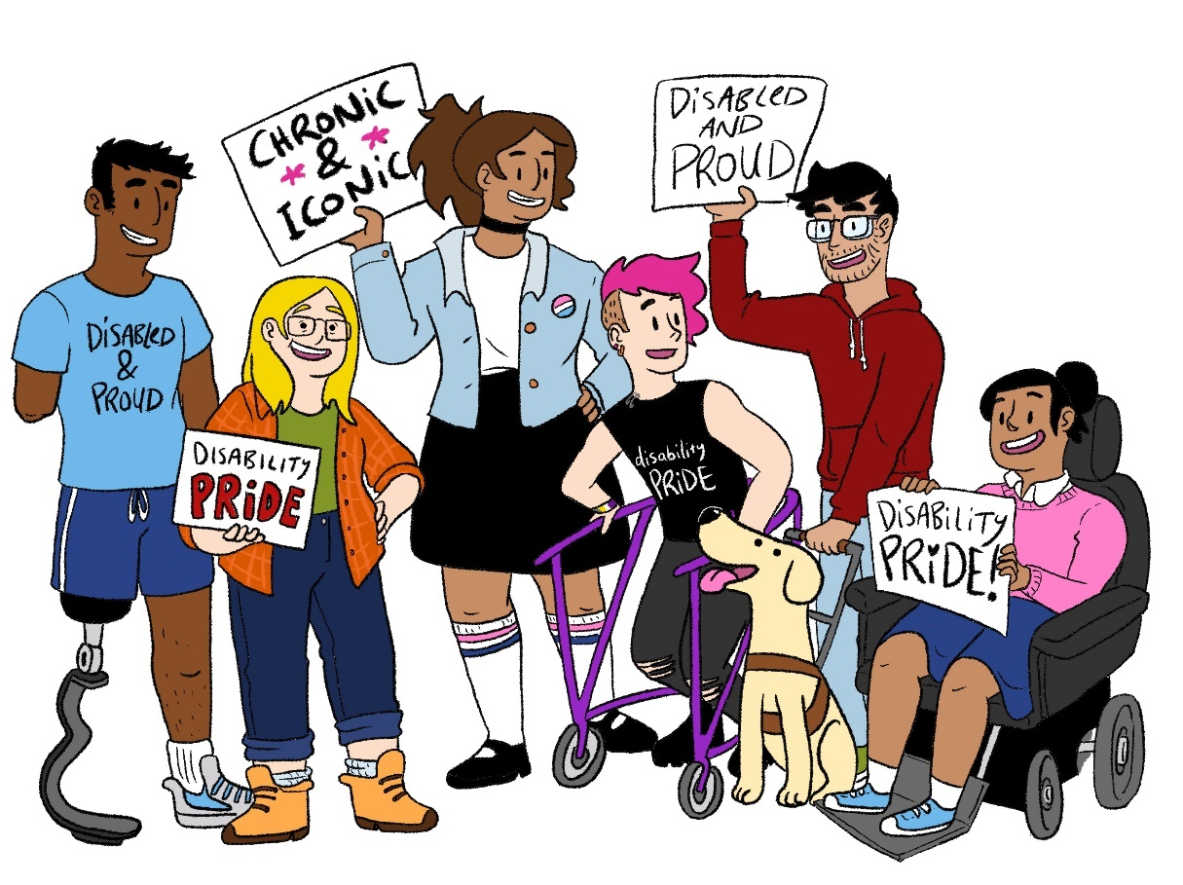
YDAS celebrated International Day of People with Disability with the launch of our new online program for disabled young people.
Map Your Future is a free online course that supports disabled young people to identify, develop, and achieve their goals.
The NDIS funds vital supports and services for the disability community, but many young people do not fully understand the NDIS or how it works. Some young people don’t even realise they receive disability supports through the scheme.
Map Your Future aims to change that. It covers important topics, including how to join the NDIS, set goals, and get the right support to achieve those goals—all designed to be fully accessible and relevant for disabled young people.
The program also covers other important topics, including disability pride, self-care, speaking up, and self-advocacy.
With extensive input from disabled young people, including YDAS staff and co-designers, Map Your Future is full of interactive activities, illustrations, and even a video series.
The video series, which features disabled young people sharing their experiences and advice for other disabled young people, has been popular on social media.
The project wrapped up with an online celebration to officially launch Map Your Future. A highlight of the event was a live Q&A session with some of the young people who starred in the video series.
“My favourite topic to talk about in the videos was disability pride because I haven’t encountered many spaces where you can discuss disability pride in any detail.” – Cindy
Map Your Future is designed for disabled young people who are aged 12 to 25, but anyone can complete this program.
Visit the YDAS website to access Map Your Future.

Strategic Goal 4: Social Justice
Koorie Youth Council (KYC)

Koorie Youth Council would like to pay our deepest respects to people of the Kulin Nation and to all Elders past and present for their knowledge, wisdom and legacies that continue to drive us. We acknowledge and thank all the incredible young people and communities we work with for standing with us as we collectively create a future where all our people can thrive.
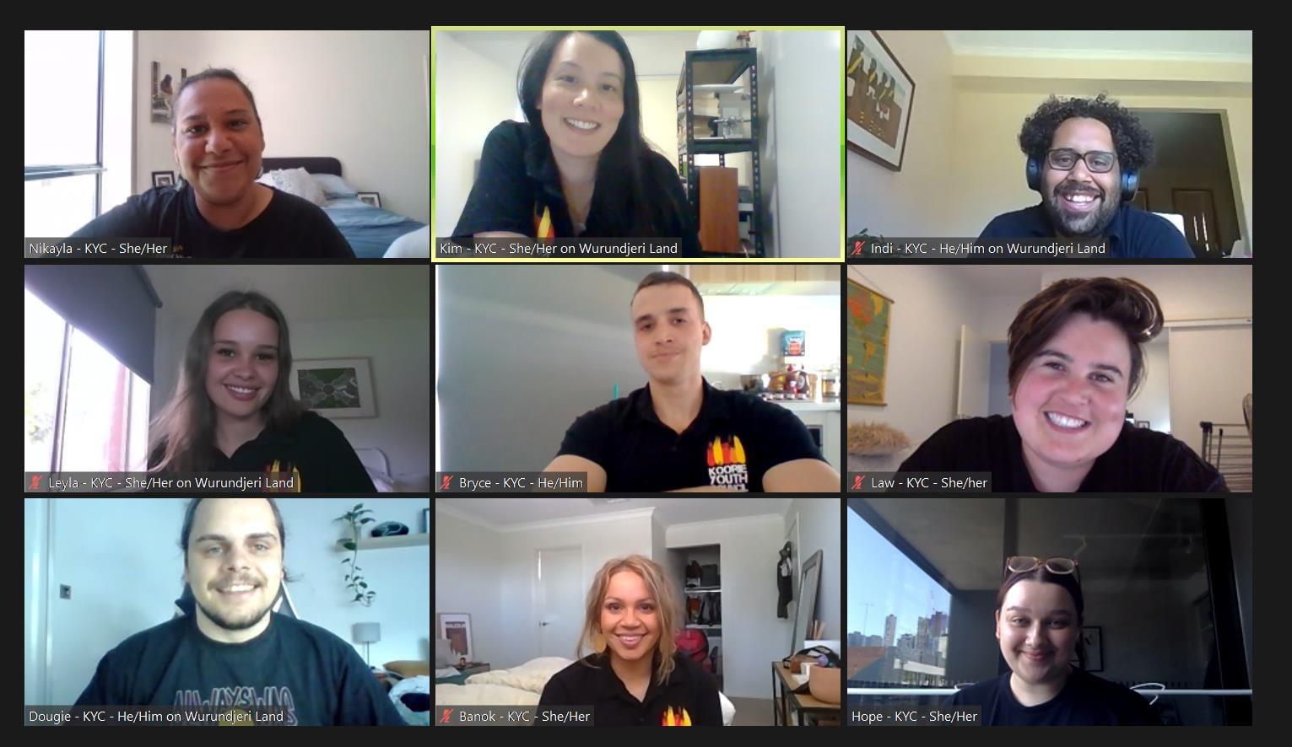
Over the past twelve months KYC has matured as an organisation despite the challenges of COVID-19, proudly continuing to create spaces for Aboriginal and Torres Strait Islander young people to connect and have their voices heard through online mechanisms.
Guided by an Executive of 15 Aboriginal and Torres Strait Islander young people aged 16-28 years living in Victoria, we all came together regularly (online and in person when possible) to plan KYC’s events, projects and programs.
We continued to be strong, active advocates for the rights and representation of young mob in many different forums, engaging our young people and working with the Victorian Government’s Aboriginal Youth Justice team to develop the Aboriginal Youth Justice Strategy, and the Office for Youth on the new Victorian Youth Strategy.
KYC started our state-wide roadshow journey to get out to communities and connect with young mob on issues important to them, always adapting to COVID-19 lockdowns and restrictions. Our youth participation network meetings and training continued to support youth workers to explore Aboriginal youth participation best practices for young mob. KYC and the Marram Nganyin Aboriginal youth mentoring program continued to support five Aboriginal organisations to deliver youth mentoring programs across the state (p 31).
In partnership with YACVic and the Victorian Government’s Office for Youth, we supported the establishment of the Aboriginal Youth Engagement Grants which saw six programs share in $250,000 to respond to the immediate needs of Aboriginal and Torres Strait Islander young people in Victoria. We continue to plan the 2021 Koorie Youth Summit, which will be held online across three weeks in November 2021.
www.koorieyouthcouncil.org.au

Key Stats
- 19 yarning circles and events connecting young mob
- 5 Koorie Youth Participation Network meetings and training sessions
- 18 Executive meetings
- 5 deadly new Executive members
- 15.3K social media audience members

Strategic Goal 4: Social Justice
Young Mob Yarns
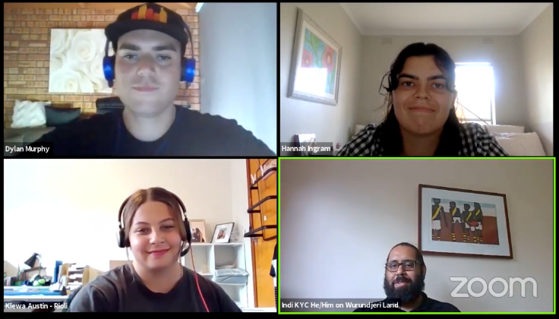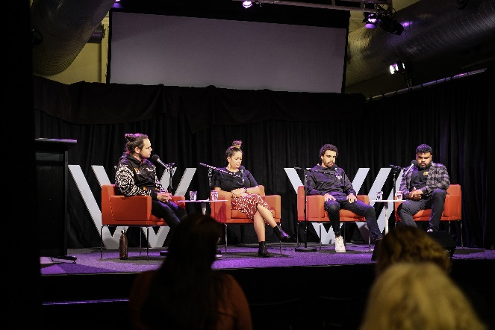
Bringing young mob together to connect, share stories and be heard on the issues that matter to them is at the heart of the work we do at KYC. The impacts of COVID-19 meant we needed to adapt, moving our yarning circles online and creating opportunities for greater participation, particularly for young people living regionally.
What began as weekly check-ins on Instagram live with the KYC team and Executive has evolved into Young Mob Yarns, our regular event series hosted by and for young people.
We hosted young members of the First People’s Assembly in our Treaty yarning circle and heard from deadly young people reflecting on the year that was 2020 and what their goals were for 2021. We also hosted an amazing panel discussion at the Wheeler Centre in Melbourne as part of YIRRAMBOI Festival exploring what truth and justice looks like for young people in light of the announcement of the Yoo-rrook Justice Commission.
We’re very proud that Young Mob Yarns has garnered over 3.5K views online, and we’re excited to continue to bring our young mob together in new ways.

Strategic Goal 5: A Thriving Organisation
Media and Communications
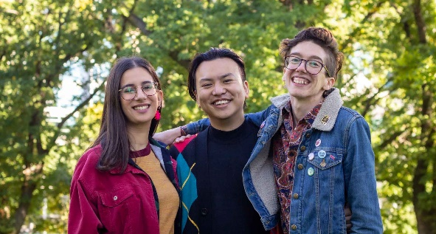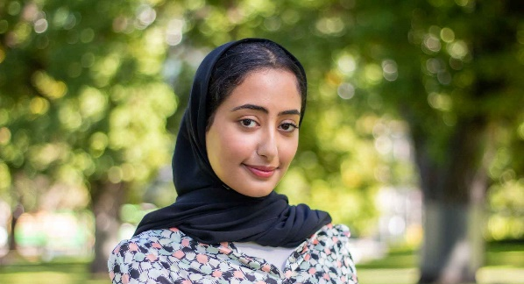
YACVic has been a trusted source of information and advocacy throughout COVID-19, translating crucial material in clear, innovative and fun ways to engage and advise our audience on the ever-evolving pandemic landscape.
YACVic’s current brand, colours and templates have been expanded as our team harnessed the power of easy to understand infographics and memes, and ensured our reports were consistent, youth-friendly and accessible. We refreshed our imagery, and increased the use of illustrations in our work, particularly for sensitive issues and de-identified case studies.
With the increasing importance of videos, we embraced the dynamic medium to showcase and celebrate YACVic’s 60-year anniversary, the 2020 Rural Youth Awards, videos for the Rural Young Activators program as well as continuing to make short videos to promote our work on TikTok and Instagram.
We enhanced our media training, creating a plain English version and delivering workshops for young people from migrant and refugee backgrounds, disabled young people, and rural and regional young people.
Our reach continues to grow with all-time highs in media hits, social media reach and website traffic. This included a front-page story in the Sunday Age, a regular op ed across a regional newspaper network, and a new regular column: Youth Matters on Pro Bono Australia, creating a new platform for young people’s voices to be heard. As the pandemic continues, we remain focused on providing young people and the youth sector with up-to-date information on the vaccine roll-out, restrictions and available support.

Key Stats
- 1,171,209 people reached through Facebook, Twitter and Instagram
- 232,495 page views
- 108 media appearances, including The Age, the ABC, and The Project
- 7 videos produced across the year
- 6 media training sessions with 54 participants

Strategic Goal 5: A Thriving Organisation
Corporate Services
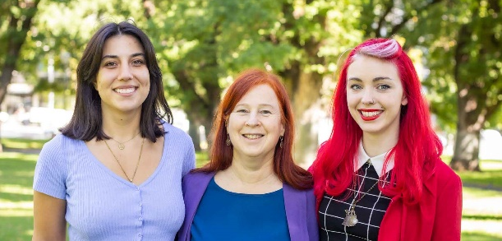
In a year with so much change and uncertainty in the world around us, the Corporate Services Team has focused on delivering internal stability, supporting our staff team and youth participants through all challenges and providing quality support that is flexible and adaptable enough to keep up with whatever is needed in the new COVID-19 world.
We continued to equip staff to work from either home or office, and to adjust meetings and communication channels to give both formal and informal online connection opportunities, since face-to-face meeting opportunities were limited. Thankfully, the 2020 Victorian lockdown lifted just in time for YACVic staff teams to participate in end of year get togethers; and we found a surprising number of opportunities to share other joyful occasions and celebrate both personal and professional achievements.
Staff wellbeing is paramount, and this year both HR and YACVic’s Staff Wellbeing Committee put their creative thinking into action, with individual Wellness Action Plans being promoted, new resources shared, and small care packages sent, and other small but thoughtful actions taken to show our appreciation of everyone’s hard work. Celebrations for IDAHOBIT Day and International Women’s Day included online movie nights.
Two staff surveys conducted during the year helped us to collect feedback on how our people were doing, on what we were doing well, and where there were opportunities for improvement. Among other areas, this led to some great online professional development workshops in areas requested by staff and management.
For Corporate Services, systems improvement is a continuous process. This year we updated and radically improved our financial reporting structure, improved the clarity and readability of many of our core policies and procedures, installed new voting software for our AGM, and upgraded communications technology in our Board room.

Key Stats
- 30 new project staff taken on as a result of growth in projects
- 60% of new staff were young people
- Improved financial and budgeting processes and systems

2020-21 Thanks to Staff

- Aakanksha Manjunathaswamy
- Akshay Kumar
- Albert Giglia
- Alexandra Iliopoulos
- Alyssa Jeffrey
- Anhar Al-Shameri
- Annelise Moller
- Ardu Cubillo
- Banok Rind
- Bianca Failla
- Bree O’Dwyer
- Briar Rolfe
- Bridget Jolley
- Bryce Taylor
- Carla Hall
- Cienan Muir
- Derm Ryan
- Douglas Briggs
- Fiona Macdonald
- Giovanna Szalkowicz
- Haley Zilberberg
- Hope Kuchel
- Ian Johnson
- Indi Clarke
- Is Hay
- Jade Maiolo
- Jennifer Rowan
- Jessica Brooks
- Jessica Standish
- Julia Baron
- Karen Walsh
- Katherine Ellis
- Katia Pellicciotta
- Kelsey McGowan
- Kim Evans
- Kirsty Greenwood
- Laura Donnelly
- Laura Pettenuzzo
- Leah Munnery
- Leyla Quartermaine
- Liam Head
- Lucia Suarez
- Luke Rycken
- Malika Kirby
- Mark Yin
- Maya Ghassali
- Mija Gwyn
- Natalie Voermans
- Nikayla Bamblett
- Nuriyah Haque
- Reece Moir
- Rhiannon Jennings
- Ruqia Mohamed
- Sam Champion
- Sebastian Antoine
- Shahnaz Rind
- Simon Green
- Stacey Christie
- Stephanie Brenkovich
- Thomas Feng

Financial Report

Treasurer’s Report
Financial Year 2020-21 (FY21) has been another challenging year and has required management and the Board to continue prudent financial management given the continued uncertainty of the COVID-19 pandemic on YACVic’s programs, people, members, partners and communities.
The FY21 surplus increased by $22,979 to $332,868 and this was largely due to:
- Increased revenues of $397,965 to $4,627,355. This increase was principally due to additional government funding of $248,458, an increase in COVID-19 related government subsidies of $132,600 including JobKeeper, offset by a reduction in conference income of $137,565 following the necessary decision to defer our conference to FY22 as a result of COVID-19 restrictions.
- Expenditures increased by $374,996 to $3,919,491. This increase was principally a result of higher workforce costs to support the many continuing and new initiatives across YACVic, offset by a decrease in project costs largely as a result of online delivery of events and programs, and the deferred conference.
Our financial position remains strong with net assets at 30 June 2021 of $1,566,432 which included a strong cash position of $3,540,657. It is important to note that this cash position was largely due to the timing of significant project funding received towards the end of the year and therefore not expended at year-end, but which will be used across many committed initiatives over the coming 12 months.
I continue to be proud of the way YACVic’s management team, people and Board continue to lead the organisation. Whilst FY21 was another challenging year, we start the new financial year from a position of financial strength which will allow us to focus on delivering our impactful strategy. Peter Glynn, YACVic Treasurer

Peter Glynn,

YACVic Treasurer

For the Year Ended 30 June 2021

Statement of Comprehensive Income
Table 1: Statement of Comprehensive Income
 | 2021 $ | 2020 $

Income
Conferences | - | 137,565
Member subscriptions | 38,306 | 26,659
Government grants | 4,042,809 | 3,794,351
Other grants | 84,600 | 36,500
Interest received | 2,337 | 25,328
Other income | 264,203 | 146,487
COVID-19 Government Stimulus | 195,100 | 62,500
Totals | 4,627,355 | 4,229,390

Expenditure
Depreciation and amortisation expense | 234,788 | 243,880
Finance costs | 13,835 | 20,035
Employee costs | 3,407,726 | 2,857,674
Project costs | 222,445 | 387,942
Accommodation expenses | 90,534 | 103,663
Administration expenses | 274,666 | 173,516
Communication expenses | 37,802 | 127,085
Publication and printing | 12,691 | 5,696
Totals | 4,294,487 | 3,919,491
Other comprehensive income for the year | - | -
Total comprehensive income for the year | 332,868 | 309,899

For the Year Ended 30 June 2021

Statement of Financial Position
Table 2 Statement of Financial Positon, Assets
Assets | 2021 $ | 2020 $

Current assets
Cash and cash equivalents | 3,540,657
Trade and other receivables | 236,842
Prepayments | 62,931
Total current assets | 3,840,430 | 2,998,270

Non-current assets
Plant and equipment | 180,051 | 261,908
Right-of-use assets | 335,234 | 497,013
Total non-current assets | 515,285 | 758,921
Total assets | 4,355,715 | 3,757,191

Table 3 Statement of Financial Position, Liabilities
Liabilities | 2021 $ | 2020 $

Current liabilities
Trade and other payables | 301,716 | 341,374
Employee benefits | 286,160 | 192,672
Other liabilities | 1,796,262 | 1,192,154
Lease liabilities | 149,941 | 137,510
Total current liabilities | 2,534,079 | 1,863,710

Non-current liabilities
Lease liabilities | 215,805 | 376,897
Employee benefits | 39,399 | 26,887
Total non-current liabilities | 255,204 | 403,784
Total non-current liabilities | 2,789,283 | 2,267,494
Net Assets | 1,566,432 | 1,489,697

For the Year Ended 30 June 2021

Statement of Changes and Equity
Table 4 Statement of Changes and Equity
 | Retained Surplus $ | VicSRC Retained Surplus $ | Total $
Balance at 1 July 2019 | 991,956 | 187,842 | 1,179,798
Surplus for the 2019-20 year | 241,608 | 68,291 | 309,899
Balance at 30 June 2020 | 1,233,564 | 256,133 | 1,489,697
Surplus for the 2020-21 year | 332,868 | - | 332,868
Ending of VicSRC auspice agreement | - | (256,133) | (256,133)
Balance at 30 June 2021 | 1,566,432 | - | 1,566,432

Note: The financial summary provides an overview of YACVic’s financial affairs. The statutory financial statements which include our accounting policies are available in PDF form at yacvic.org.au/about-us/about-yacvic.

Accru Melbourne (Audit) PTY LTD

GD Winnett, Director

Wurundjeri Country
Level 2, 235 Queen Street,
Melbourne, Victoria, 3000
www.yacvic.org.au
info@yacvic.org.au
November 2021

YACVic

