Young Leaders Program

Youth Disability Advocacy Service

This is an Easy English book.
It uses pictures to explain ideas.

About this book
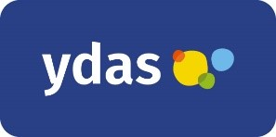
This book is from Youth Disability Advocacy Service or YDAS.

We support disabled young people in Victoria.

This book is about our Young Leaders program.

We call it the program.
The program happens on Zoom.
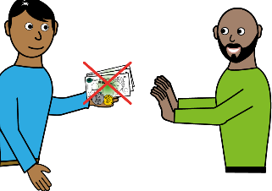
You do not have to pay to do the program.

Who is the program for?

The program is for people who
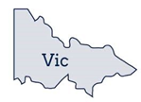
- are 14 to 25 years old
and
- live in Victoria
and
- have a disability.
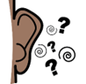
Disability might mean you are
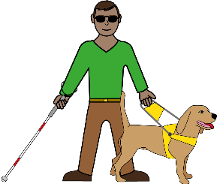
- deaf or hard of hearing
- blind or you have low vision
- autistic.
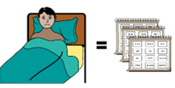
Disability might also mean you
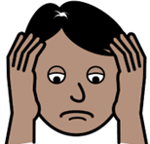
- have a chronic illness
- have a mental illness
For example, depression or anxiety.

What is the program about?

The program will tell you about how to be
a leader.
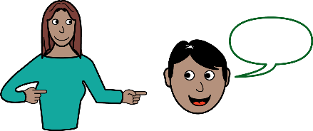
The program will also tell you about advocacy.
Advocacy means speaking up about issues that are important to you.
For example, you can speak up about how people with disability might not have
enough money.

You can speak up for
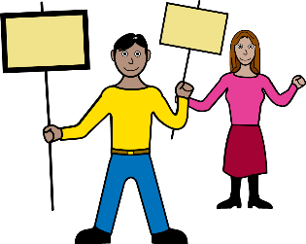
- yourself
- someone else.
When you do the program we will tell you about
- jobs for disabled young people
- how you can volunteer.
Volunteer means you
- work to help other people
- are not paid.

More about the program
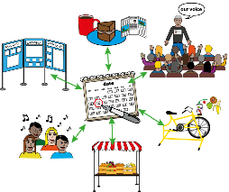
We will also tell you about other opportunities.
For example, events for disabled young people.

In the program you will also learn about how to
be accessible.
Accessible means everyone can
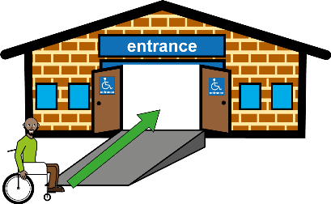
- understand information
- get to a place
- use a place.
For example a ramp means that wheelchair users can get into a building.
The program happens over 4 Zoom meetings.

You will hear from other disabled leaders.

For example, you might hear from Chloe Hayden.

How do I apply for the program?
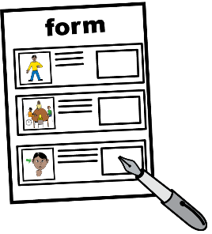
You can
- fill in a form on our website
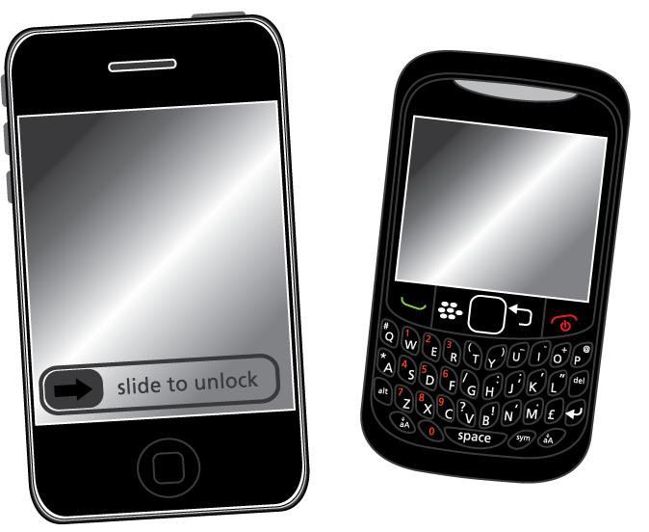
or
- call us.

You can call Haley if you want to apply on
the phone.
0476 287 414.

Haley will ask you the questions that are in
the form.
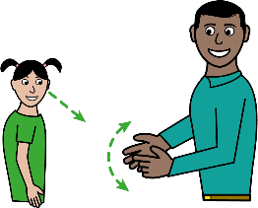
If you do not want to write your answers in the form you can also use
- Auslan
- Video
- Voice recording

You can contact Haley if you have any questions about the program.
Email
youngleaders@ydas.org.au

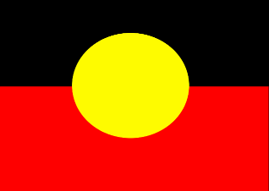
First Nations people are important

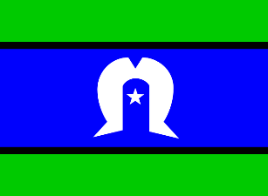
First Nations people are Aboriginal and
Torres Strait Islander people.
First Nations people have looked after the land for a long time.
We work in Melbourne or Naarm.
In Naarm the First Nations people are called the Wurundjeri people.

