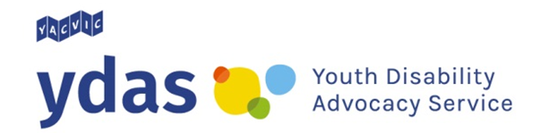

NDIS 101: Managing your plan

When you join the National Disability Insurance Scheme (NDIS) you get a plan. Your NDIS plan is about you and your needs. It lists the disability supports you get through the NDIS and the amount of money you can use to pay for them. There are 4 ways to manage your NDIS plan and money.

4 ways to manage your NDIS plan

1. You look after your NDIS plan
NDIS wording: Self-managed
This means you organise your own disability supports. The NDIS will give you money to pay for the supports in your plan. Looking after your own NDIS plan gives you more choice about your disability supports. It means that you can get support from people and companies that are not registered (signed up) with the NDIS.
You can look after your NDIS plan yourself or choose someone to help you. This could be a friend or family member.

2. Someone who knows how to manage your plan can do it for you
NDIS wording: Plan-managed
This person or company can look after some, or all, of your supports. They have to be approved by the NDIS to manage your plan.
Choosing this option means that you can get disability supports from people and companies that are not registered (signed up) with the NDIS. They can help you organise and pay for your supports. They can also help you learn new skills so that you can have more control over your NDIS plan.

3. NDIA looks after your NDIS plan
NDIS wording: Agency-managed
The National Disability Insurance Agency (NDIA) can organise your supports.
If your NDIS plan is looked after by the NDIA you can only get supports from some people and organisations. They have to be registered (signed up) with the NDIS. The NDIA will pay the people or companies who support you directly.

4. A combination of these
You can choose more than one of these options to manage your NDIS plan. For example, you might choose to self-manage some of your disability supports while a plan manager looks after your other supports.
This means that you can have as much control over your NDIS plan as you want to.

Comparing the ways you can manage your NDIS plan

Compare the 3 ways to manage your NDIS plan below. Think about which things are important to you.
Don’t forget that you can choose more than one of these options to manage your plan.

 | Self-managed | Plan-managed | Agency-managed
I will look after my own NDIS plan and money. I will organise my own supports. | Yes | No | No
I can choose anyone to give me support (as long as it’s in my plan). | Yes | Yes | No
I have to get supports from people and companies that are registered (signed up) with the NDIS. | No | No | Yes
I need to use the online NDIS portal to record my disability supports and the money I’ve used from my NDIS plan. | Yes | No | No
I need to keep the bills and receipts for the disability supports I use. | Yes | No | No
I should talk to people about how things are going – both when things are going well and when they need to change. | Yes | Yes | Yes

YDAS acknowledges the support of the Victorian Government.

