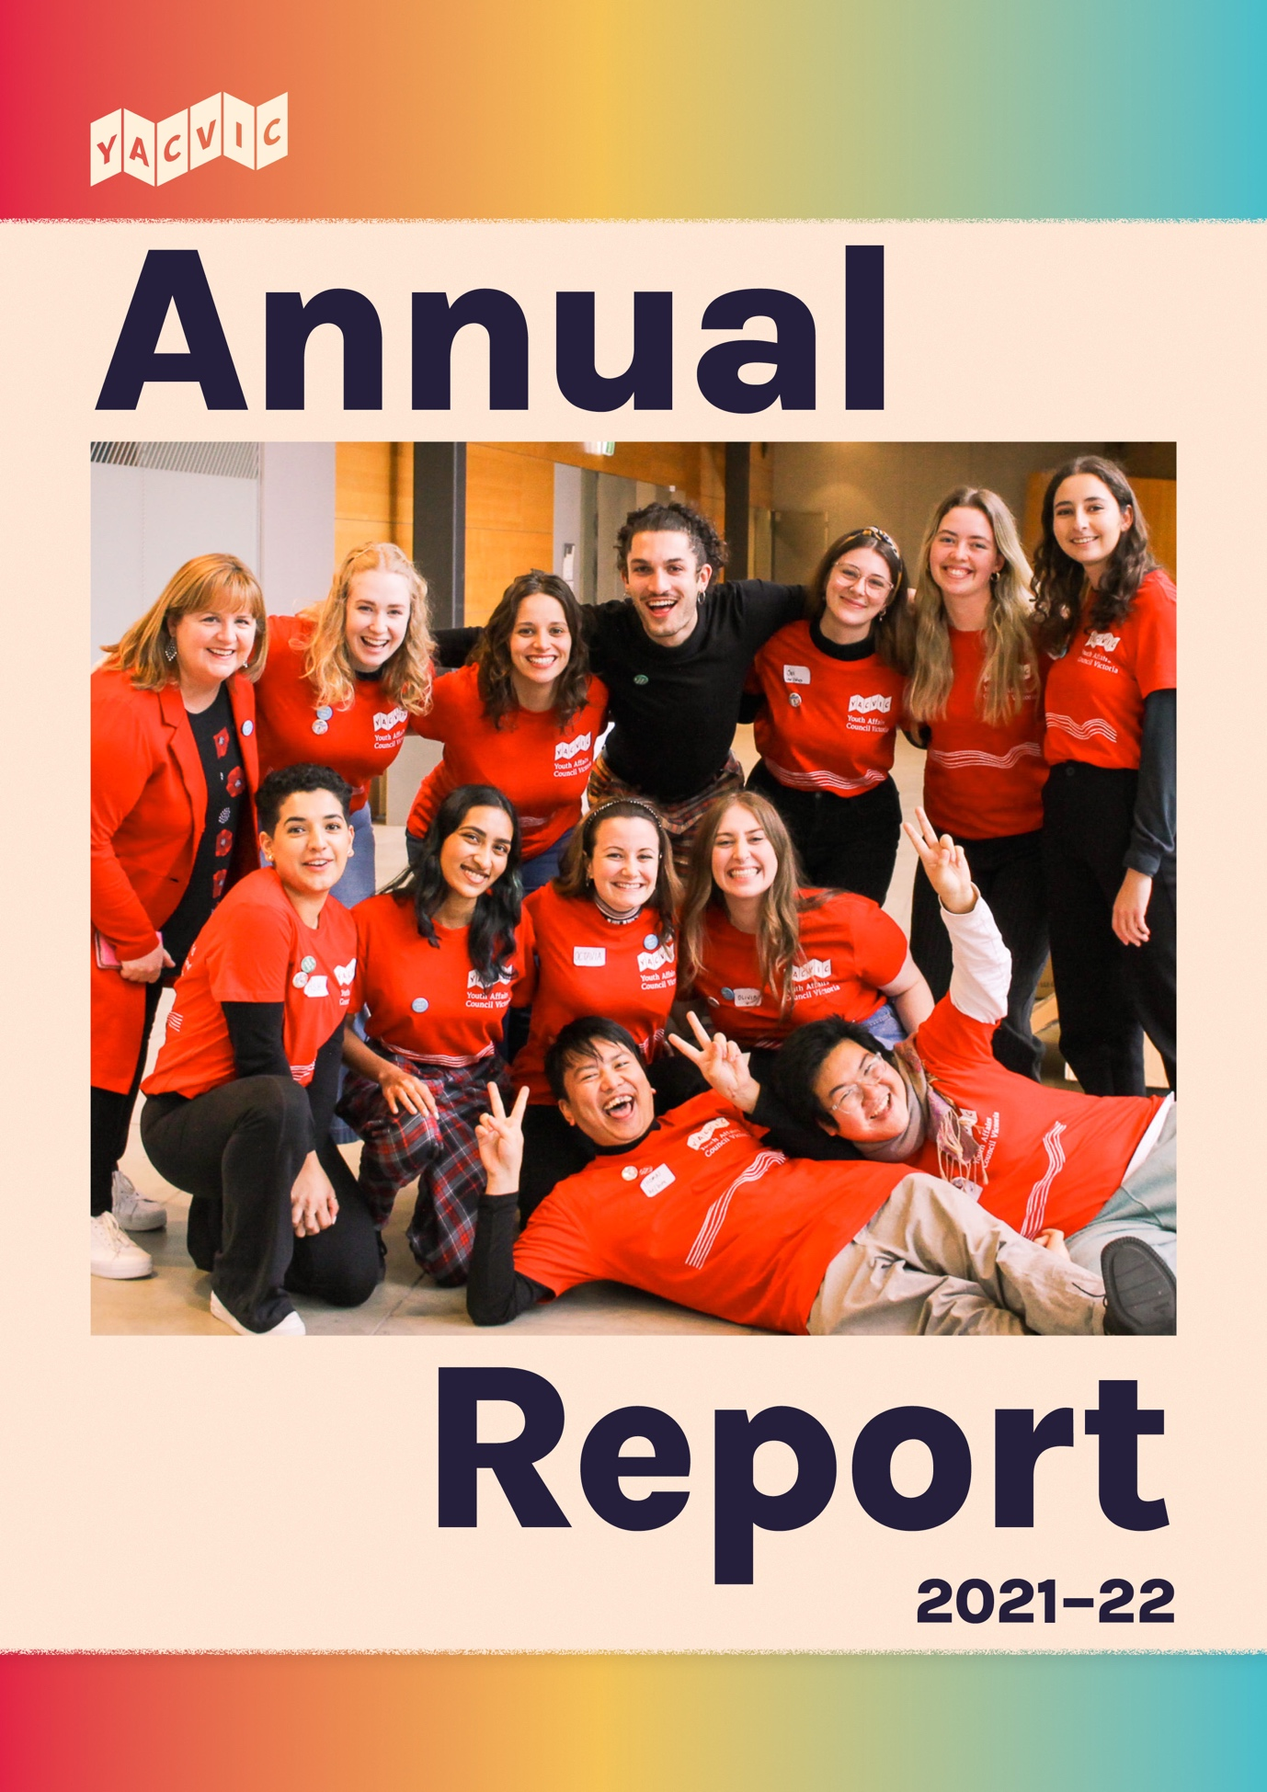

Acknowledgement of Country
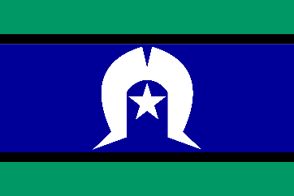

Our work takes place across Victoria.
YACVic’s head office is on the lands of the Wurundjeri people of the Kulin Nation in Naarm (Melbourne). We also have offices on the lands of the Gunditjmara Nation in Warrnambool, and on the lands of the Wemba Wemba and Wadi Wadi Nations in Swan Hill.
YACVic pays our respects to Elders past and present past and present for their wisdom, strength, support and leadership. Bunjil’s lore states that those who walk on this land must care for Country and the waterways as well as care for the children and young people.
We stand in solidarity to pay respect to the ongoing culture and continued history of all Aboriginal and Torres Strait Islander nations. Sovereignty was never ceded.

This always was, and always will be, Aboriginal land.

About YACVic

Youth Affairs Council Victoria (YACVic) is the peak body and leading advocate for young people aged 12–25, and the youth sector that supports them. Our vision is that the rights of young people in Victoria are respected, and they are active, visible and valued in their communities.
We promote youth participation and make policy recommendations on issues that affect young people’s lives, build the capacity of the youth sector and nurture connections for collaboration and support, and identify and advance thinking on emerging issues for young people. We have a particular focus on young people who face marginalisation and disadvantage.
We provide additional targeted advocacy through our key services, YACVic Rural and the Youth Disability Advocacy Service (YDAS), and proudly auspice and support our partner agency, the Koorie Youth Council (KYC).

Wurundjeri Country

Level 2, 235 Queen Street,

Melbourne, Victoria, 3000

www.yacvic.org.au

info@yacvic.org.au

Table of Contents

Acknowledgement of Country 2
About YACVic 2
Table of Contents 4
Chairperson’s Report 5
Board of Governance 6
CEO’s Report 7
Appreciating Our Partners 8
Where We’ve Been 10
Organisational Members 14
Where We Represent You 17
Reshape Our Future 21
Bringing People Together 22
Youth Sector Conference 24
Youth Forums 27
Policy and Advocacy 30
Youth Participation and Development 34
Recruiting new Young Peer Facilitators 36
Establishing Youth Advisory Groups 37
YACVic Rural 38
HEY Partners & Grants 41
YDAS: Advocacy by, with, and for disabled young people 42
Koorie Youth Council (KYC) 45
Marram Nganyin 46
Media and Communications 47
Co-designing a vaccine campaign 48
Federal Election Navigator 49
Corporate Services 50
Thanks To Staff 51
Financial Report 53
Treasurer’s Report 54
Statement of Comprehensive Income 55
Statement of Financial Position 56
Statement of Changes of Equity 57

Chairperson’s Report
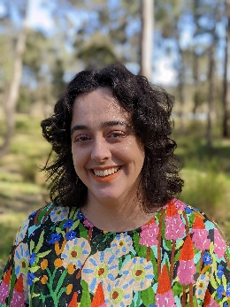
- Alex Neill (she/her) Board Co-Chair
- Kareem El-Ansary (he/him) Board Co-Chair and Young Member
COVID-19 cast a long shadow over the past year. Recent events have taken their toll, and we are still seeing their lasting impacts among YACVic’s members and the young people we support.
As things have begun to slowly open up, our organisation has played a vital role, helping the youth sector remain connected and collaborative during uncertain times.
We are especially proud of our continued commitment to accessible and hybrid ways of working. Despite the challenges, the pandemic has facilitated many advances in accessibility, and it’s been a pleasure to see YACVic, along with YDAS and KYC, strive to be leaders in this regard.
Further to this, after a motion at the last AGM, membership to YACVic is now free for young people. In a short period of time, we’ve seen an exciting increase to our young membership base as a result.
We’d like to thank our members, especially these young members, for your passion and dedication. We are proud to support a group as inspiring as the young people of Victoria and the sector which supports you.
We want to acknowledge and thank YACVic’s staff, under Katherine’s leadership, for your steadfast dedication to young people and to supporting our sector. Across our organisation, including KYC, YDAS and YACVic Rural, our staff are exemplars in providing the best possible service to the young people of Victoria.
We also want to thank our fellow Directors for your time and dedication. We are immensely proud of what we have achieved this year.
Meanwhile, YACVic faces uncertainty due to a reduction in real terms of core funding. We hope the upcoming year will lead to positive improvements, so that our organisation can continue to do its vital work for many years into the future.
—Alex and Kareem, YACVic Board Co-Chairs

Board of Governance
- Alex Neill (she/her) Board Co-Chair
- Kareem El-Ansary (he/him) Board Co-Chair, Young Member
- Natasha Ritchie (she/her) Deputy Chair
- Galina Fidler (she/her) Treasurer
- Katerina Dandanis (she/her)
- Tim Harte (he/him) Young Member
- Dylan Broomfield (he/him)
- Jas Elliott (she/her) Young Member
- Kelly Phan (she/her) Young Member
- Kerrie Loveless (she/her)
- Tessa Jenkins (she/her) Rural Representative, Young Member

CEO’s Report
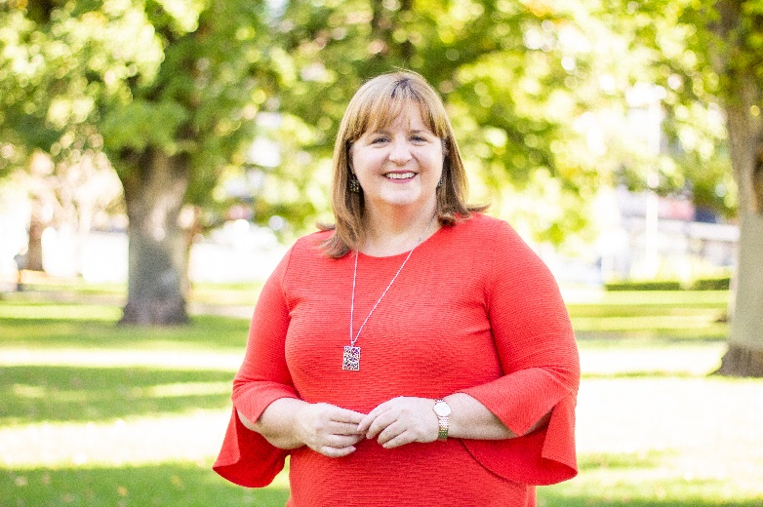
My most compelling reflection on this year is the need for a heartfelt thanks. Thanks to young people who continued to make sacrifices in their education, jobs, sport and social lives for the safety of the community; to frontline youth workers who kept turning up despite major challenges; to youth sector partners who pulled together and collaborated with heart; and to funding partners who recognised the need for greater support in difficult times. I hope we will remember these extraordinary achievements as we move beyond the worst days of the pandemic.

Thanks also to our wonderful and supportive Board, and the staff of YACVic, YDAS and KYC, who all stepped up with passion, energy and innovation. On top of ‘business as usual’ amidst a pandemic and lockdowns, we took on a key role in COVID vaccines communication for young people, and delivered a major online YACVic Conference and five in-person Youth Forums across the state. Our Rural team developed Australia-first resources for young people to have A Seat at the Table in disaster recovery and resilience efforts, YDAS empowered disabled young people to define and pursue their goals with the award-winning Map Your Future tool, and KYC launched Wayipunga, an amazing Aboriginal and Torres Strait Islander youth participation framework.
It was a landmark time for the youth sector to work collectively, as we completed the successful eight-partner Working for Victoria project, brought the leaders of 17 member organisations together over 18 months to articulate and demonstrate why Youth Work Matters, and led a collective of 14 partners to secure a major federal government grant for youth-led bushfire recovery in Eastern Victoria.
Looking ahead, we don’t plan to stand still! We are working towards the exciting independence of KYC and YDAS, which will walk our talk of youth participation and self-determination. We will continue pursuing better outcomes for young people, systems change in key policy areas, and meaningful youth participation, as well as building the capacity of the youth sector in Victoria.

YACVic’s track record, networks, and trusted role in the sector positions us strongly to do more collective work—securing greater resources across the sector, building connection and collegial support, and elevating united voices.
Looking forward to working with you all!

Appreciating Our Partners
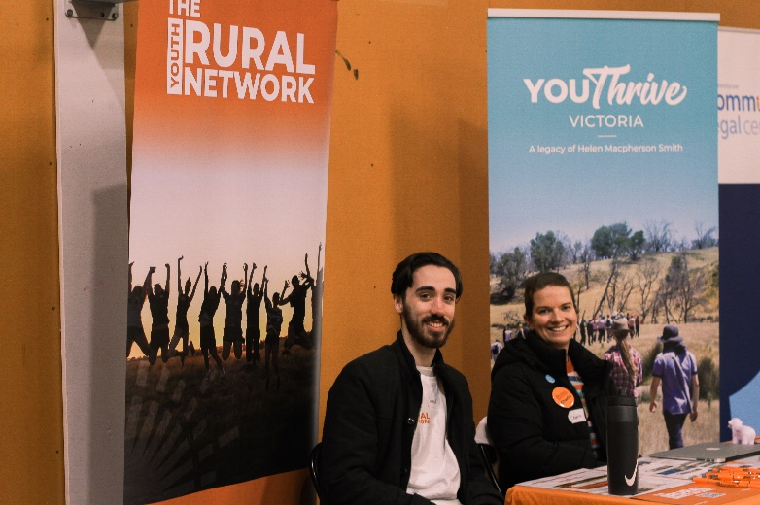
Thanks to our many amazing partners with whom we work to support and advocate for young people across Victoria.
We are grateful for our close collaboration with the Victorian Government, with special thanks to Minister for Youth Hon. Ros Spence MP and the Victorian Government Office for Youth (OfY), which provides funding for YACVic, YACVic Rural, and the Marram Nganyin Aboriginal Youth Mentoring Program. Also to the Office for Disability which continues to provide key support for YDAS, and the First Peoples—State Relations Group (formerly Aboriginal Victoria) which provides ongoing support to KYC.

YACVic’s established partnerships with VicHealth, the Commission for Children and Young People, and Victoria University also continue to strengthen and grow. YACVic Rural thanks Brophy Family and Youth Services and Swan Hill Rural City Council Youth Inc. for their partnership across the Great South Coast and Southern Mallee respectively.

YDAS is also grateful to the Lord Mayor’s Charitable Foundation for its support of YDAS’ human rights advocacy team; the Federal Government’s ILC program which funds the Young Leaders and Together programs; and CYDA, which auspiced and partnered with YDAS for the Young Leaders Program.

YACVic worked in new ways with the Victorian Government Department of Health on COVID-19 and mental health reforms, along with their ongoing support for the HEY grants and partners. Similarly, our work elevating youth participation in bushfire recovery generated new partnerships with Bushfire Recovery Victoria and the Department of Education and Training.

As well as OfY support, the Department of Families, Fairness and Housing and Department of Justice and Community Safety have provided support for a variety of activity related to COVID vaccinations, youth voice, and family violence prevention.

The Working for Victoria Coalition of eight organisations (YSAS, Whitelion, Brophy, CMY, CFECFW, LLENs, PCC and YACVic), funded by the Victorian Government Department of Jobs, Precincts and Regions drew to a successful close, with 94 positions funded to boost capacity and innovation in the youth sector.

Over more than 18 months, leaders from 17 of our key member organisations gave very generously of their time, expertise, and in some cases funds, to the Youth Work Matters project. This has resulted in an important analysis of the Social Return on Investment (SROI) in Youth Work, undertaken pro bono by Deloitte. Our gratitude also goes to Gilbert + Tobin for their unstinting pro-bono legal support.
Thanks to everyone involved!

Where We’ve Been
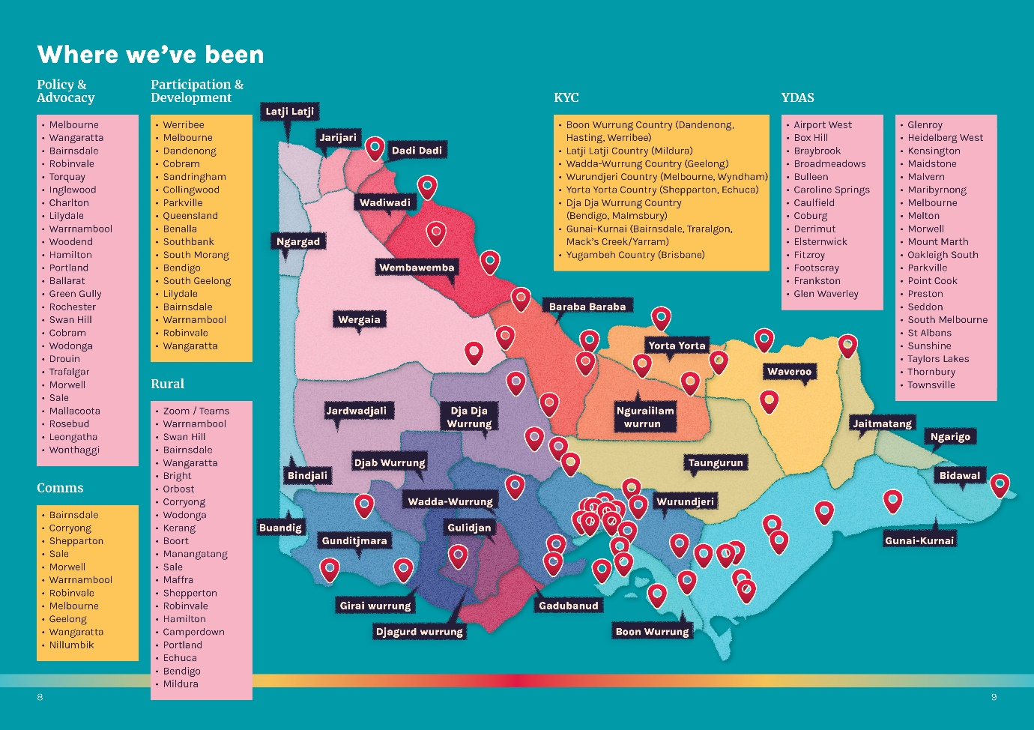

Policy and Advocacy
- Bairnsdale
- Ballarat
- Charlton
- Cobram
- Drouin
- Green Gully
- Hamilton
- Inglewood
- Leongatha
- Lilydale
- Mallacoota
- Melbourne
- Morwell
- Portland
- Robinvale
- Rochester
- Rosebud
- Sale
- Swan Hill
- Torquay
- Trafalgar
- Wangaratta
- Warrnambool
- Wodonga
- Woodend
- Wonthaggi

Comms
- Bairnsdale
- Corryong
- Shepparton
- Sale
- Morwell
- Warrnambool
- Robinvale
- Melbourne
- Geelong
- Wangaratta
- Nillumbik

Participation and Development

- Werribee
- Melbourne
- Dandenong
- Carlton
- St Kilda
- Cobram
- Sandringham
- Coburg
- Collingwood
- Parkville
- Queensland
- Benalla
- Southbank
- South Morang
- Bendigo
- South Geelong
- Lilydale
- Bairnsdale
- Warrnambool
- Robinvale
- Wangaratta

Rural
- Zoom / Teams
- Warrnambool
- Swan Hill
- Bairnsdale
- Wangaratta
- Bright
- Orbost
- Corryong
- Wodonga
- Kerang
- Boort
- Manangatang
- Sale
- Maffra
- Shepperton
- Robinvale
- Hamilton
- Camperdown
- Portland
- Echuca
- Bendigo
- Mildura

Koorie Youth Council
- Boon Wurrung Country (Dandenong, Hasting, Werribee)
- Latji Latji Country (Mildura)
- Wadda-Wurrung Country (Geelong)
- Wurundjeri Country (Melbourne, Wyndham)
- Yorta Yorta Country (Shepparton, Echuca)
- Dja Dja Wurrung Country (Bendigo, Malmsbury)
- Gunai-Kurnai (Bairnsdale, Traralgon, Mack’s Creek/Yarram)
- Yugambeh Country (Brisbane)

YDAS
- Airport West
- Box Hill
- Braybrook
- Broadmeadows
- Bulleen
- Caroline Springs
- Caulfield
- Coburg
- Derrimut
- Elsternwick
- Fitzroy
- Footscray
- Frankston
- Glen Waverley
- Glenroy
- Heidelberg West
- Kensington
- Maidstone
- Malvern
- Maribyrnong
- Melbourne
- Melton
- Morwell
- Mount Marth
- Oakleigh South
- Parkville
- Point Cook
- Preston
- Seddon
- South Melbourne
- St Albans
- Sunshine
- Taylors Lakes
- Thornbury
- Townsville

Organisational Members

Afro-Australian Student Organisation
Alpine Shire Council
Anglicare Victoria
Ardoch Youth Foundation
Association for Children with a Disability
Australian Catholic University - Youth Work
Australian Red Cross - Victorian Division
Banyule City Council
Banyule Nillumbik LLEN
Baw Baw LLEN
Bayside City Council Youth Services
Bayside Glen Eira Kingston LLEN
Beyond the Bell Great South Coast
BGT
Blue Light Victoria
Boroondara City Council
Brimbank Youth Services
Brophy Family & Youth Services Inc
Campaspe Cohuna LLEN
Campaspe Shire Council
Capital City LLEN
CEDA
Central Grampians LLEN
Central Ranges LLEN
Centre for Adolescent Health
Centre for Excellence in Child and Family Welfare
Centre for Multicultural youth
City of Ballarat
City of Greater Bendigo
City of Greater Geelong
City of Greater Shepparton
City of Kingston
City of Melbourne
City of Monash Youth Services
City of Port Phillip
City of Stonnington Middle Years and Youth Services Unit
City of Whittlesea
City of Yarra Youth Services
Colac Area Health
Community Health Advancement and Student Engagement (CHASE)
Concern Australia
CVGT Australia Ltd
Family Access Network Inc.
Frankston Mornington Peninsula LLEN
Future Connect
Gateway LLEN
Geelong Region LLEN
Gippsland East LLEN
Glenelg and Southern Grampians LLEN
Golden Plains Shire
Goldfields LLEN
Goulburn Murray LLEN
Grampians Community Health
Headspace Albury Wodonga
Headspace Bentleigh
Headspace Each
Headspace Elsternwick
Headspace National
Headspace Syndal
Hepburn Shire Council
Highlands LLEN
Hobsons Bay City Council
Hope Street Youth and Family Services Limited
Hume City Council Youth Services
Hume Whittlesea LLEN
Inner Eastern LLEN
Inner Melbourne VET Cluster
Inner Northern LLEN
Innovation Youth Centre
Job Watch Inc.
JobFind Centres Pty Ltd
Junction Support Services Inc
Kids Under Cover
Knox City Council Youth Services
La Trobe City Council
Ladder Project Foundation
Les Twentyman Foundation
Live4Life
Macedon Ranges Shire Council
Mansfield Shire Council
Maribyrnong & Moonee Valley LLEN
Maribyrnong City Council
Maroondah City Council
Melbourne City Mission
Mental Health Victoria
Merri Health
Mildura Rural City Council
Moira Shire Council
Moonee Valley City Council
Moorabool Shire Council
Moreland City Council
Mornington Peninsula Shire Council
Mount Alexander Shire Council
Murray Mallee LLEN
NE Tracks LLEN
NESAY Inc
North Central LLEN
North East LLEN
Northern Mallee LLEN
Outer Eastern LLEN
Primary Care Connect
Rural City of Wangaratta
Save the Children
South East Community Links
South East LLEN
South Gippsland Bass Coast LLEN
South West LLEN
State Library of Victoria
SYN Media
The Bridge Youth Service
The Foundation for Young Australians
The Push
The Reach Foundation
The Salvation Army
The Youth Junction Inc.
Tomorrow Today Education Foundation
TRY Australia
UN Youth Australia
VCOSS
VicHealth
VicSRC (includes exec)
Victoria University - Youth Studies
Victorian Local Governance Association (VLGA)
Volunteering Victoria
WAYSS
Wellington Shire Council
Western Bulldogs Community Foundation
Whitelion Youth Agency
Whittlesea Community Connections
Wimmera Southern Mallee LLEN
Wodonga City Council
Women's Health Goulburn North East
WynBay LLEN
Wyndham City Council - Youth Services
Youth Action
Youth Affairs Council Western Australia
Youth Affairs Network of Queensland (YANQ)
Youth Coalition of the ACT
Youth Network of Tasmania (YNOT)
Youthlaw
YSAS Pty Ltd
YWCA Australia

Where We Represent You

Koorie Youth Council (KYC)
- Aboriginal Justice Forum
- Aboriginal Strategic Governance Forum
- Closing the Gap Partnership Forum
- Dhelk Dja Partnership Forum
- Marrung Central Governance Committee (DET)
- Victorian Aboriginal Employment & Economic Council (DJPR)
- Aboriginal Justice Caucus
- Youth Collaborative Working Group (co-chair)
- Aboriginal Youth Justice Strategy Steering Committee (co-chair)
- Aboriginal Case Management Review working group
- Youth Justice service response for Aboriginal and Torres Strait Islander children and young people aged 10 – 13 working group
- Court Service Victoria Collaborative Working Group
- Victoria Police – Aboriginal Reference Group
- Indigenous Advisory Group of the Australasian Youth Justice Administrators (Australia & New Zealand)
- Aboriginal Self-Determination in Education Reform (DET – SDER)
- DET – SDER – Koorie Young Person Advisory Group
- DET Koorie Education Stakeholder Group
- DET Children Services Coordination Board – Aboriginal Families & Children working group
- Koorie Caucus – Dhelk Dja, Family Safety Victoria
- Koorie Caucus - Aboriginal Strategy & Oversight (DFFH)
- Aboriginal Workforce Funds Steering Committee (DFFH)
- Aboriginal Executive Council
- Murdoch Children’s Research Institute – Aboriginal Reference Group

Youth Disability Advocacy Service
- Disability Act Review Advisory Group (DFFH)
- Disability Stakeholder Group (DET)
- Disability Inclusion Reform Advisory Committee (DET)
- COVID Advisory Group (DET)
- Statewide Culturally Diverse Disability Network
- Australian Coalition on Inclusive Education (ACIE)
- National Youth Disability Network
- Human Rights Sub-Committee (Law Institute of Victoria)
- Disability Law Sub-Committee (Law Institute of Victoria)
- Victorian Disability Advocacy Network (VicDAN)
- Victorian Police - Disability Reference Group

Youth Justice
- Smart Justice for Young People Coalition
- Raise the Age Victorian and National Working Groups
- Project Night Justice Advisory Committee

Mental Health
- Mental Health Ministerial Advisory Committee
- School Mental Health Reform Reference Group (DET)
- Mental Health and Wellbeing Promotion Strategy Advisory Group (DoH)
- Victorian Mental Health Policy Network
- Women’s Mental Health Alliance
- Mental Health Victoria Service Reform Advisory Network
- VicHealth Mental Wellbeing COVID-19 Working Group
- Child & Adolescent Mental Health Conference Advisory Committee
- Child and Youth HOPE Services Design Group (DoH)

Social Sector
- VCOSS Peaks and Statewide Organisations
- VCOSS DET-CSO Governance Group
- Australian Youth Affairs Coalition (AYAC) Board
- Consumer Participation Practice Network
- Lived Experience Engagement Network
- City of Greater Geelong Youth on Board Steering Committee
- Merri Health Young Carer Guidelines Policy Advisory Group

Education, Employment & Economy
- Clean Economy Workforce Development Strategy consultations
- VCOSS Education Equity Coalition
- VCOSS Policy Advisory Group focusing on Employment
- VCCI Victoria Summit Reference Group & ‘Future of Work’ Working Group
- Monash University Centre for Youth Policy and Education Practice Advisory Board
- RMIT University Youth Work Degree Industry Advisory Committee

Other Policy
- Human Services and Health Partnership Implementation Committee (HSHPIC – DoH)
- Alcohol & Drug Foundation Expert Advisory Group on Youth Participation
- MARAM Development: Adolescent-focused and Child and Young Person Practice Guidance (DFFH)
- VCOSS election platform consultations
- Victorian Peaks Coalition on LGBTIQ+ investment
- Vaccine Ambassadors Group (DoH)
- COVID-19 and Youth (20–29) Youth Engagement Working Group (DFFH/DoH)
- Multicultural Communications Outreach Program Community of Practice
- National Peak Bodies Bushfire Recovery Forum
- Improve Your Play Advisory Committee

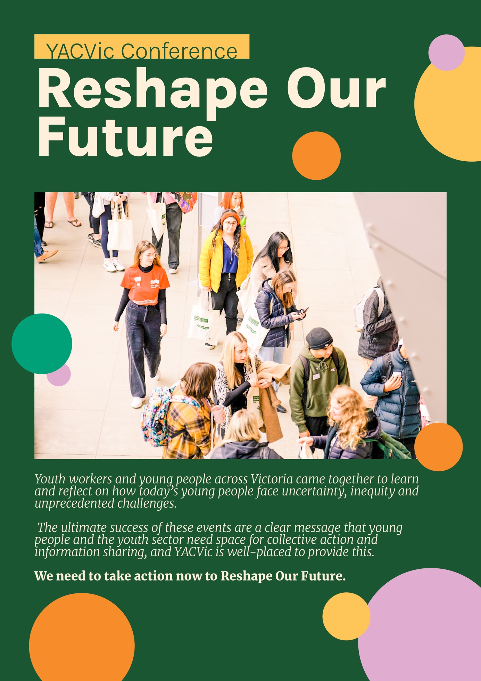

Reshape Our Future
Youth workers and young people across Victoria came together to learn and reflect on how today’s young people face uncertainty, inequity and unprecedented challenges.
The ultimate success of these events are a clear message that young people and the youth sector need space for collective action and information sharing, and YACVic is well-placed to provide this.
We need to take action now to Reshape Our Future.

Bringing People Together

Across The State—And Online

Reshape Our Future Introduction
Reshape Our Future was originally planned as a 3-day hybrid event with a Youth Sector Conference and Youth Forum which would run both in-person and online at the same time across multiple locations. However, Victoria went into lockdown the week before the original dates of 31 May–2 June 2021, and again less than two weeks before the rescheduled dates of 11–13 August 2021.
The complexities, frustrations and barriers we faced mirrored the dire experiences of young people throughout the pandemic, and the many challenges faced by community organisations in continuing services. We have a wholehearted appreciation for the patience of speakers, venues and attendees who stayed with us as we rescheduled and rescheduled, the funders and sponsors who showed great flexibility, and the amazing efforts of the hard working and persistent YACVic team.
We thank our funding partners, including the Victorian Government Office for Youth, Regional Development Victoria, the Warrnambool City Council, Spark Strategy, MacArthur, HESTA, Youth Workers Australia, and the Richmond Football Club. Australian Progress were also brilliant, supporting the online platform and engagement.

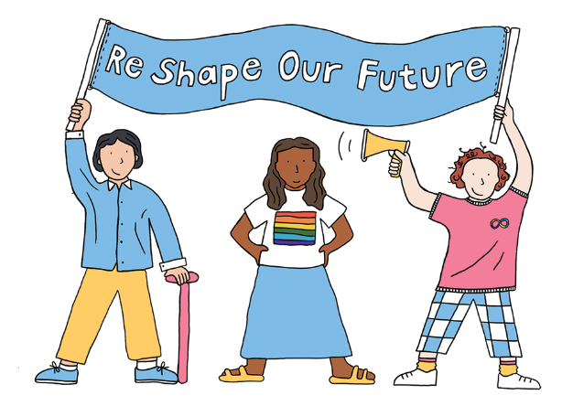

Timeline
December 2019: Initial discussions and planning for YACVic Conference begins
January 2020: First case of COVID-19 comes to Victoria
March 2020: YACVic shuts down office, Victoria goes into lockdown
June 2020: Second lockdown; YACVic secures funding from Victorian Government to deliver sector conference and youth forum in 2020-21 financial year as part of COVID-19 response and recovery
November 2020: Victoria exits lockdown
January 2021: YACVic decides on a hybrid state-wide model with five hubs plus online for the event, youth steering committee formed for youth forum
February 2021: Save the date is sent out to key stakeholders; Victoria goes in and out of third lockdown
March 2021: Early bird ticketing opens for May/June dates, all venues booked
April 2021: Speakers announced for sector conference and youth forum
May 2021: Victoria goes into fourth lockdown, four days out from the conference
June 2021: YACVic moves the sector conference online; YACVic young members provide feedback to postpone youth forum until it can be delivered in-person
August 2021: YACVic delivers Reshape Our Future sector conference
January 2022: Planning commences (again!) for youth forums.
June 2022: YACVic delivers five in-person Reshape Our Future youth forums in Warrnambool, Melbourne, Wangaratta, Robinvale and Bairnsdale.

Youth Sector Conference

2021

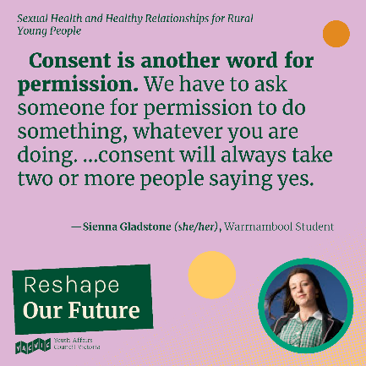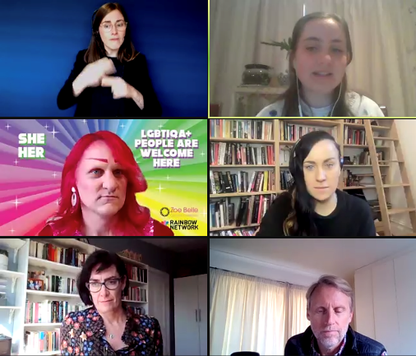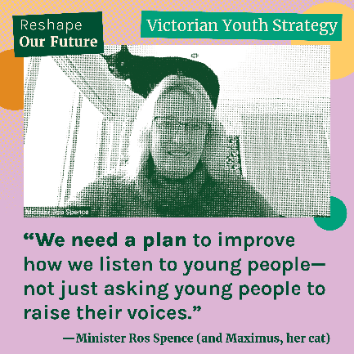

Introduction
The ‘Reshape Our Future’ Youth Sector Conference brought together 437 workers who support young people, policy-makers and thought leaders from multiple sectors, including young people, to discuss and address key challenges, build connections, and showcase the cutting-edge of youth work practice.
Originally planned as an in-person event across five locations and online, the 2-day Youth Sector Conference component of Reshape Our Future was eventually delivered on 11-12 August 2021 as a fully online event.
The engaging and interactive Conference facilitated connection and discussion, with a high calibre and diverse speaker line-up. 81% of attendees said they liked the format of the conference, while some understandably lamented the chance to catch up in-person with sector colleagues.
“I’ve never participated in an online conference set up that was so detailed and easy to follow. I thought it went really smoothly and the speaker were wonderful. The parts I was able to join also had high engagement, which is not an easy feat in an online environment.” – Attendee feedback

Topics and Speakers
We made a huge effort to ensure a variety of session topics and a diverse and high-quality speaker line-up, including young people with lived and/or learned expertise on every panel. A total of 75 speakers presented over the two days, and of these:

- 53% were young people
- 7% were Aboriginal or Torres Strait Islander people
- 20% were people of colour
- 9% identified as disabled
- 15% identified as LGBTIQA+
- 72% were women, trans, non-binary or gender diverse

- 32% were from rural or regional communities, with four rural young MCs
- 7% were from other countries or interstate

We also had a strong focus on rural-relevant content, and the YACVic Rural team took a leading role in key sessions: ‘Young People in Rural Disaster Recovery and Emergency Management’, ‘Where have all the Rural Youth Workers Gone?’ and ‘Sexual Health and Healthy Relationships for Rural Young People’. This was well-received by our many rural speakers and attendees.
Attendees’ favourite session on Day 1 was ‘Young People are Reshaping Our Future’, focused on more youth participation opportunities for young people to be decision-makers on issues that affect their lives. Speakers included international expert Dr Harry Shier, student voice advocate Andrew Leap, the Koorie Youth Council’s Bryce Taylor, and the Amy Chu and Catherine Maine from the City of Greater Dandenong’s ‘Youth Against Family Violence’ initiative.
Day 2’s most popular session was ‘Guaranteeing Decent Work for Young People’, which explored young people’s access to suitable, safe and meaningful work in times of recession and recovery. Speakers included Emma Cull from the Brotherhood of St Laurence, the Young Workers Centre’s Mairead Lesman, Emma Linton from the Loddon Campaspe LLEN’s ‘How Work Works’ project, and Kate Roache from Beyond the Bell.
Other notable sessions saw:
- Saji Prelis, the Co-Chair of the Global Coalition on Youth, Peace and Security, Ofeira Satele from Know Your Roots in Shepparton, and Zoe Condliff, Founder of She’s a Crowd, speaking about ‘Young People Leading Peace and Connection’.
- Children & Youth Commissioner Liana Buchanan, Victoria’ University’s Dr Tim Corney, Project ROCKIT’s Lucy Thomas, Youth Disability Advocacy Services (YDAS)’ Mija Gwyn, and Starlady from the Zoe Bell Gender Collective exploring the evolution of the Victorian Code of Ethical Youth Work Practice.
- A vibrant discussion on “technology and Innovation in Youth Work’ led by Juha Kiviniemi from the Finland Centre of Expertise for Digital Youth Work, Elizabeth Smith from Gippsland’s Broadening Horizons, and Jason McCurry from Children and Young People with Disability Australia (CYDA).
“I came to the conference for ‘professional reasons’ but felt I got so much out of it personally and left inspired by the diverse and optimistic voices that were prioritised. My heart has been filled by the messages of hope! I am definitely going to be revisiting some of the amazing sessions. I continue to be inspired by the work you all do at YACVic. Congratulations.” – Attendee feedback

Access and Inclusion
Accessibility and inclusion were a priority for the Conference, with YDAS providing technical expertise to ensure the online platform was accessible. A team of young staff created an amazing speaker’s brief which provided clear information about cultural safety, content warnings, visual and image descriptions, language use and advice on presenting to an audience who may have diverse access needs. For attendees, access needs were captured on registration to ensure they would be met. Every session was supported with Auslan interpreters and live closed captioning.
“Inclusion was fabulous. All from acknowledgments, pronouns, descriptions of speakers, captions, interpreters, Auslan, vulnerable stories. Leaders in this space for sure!!” – Attendee feedback

A Real Team Effort
The Conference came together as a result of a colossal effort by everyone at YACVic. This included exploring ideas and deciding on session topics; identifying and engaging speakers; sourcing, booking (and cancelling!) venues and catering; designing and producing merchandise and signage; promoting the event; creating schedules and briefing speakers; coordinating tech; communicating with stakeholders; MC-ing and moderating sessions; evaluating everything; and writing the final report to funders.

The team should also be acknowledged for the flexibility, perseverance and spirit that kept everyone committed to a successful outcome in the face of genuine disappointment and pressures due to COVID-19 restrictions. Despite the many barriers faced, everyone did their utmost in making the conference a seamless, high-quality experience for all attendees.

Youth Forums

2022
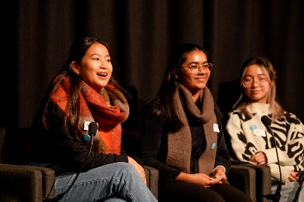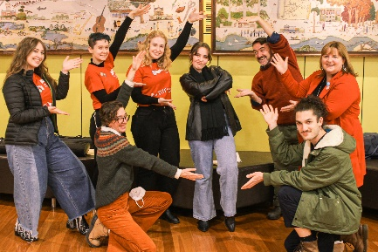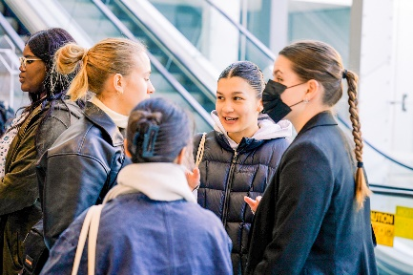

Introduction
The ‘Reshape Our Future’ Youth Forums were a series of events held across regional and metropolitan Victoria. They brought together over 460 young people to engage in discussions on leadership, advocacy, and a range of place-based, themed topics.
When the original project timeline was thrown into chaos by COVID lockdowns, we asked young people whether they would prefer to have online events or wait until in-person events were possible. Screen-weary young people gave strong feedback that they preferred in-person, so we extended the timeline, and eventually delivered five separate in-person events in five locations across Victoria throughout June 2022.
Across all five events, almost all speakers were young people, with young advocates, young youth workers and young leaders leading the presentations and panel discussions. YACVic’s youth participation principles were key to the program design, with young people co-designing the topics, questions, and speakers at each forum.
All the forums included a session on Youth Leadership, with local young leaders speaking about their activities and motivations, and a session on Pathways to Power, which explored how young people can find ways to effect change in their communities. A different themed session was held in each location. 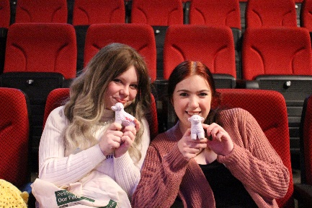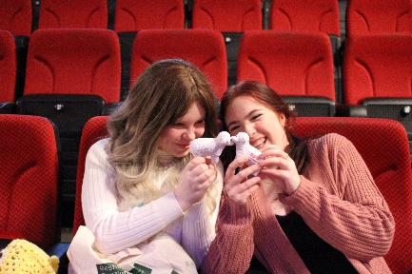
Warrnambool, Gunditjmara Country: Smashing Mental Health Stigma
Wangaratta, Pangerang Country: Disability Justice, Inclusion, and access
Melbourne, Wurundjeri Country: How to be a better ally
Robinvale, Latji Latji Country: Consent, Sexual Health, and Relationships
Bairnsdale, Gunaikurnai Country: Meaningful work
The Disability Justice and Education session in Wangaratta had four disabled young people as speakers – one as moderator, and three as presenters. The session was a favourite with 75% of participants that day ranking it as their top session of the event.
Like the Youth Sector Conference, the Youth Forums were a huge team effort, with YACVic staff pulling together once again to make them a success, and many travelling all over the state to run the events on the day.
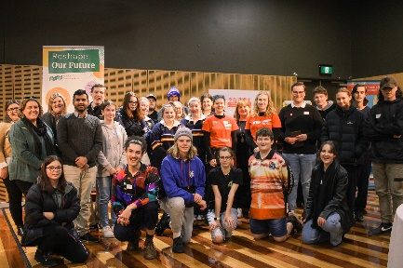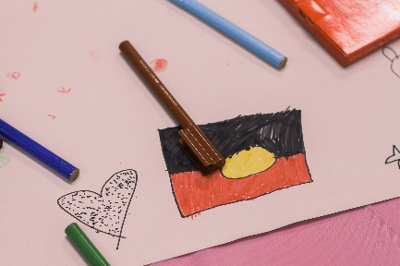

Where We Went
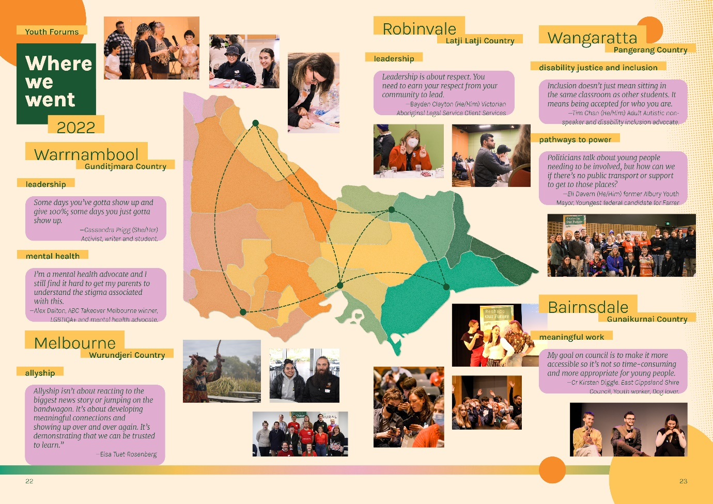

Melbourne, Wurundjeri Country

Leadership
A big part of Leadership is not just being strong all the time, it’s about being vulnerable and aware of the people around you.
—Tiffany (she/her). VicSRC Executive

Allyship
Allyship isn’t about reacting to the biggest news story, or jumping on the bandwagon. It’s about developing meaningful connections with the community, and showing up over and over again. It’s demonstrating that we can be trusted to learn from our mistakes." —Elsa Tuet-Rosenberg (she/her), Co-founder of Hue

Wangaratta, Pangerang Country

On Disability Justice and Inclusiveness in Education.
Inclusion doesn’t just mean sitting in the same classroom as other students. It means being accepted for who you are.
—Tim Chan (He/Him) Adult Autistic non- speaker and disability inclusion advocate.

On Pathways to Power
Politicians often talk about young people needing to be more involved, but how are meant to do that if there’s no public transport or support to get you to those places.
—Eli Davern (He/Him) former Albury Youth Mayor, 2022 Young Citizen, Youngest federal candidate for Farrer

Bairnsdale, Gunaikurnai Country

On meaningful work
My goal on council is to make it more accessible so it’s not so time-consuming and more appropriate for young people.
—Cr Kirsten Diggle (she/her). East Gippsland Shire Council, Youth worker, Dog lover.

Warrnambool, Gunditjmara Country

On Leadership
Some days you’ve gotta show up and give 100%, some days you just gotta show up.
—Cassandra Prigg (She/Her) Activist, writer and student.

On mental health
I’m a mental health advocate and I still find it hard to get my parents to understand the stigma associated with this.
—Alex Dalton (he/him), ABC Takeover Melbourne winner, LGBTIQA+ and mental health advocate.

The conversation is still not where we need it to be. It's better, we have come a long way in a short time and we are talking more, but there is still lots to do
—Kyle Hayes (he/him), peer advocate

On Pathways to Power
I strongly believe we should lower the voting age to 16 but only make it compulsory at 18. Because some young people are really passionate about making a change in their community, or Victoria, or Australia. —Sienna Gladstone (she/hHer) student activist VicSRC Executive.

Robinvale, Latji Latji Country

On leadership
Leadership is about respect. You need to earn your respect from your community to lead.
—Bayden Clayton (He/Him) Victorian Aboriginal Legal Service Client Services

Policy and Advocacy

Amplifying young people’s voices across the state
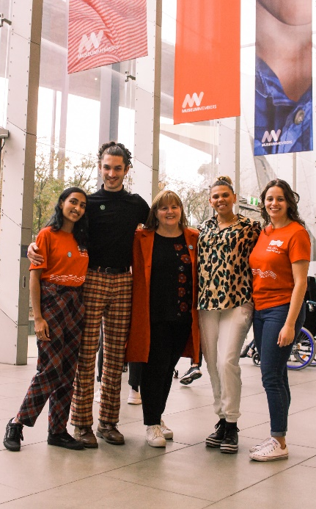
This past year held an array of opportunities to advocate for the needs of young people across a wide variety of topics and issues.

YACVic Policy
The team conducted consultations with young people and the youth sector to gather input which formed the basis of our submission to the Parliamentary Inquiry into the Use of School Buses. Our submission focused on the need for accessible, safe, and reliable public transport across rural and regional Victoria to ensure young people were able to engage in education, employment and other services. Our submission led to an invitation to attend a Hearing, where we supported a young person from regional Victoria to provide evidence to the Committee on how a lack of reliable public transport impacted her ability to engage in her community.
Additionally, we made a submission to the Parliamentary Inquiry into Victoria’s Criminal Justice System, using input from young people who have had contact with the justice system to highlight the need for justice reinvestment, a focus on early intervention, and genuine rehabilitation over punitive measures. YDAS contributed to a substantive section on disabled young people’s experiences, and we partnered with KYC to provide evidence at a Hearing outlining why a shift in approaches to youth justice is crucial to ensuring safer communities for everyone.
Young people also informed our submissions to the Social Housing Regulations Review, the Mental Health and Wellbeing Act, the Review of Vocational and Applied Learning in Senior Secondary Schooling, the Review of the Foundation to Year 10 Curriculum, Social Services Reform, and the Reportable Conduct Scheme Review.
The 2022 federal election also provided the opportunity to engage young people in discussion about democratic processes. We developed an online resource to educate young people on Australia’s political system, how to find their local candidates, and how to vote. We also collaborated with other youth peak bodies across the country to advocate for a National Plan to better support young Australians.

Key Stats
1. 88 young people directly involved in developing policy recommendations
2. 11 submissions, reports and research publications
3. 5 unique opportunities to involve young people in policy making
4. 3 presentations on the importance of youth participation in policy development at national conferences
5. 2 opportunities to speak at hearings

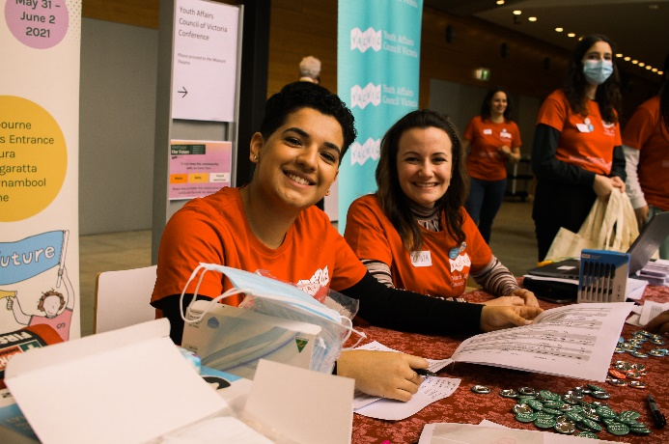

KYC Policy
Since March, KYC Deputy Executive Officer Bonnie Dukakis and Policy and Advocacy Officer Zach Smith supported DET with co-facilitation of their Koorie Young People Advisory Group. This working group met fortnightly, with the aim to catch the voices and experiences of Aboriginal and Torres Strait Islander young people's experiences at school. Throughout the sessions we yarned about family, community, the struggle of living in two worlds and what self-determination in education looks like. We yarned about racism, the different support services offered/not offered at different schools, and the cultural load young people carry and the expectations that come with that. Seeing these young people feeling comfortable enough to be vulnerable and sharing their stories is something we’re very thankful and proud of.
Alongside these yarns, Zach Smith and Policy and Research Officer Daphne Arapakis worked together to ensure the voices of children and young people are heard, considered and listened to in discussions of First Nations and youth encounters with the justice system. We are proud of our co-authored article, ‘In the face of injustice’, published in the NAIDOC Special Edition of the Law Institute Journal, which echoes the tireless advocacy of the Aboriginal Justice Caucus and the commitment of its dedicated members to upholding the rights of Aboriginal and Torres Strait Islander children and young people, families and communities to self-determination (Arapakis, Duggan & Smith 2022). We are as strong as the sense of community that we build together.
We also continue to represent First Nations young people’s perspectives in a diverse range of forums and reforms (see P.12-13).

Policy Story

Just Outcomes for Young People

YACVic’s response to the Parliamentary Inquiry into Victoria’s Criminal Justice System
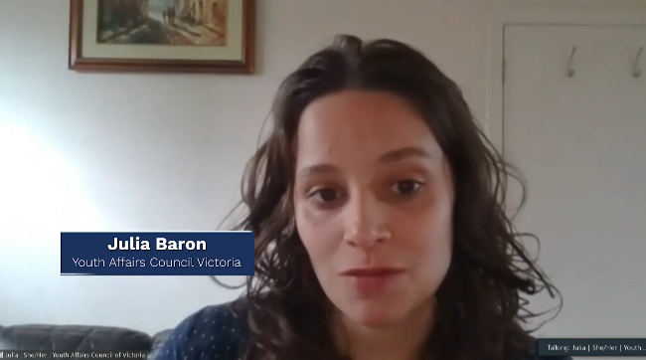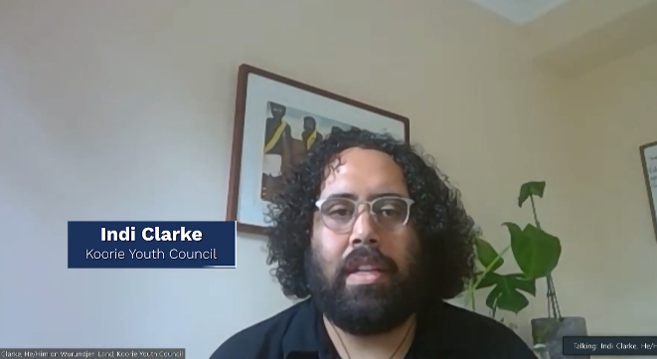
The Parliamentary Inquiry into Victoria’s Criminal Justice System provided another opportunity to continue advocacy for justice reinvestment which prioritises early intervention and rehabilitation over punishment of young people who come into contact with the justice system.
A team of five staff, including four young people, worked on this submission, running consultations with young people who have had contact with the justice system to hear about their experiences and understand their perspectives of how the justice system could be improved. We also partnered with YDAS, who undertook research based on their advocacy services to contribute a section which highlighted the specific experiences and needs of disabled young people.
Many months went into researching and writing, which culminated in a detailed report that provides evidence-based recommendations on bail reform, overhauling remand procedures, improving how Victoria Police interact with young people, investing in more early intervention and prevention services, improving the services delivered within prison, and reimagining the support provided to young people when they are released with the goal of reducing recidivism and supporting young people to thrive.
We were then invited to provide evidence at a Hearing alongside KYC, where we re-iterated the need for more investment in early intervention and prevention services, whilst also acknowledging the overrepresentation of Aboriginal and Torres Strait Islander young people and how this needs to be addressed.
YACVic will continue to advocate for a youth justice system that recognises the rights of young people and prioritises holistic care.
Read more: yacvic.org.au/ just-outcomes-criminal-justice

Policy Story

Ministers and Youth Workers Roundtable
Supporting young Youth Workers to engage directly with Government
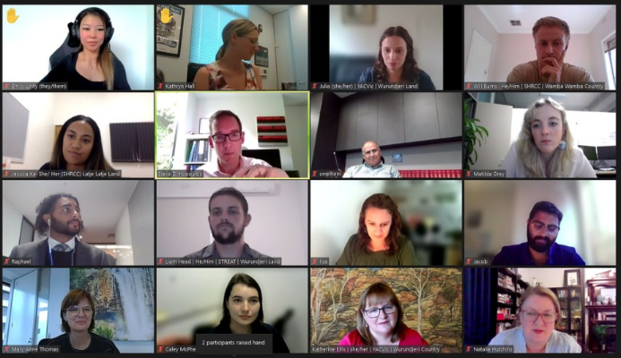
This year we continued to advocate for more investment across the state in youth worker capacity, to support all young people who need it. As part of this work, we convened a virtual roundtable that connected five young youth workers with Ministers and other leaders, so they could share their experiences directly with Government.

The young youth workers were from both Melbourne and rural/regional areas, and work in council youth services, community programs and peak body organisations, delivering individual and group programs across education and employment, youth justice, mental health, and community sport.

The youth workers spoke passionately about the young people they support, and highlighted the wide variety of ways they help them deal with issues and pursue their goals. They also spoke about the significant challenges they face day-to-day in their jobs due to limited resourcing and a lack of recognition for the important role they each play in their communities.

The roundtable was attended by a number of Parliamentarians with a keen interest in the needs and potential of young people; the Minister for Youth Justice, the Minister for Regional Development, the Parliamentary Secretary to the Premier and for Mental Health, the Parliamentary Secretary for Youth, the Parliamentary Secretary for Skills and Training, and the CEO of Jobs Victoria.

The roundtable was a huge success, with all participants agreeing on the value in young people speaking directly with decision-makers to share their experience and expertise. It raised awareness of the important role youth workers play in supporting young people, whilst acknowledging the many and varied challenges they face in their work with young people.

Youth Participation and Development

Expanding our reach to young people and the youth sector
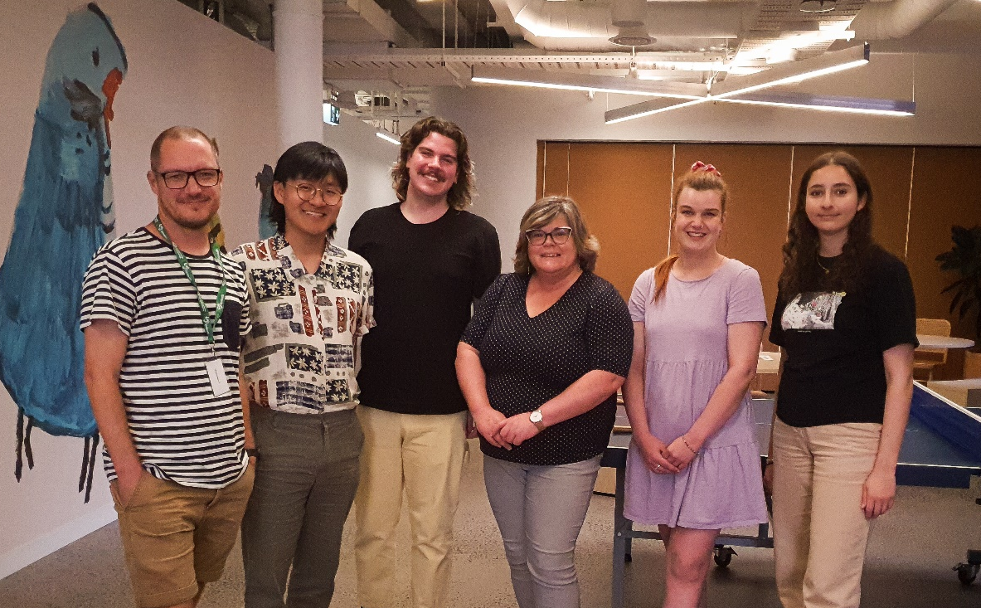
It has been a huge year in Participation & Development as we developed our Young Peer Facilitator model and expanded our reach to both young Victorians and the sector that supports them.

YACVic Participation and Development
Over the past two years we have moved to having young people lead the vast majority of our training and consultancy work.
These projects have included partnerships with Tomorrow Today, Merri Health, Alcohol and Drug Foundation and the Victorian Government Department for Families, Fairness and Housing, in which we have supported them to connect with young people across the state in multiple ways. Young Peer Facilitators have led focus groups, consultations and co-design processes that aim to establish youth-led spaces that empower young people and enable their voices to be heard. They have also provided further support to these partners by offering guidance with recruitment, engagement and leading meetings.
But for us the clearest way to describe our hard work this year is in the number of training sessions we have delivered. We ran training for a total of 867 participants across 60 workshops, which is a more than 300% increase on the previous year for participants. This doesn’t include any sessions associated with the Youth Sector Conference or Youth Forums or other workshops delivered by YACVic Rural, YDAS or KYC!
As well as delivering the Youth Sector Conference, we have continued and strengthened our regular networks and events, including Youth Sector Leaders Huddles, Rural Huddles, the HEY Partners, and regional networks in the Southern Mallee and the Great South Coast.
Finally, our Youth Participation Practice Network (YPPN) continues to go from strength to strength, with over 200 workers from youth services attending monthly community of practice meetings to further deepen youth participation in the sector.

Key Stats
- 867 participants
- 60 workshops
- 8 new Young Peer Facilitators
- 220 YPPN new sign ups in 2021-22

KYC Participation and Development
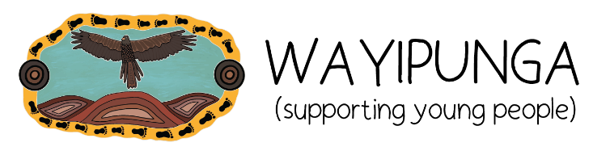
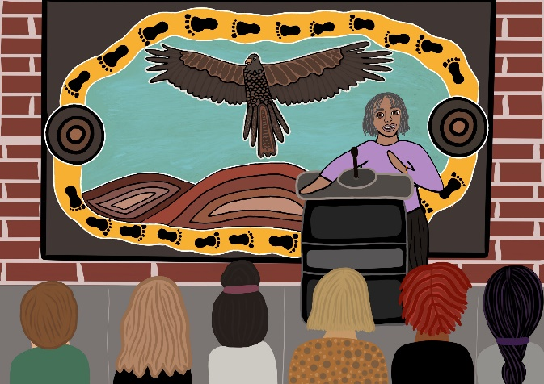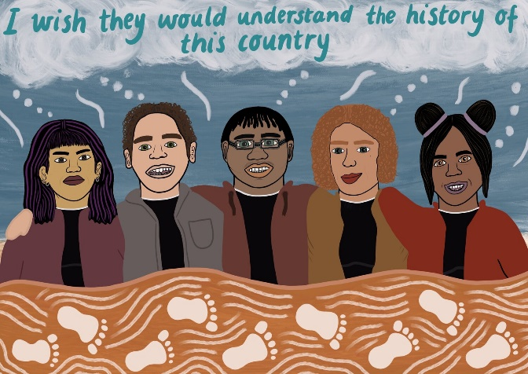
Caption: Wayipunga logo and illustrations for Cultural Safety and Historical Context by Nakia Cadd. Nakia is a proud Gunditjmara, Yorta Yorta, Dja Dja Wurrung and Bunitj young woman living on Wurundjeri country.

Koorie Youth Council launched Wayipunga (‘supporting young people’ in Dja Dja Wurrung language), an Aboriginal and Torres Strait Islander youth participation framework that provides workers, organisations and government with strategies to support young people's participation in decision-making processes.

Years in the making, this landmark resource is all about improving participation for our young mob. The framework is made up of three sections. All are interrelated and each informs the other.
- Values - provides the foundations for the ways in which workers, organisations and governments support and embrace Aboriginal and Torres Strait Islander young people’s participation.
- Knowledge - outlines the knowledge required for workers to understand Aboriginal and Torres Strait Islander young people’s experiences.
- Actions - provides many strategies to help workers, organisations and communities embed the values and knowledge of Wayipunga into their everyday practice working with young mob.

Over 150 quotes from young people and youth workers provide further context for what is an accessible, insightful read all about how to meaningfully engage with Aboriginal and Torres Strait Islander young people.

Check out Wayipunga: https://wayipungaresource.org

Next steps for the coming year are developing a training component to help youth workers put the Wayipunga resource into action in their work with young mob.

Participation Story

Recruiting new Young Peer Facilitators
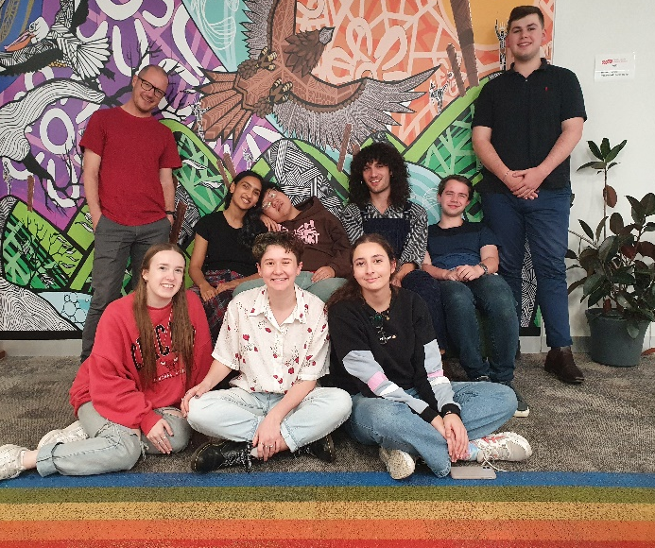
In mid-2020 we received Working for Victoria (WfV) funding from the Victorian Government which enabled us to trial a brand new way of approaching our Training & Services. We created a Young Peer Facilitator (YPF) model that trained and supported young people from a variety of backgrounds and experiences to facilitate our training, consultation and co-design workshops.

They were an amazing group and added huge value to YACVic, our partners and young people. By the end of 2021 the WfV funding had run dry, and many of the YPFs had propelled into exciting new opportunities, including finding their first youth work roles in community and local government, and jobs within the Victorian Government, but we knew that we wanted to continue this impactful new approach to our work.

We decided to scrape together funding to recruit and train a new cohort of YPFs with a focus on diversity and representing young people from marginalised groups. The new team of eight have rich and powerful lived experience that drives their advocacy on First Nations, LGBTQIA+, mental health, Culturally and Linguistically Diverse and rural issues.

The YPFs are trained to deliver all our workshops for young people and workers, and to assist organisations to co-design and run consultations, establish youth advisory groups, and include young people’s perspectives in their work. The YPFs receive ongoing training and development to build their skills and confidence in both leading workshops and advocating for young people.

To say we are excited about the work they will do and their journeys at and beyond YACVic is an understatement.

Participation Story

Establishing Youth Advisory Groups

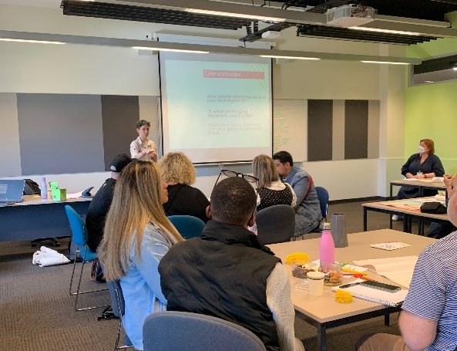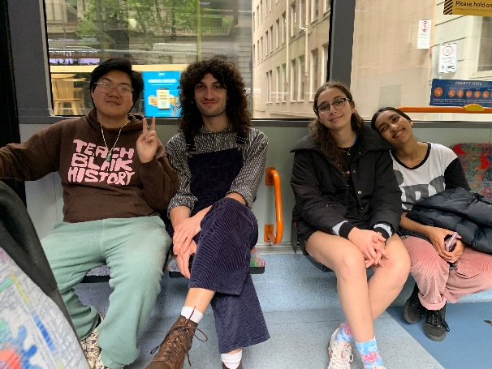
In the second half of 2021 we started two similar projects supporting organisations to better connect with young people. These were Merri Health located in Melbourne and Tomorrow Today Foundation based in Benalla, who were both looking to establish the very first Youth Advisory Groups in their respective organisations. Merri Health’s became the Young Carer Advisory Group and Tomorrow Today’s became The Squad.

YACVic offered regular advice, guidance, and access to resources and networks to help both organisations to plan their approaches, write their recruitment strategies, design their programs and lead their meetings and workshops.
In both partnerships, YACVic Young Peer Facilitators adapted our training content to best fit the needs of the group and led conversations on Youth-Led Meetings, Advocacy, and Running Great Workshops to empower the members of the Youth Advisory Groups to gradually step into leading the space for themselves.

Alongside this training component we offered ongoing advice and guidance for the coordinators of the programs, to problem solve and generate ideas to progress the programs.

YACVic Rural

‘Beyond the ring of steel’: Including and amplifying rural and regional voices.
If COVID-19 has taught us anything, it’s the need to develop and support targeted, small, local projects, which enhance young people’s abilities to contribute to their communities.
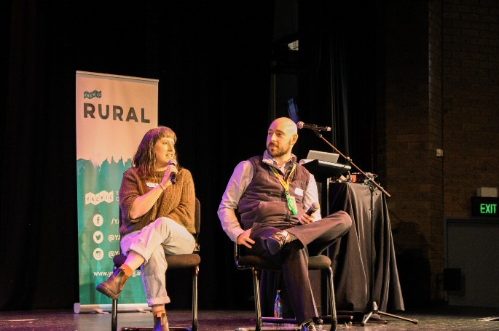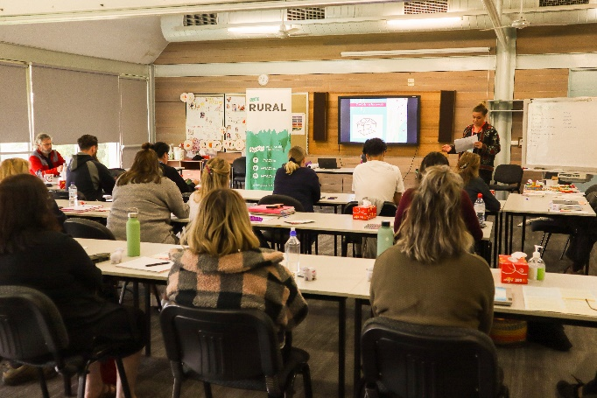
In addition to hosting our Conference and Youth Forums (read more on pages 19-27), the Rural team focused on building advocacy and participation capacity in rural and regional communities, with over 30 engaging and informative sessions delivered to young people.
Highlights included 60 young people from Campaspe participating in a Youth Leadership Forum run by YACVic Young Peer Facilitators, and 128 young people participating in Advocacy workshops across three rural communities as part of the VicHealth-funded Youth In Action Project led by YACVic in partnership with the Reach Foundation and local councils.
Rural and regional young people’s voices have remained a prominent feature in YACVic’s policy submissions with 139 young people being included across seven reports on topics such as justice, health, mental health, education and transport. (read more about public transport on page 37) This included Mapping Youth Policy, Participation Mechanisms and Services across Local Councils in Victoria – a research report reviewing youth services across each local government, and identified gaps related to youth services in regional areas.
In response to increasing threats from natural disaster, we released a major report Speaking Up which outlines the findings from consultations and workshops conducted with over 190 young people and community members across Eastern Victoria, with support from the Department of Education and Training and Bushfire Recovery Victoria. This project also released A Seat at the Table: Young People and Disaster Recovery, a guide to meaningful youth engagement, participation and inclusion in bushfire recovery and emergency management.
This formed the basis for successfully securing a $9.93 million Federal Government grant in February 2022 for ‘Future Proof: Young People, Disaster Recovery and (Re)building Communities’, a 14-partner project led by YACVic to drive recovery outcomes for fire-affected young people and communities across Eastern Victoria.
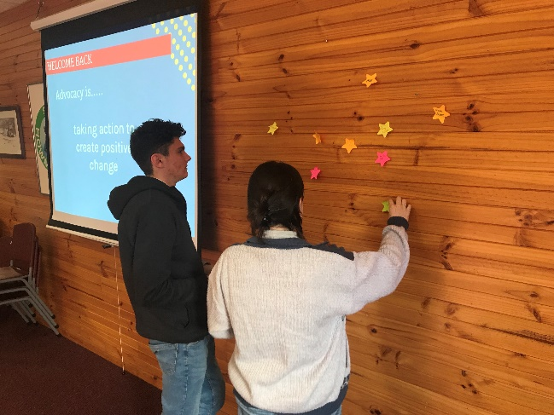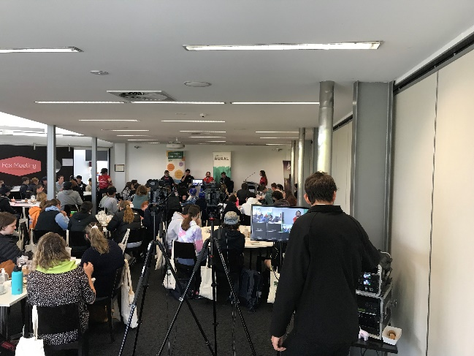

Key Stats
1. 992 young people engaged in programs
2. 253 young people actively involved in decision making processes
3 277 young people attended 4 Youth Forums held in Warrnambool, Robinvale, Wangaratta and Bairnsdale.
4 139 regional and rural young people contributed to 7 policy submissions
5. 190 workers engaged in activities and initiatives
4. 992 young people engaged in programs
5. 253 young people actively involved in decision making processes
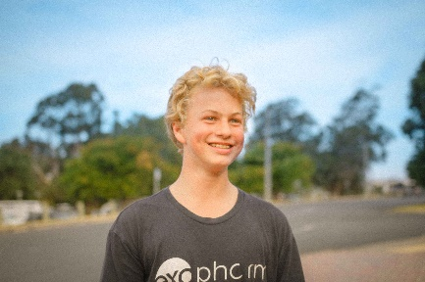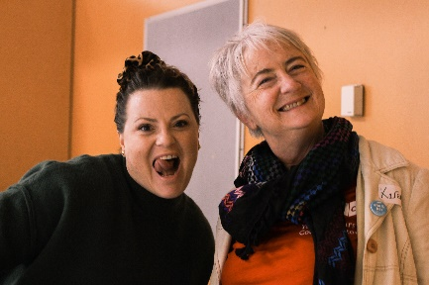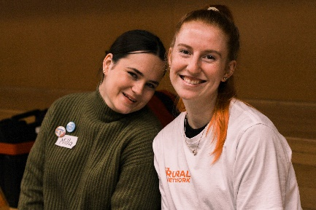

Rural Story

On The Buses

Improving Rural and Regional Public Transport

YACVic’s Response to the Parliamentary Inquiry into the use of School Buses in Rural and Regional Victoria
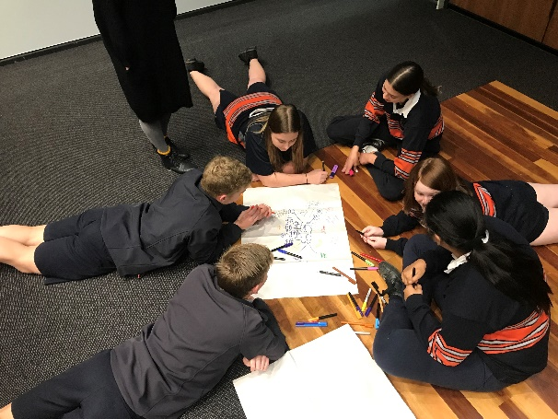
The Parliamentary Inquiry into the use of School Buses in Rural and Regional Victoria provided an opportunity to hear from young people and youth sector colleagues in rural and regional Victoria, to understand the challenges they face related to public transport, and how they might be addressed by better utilising school buses.
YACVic’s Policy and Rural teams collaborated to develop a survey that was completed by 208 people from across rural and regional Victoria — 97 youth workers, 96 young people, and an additional 15 young people who are also working as youth workers. They answered questions on the type of public transport available to young people in their area, the challenges associated with public transport for young people, and ways the system could be improved.
The survey was followed by a series of consultations to gain further understanding of transport disadvantage and how utilising school buses may help to alleviate this.
The final result was a detailed report with 14 recommendations to improve the public transport system via the use of school buses in rural and regional Victoria. The recommendations emphasised the need for youth participation in any decision-making related to changing how school buses are utilised, as well as centring bus routes around places that young people go including employment and education institutions, community sport programs, youth services and other community centres.
We were then invited to provide evidence at a hearing for the Inquiry; we supported a young person from the Greater South Coast to present alongside YACVic.
YACVic is currently undertaking additional work to understand how transport disadvantage impacts young people in rural and regional areas, and will continue to work with our rural and regional stakeholders to advocate for improvement across the public transport system.
Read more: yacvic.org.au/rural-public-transport

HEY Partners & Grants
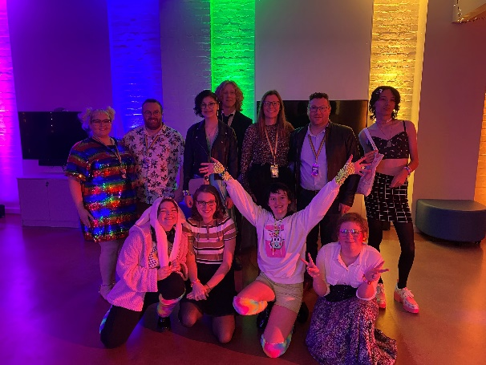
With significant public discourse over the past year about religious discrimination and the rights of LGBTIQA+ young people, the HEY (Healthy Equal Youth) initiative, which YACVic oversees on behalf of and in partnership with the Victorian Government, has been more important than ever. It aims to support LGBTIQA+ young people and LGBTIQA+ workers in the youth sector.
In its eleventh iteration, this year’s HEY grants program focused on improving social connection after two years of restrictions which exacerbated the challenges of isolation already faced by many LGBTIQA+ young people. Thirteen projects were funded, supporting intersecting identities within the LGBTIQA+ community such as international students, autistic people, and young people in rural and regional communities. 90% of applications received were first time applicants and six of the 13 projects funded were led by LGBTIQA+ young people, for LGBTIQA+ young people.
The annual HEY Day was held online, featuring the announcement of the new HEY Grant recipients, and a panel discussion for QTPOC (queer trans people of colour) with new Victorian Commissioner for LGBTIQA+ Communities, Todd Fernando.
YACVic continued to convene regular meetings of the HEY Partners, designed to break the isolation experienced by LGBTIQA+ workers. This provided regular peer support, information-sharing and stronger collaboration across the HEY Partners, with new groups formed to connect LGBTIQA+ young people across different regions.
Importantly, HEY has been active in ongoing advocacy for better support for LGBTIQA+ students within schools, improving community and peer-led suicide prevention initiatives, and highlighting service gaps for LGBTIQA+ young people across Victoria.
Read more: yacvic.org.au/hey

Youth Disability Advocacy Service (YDAS)

YDAS: Advocacy by, with, and for disabled young people
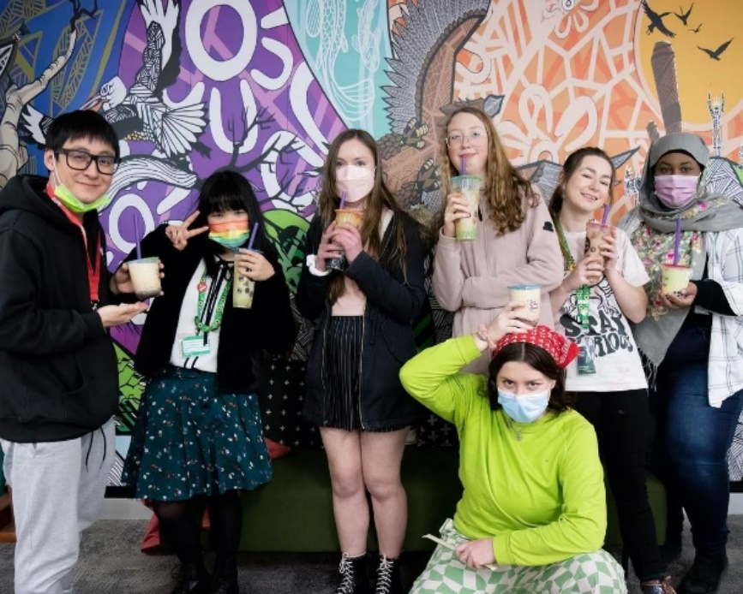
It was another year of extraordinary changes for disabled young people as the pandemic continued. Although lockdowns came to an end, many disabled young people are still unable to fully participate in their communities. This is both due to barriers that existed prior to the pandemic, and because of the increased health risks some disabled people face now due to COVID-19.
Disabled young people however continue to speak up for themselves and for their peers. YDAS advocates for, with and alongside these young people to create momentum for change, so disabled young people can participate in their communities as valued members.
In recognition of the importance of self-determination for disabled young people, YDAS and YACVic ran focus groups with disabled young people and other stakeholders to understand how YDAS and YACVic can support this self-determination and expand the work of YDAS.
Our human rights advocacy service, with support from the Lord Mayor’s Charitable Foundation and Office for Disability, provided direct advocacy support, information and referrals for issues such as school exclusion, discrimination, lack of safe housing, abuse and neglect, issues accessing services and NDIS funding and supports.
We continued our systemic advocacy work, providing evidence at the Disability Royal Commission (DRC) Public Hearing 21 about the experience of disabled young people who are clients of Disability Employment Services, and providing expertise and advice about supported decision-making and guardianship at a DRC policy roundtable. We also continued to work closely with the Victorian Government Office for Disability, Office for Youth, and Department of Education to make sure disabled young people are included in the planning and delivery of strategies, services and programs.
Recognising disabled young people as the experts in their lives is crucial and leads to higher quality outcomes, as demonstrated by the success of our co-designed and co-produced resources, projects and programs.
Key Stats
  - 73 disabled young people received individual advocacy support
  - 82 further disabled young people received information and referrals
  - 39 young people graduated from the YDAS Young Leaders Program and celebrated 313 success stories
  - 328 youth workers completed Together: Access and Inclusion training
  - 74 disabled young people contributed to YDAS’s systemic advocacy.
  - 12,678 combined followers on Instagram, Facebook, Twitter, LinkedIn and TikTok

YDAS Story
Empowering disabled young people and the workers who support them
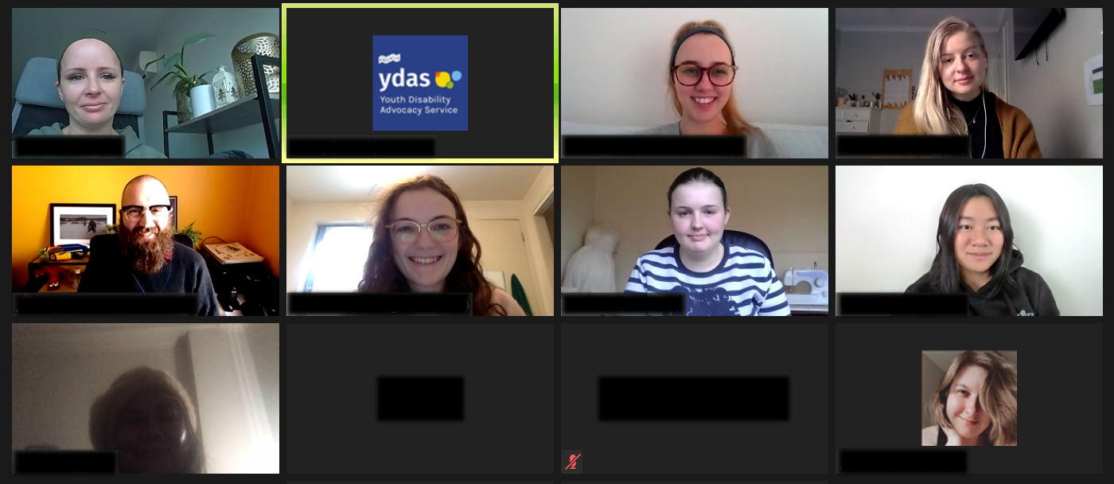
YDAS’ co-designed and youth-led programs make Victoria a more accessible and inclusive place for disabled young people. We work directly with disabled young people to build their skills, knowledge, confidence and self-advocacy.
This includes our flagship YDAS Young Leaders Program. Our dedicated team continued to collaborate widely to develop and fortify an innovative, extremely accessible leadership program for 14 -18 and 20 - 25 year old Victorians. 39 disabled young leaders graduated this year, and have celebrated 313 success stories of working, learning and advocating in their communities.
Last year we produced Map Your Future, a self-guided online tool with learning modules that develops disability pride, self-advocacy and goal setting, and supports NDIS planning. This year, Map Your Future won two gold and one silver at the Melbourne Design Awards. Thanks go to Today, the design studio that worked with us to make this happen.
Together: Access and Inclusion, another key YDAS program, trains those who work with all young people to make their programs, services and events more accessible and inclusive for disabled young people.
This year we took Together through an incredible overhaul. Thanks to funding from the Australian Government Department of Social Services, our young disabled co-designers and facilitators undertook copious research and interviewed youth workers to learn what’s needed to better support the youth sector. We then used this data and insight to update Together, with new themes including the broader contexts of disabled young people and how their varying identities intersect, as well as including a deeper sharing of lived experience throughout the training. We have already seen incredible feedback and improvements from the 328 youth workers who have completed the training.
By focusing on both disabled young people and youth services, we are helping build a society where disabled young people achieve their human rights to education, work, and a fun, active participation in their community.

Koorie Youth Council (KYC)
Koorie Youth Council (KYC) pays our deepest respects to people of the Kulin Nation and to all Elders past and present for their knowledge, wisdom and legacies that continue to drive us. We acknowledge and thank all the incredible young people and communities we work with for standing with us as we collectively create a future where all our people can thrive.
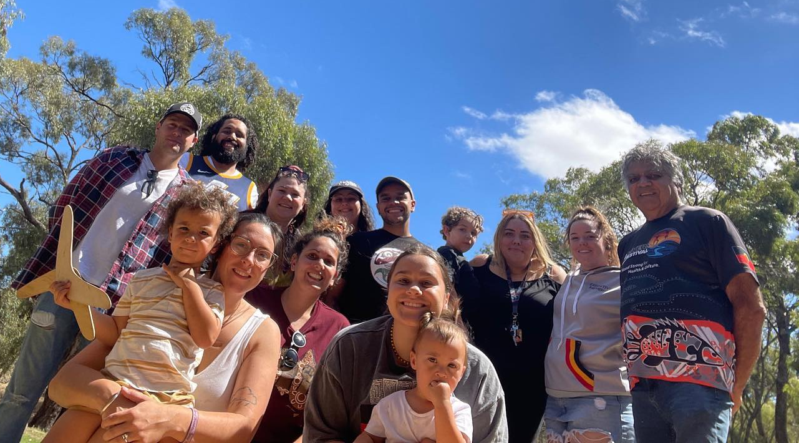
KYC has continued to create spaces for Aboriginal and Torres Strait Islander young people to connect and heal from the pandemic, and forged new ways for better Aboriginal youth participation across the sector.
Years in the making, KYC launched Wayipunga (‘supporting young people’ in Dja Dja Wurrung language), a landmark resource to support Aboriginal and Torres Strait Islander young people's participation in decision-making processes. (read more on page 32)
Guided by our KYC Executive of 15 Aboriginal and Torres Strait Islander young people aged 16-27 years living in Victoria, we planned projects, events and programs to support Aboriginal and Torres Strait Islander young people coming out of the pandemic.
We ran and delivered our Koorie Youth Summit in November 2021 online across three weeks, with 15 deadly speakers and performers who shared their stories and talents to connect young mob with culture and community.
We worked with the Victorian Government’s Office for Youth and YACVic to transition the Marram Nganyin Aboriginal Youth Mentoring Program to be solely delivered by KYC, so it is now entirely led and run by and for Aboriginal and Torres Strait people and a clear example of true self-determination in action. (read more on Page 43)
KYC continues to be a strong, active advocate for the rights and representation of young mob, as a major player in guiding the development of Wirkara Kulpa (‘alongside, next to talking/speaking; in Barkindji language), the Aboriginal Youth Justice Strategy 2022-32, and Our Promise, Your Future Victorian Youth Strategy 2022-27, and as a key voice at Dhelk Dja Partnership Forum, Aboriginal Justice Forum, Self-Determination in Education Reform and many other spaces.
www.koorieyouthcouncil.org.au

Marram Nganyin

Self-determination of the Marram Nganyin Youth Mentoring Program
Marram Nganyin is a youth mentoring program for Aboriginal and Torres Strait Islander young people aged 12-25 years old, and for the last five years KYC and YACVic have jointly supported the partner organisations that deliver the programs.
As of 1 January 2022, KYC is now solely responsible for supporting the entire program, and we look forward to supporting the partner organisations to deliver programs that are community designed and led. We thank YACVic and acknowledge their work in supporting the self-determination of the program.
As Aboriginal people, we know what is best for Aboriginal people. We know how to look after our mob and how to work with our mob to have meaningful outcomes that empower our people.
We are really excited for the next two years of the Marram Nganyin program to be led by Aboriginal people, with and for Aboriginal people and what that will mean for the communities that we work with, especially for the Aboriginal young people involved in the programs.
Marram Nganyin is a name provided by the Wurundjeri Woi Wurrung Cultural Heritage Aboriginal Corporation, meaning ‘we are strong’ in language provided by the Wurundjeri People.
Mentoring has been taking place in Aboriginal and Torres Strait Islander communities for generations. It is often innate and/or informal, and carried out through the Elders’ traditional role of sharing the wisdom, the knowledge and the spirit.
The work of Marram Nganyin and the local mentoring projects seeks to build on this natural mentoring process and combine it with formal structures to further improve outcomes for young participants.
Koorie Youth Council (KYC) acknowledges the Office for Youth within the Department of Fairness, Families and Housing (DFFH) for funding KYC to oversee the Marram Nganyin Youth Mentoring Program.
Find out more about Marram Nganyin here: https://koorieyouthcouncil.org.au/projects/marram-nganyin/

Media and Communications

Sharing vital information in challenging times
Through changing restrictions, new COVID-19 strains, elections, fires and floods, YACVic has been there to support young people and the sector.
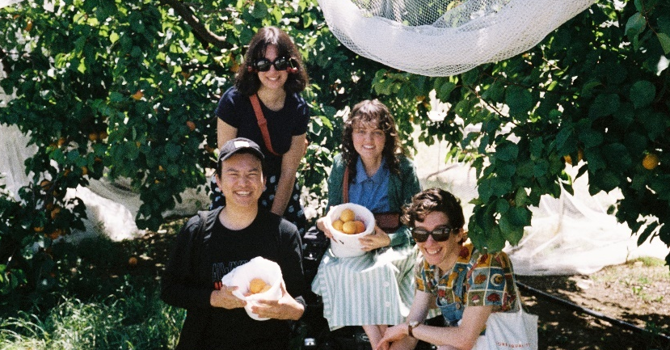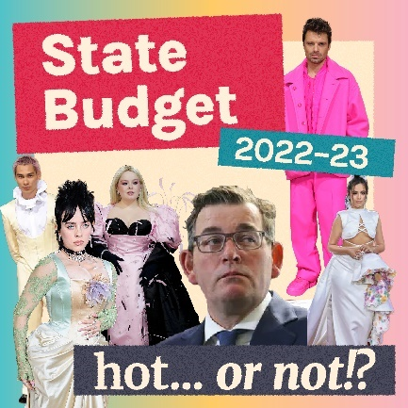
Through 2021-22 the YACVic comms team has continued to translate crucial information into easy-to-understand and engaging material for young people across Victoria.
This year, the Victorian Government also asked us to create a campaign for young people who had questions about COVID-19 vaccines. We ran multiple ambassador programs with young people from under-represented communities, upskilling them as communicators. By co-designing our communications campaigns with these ambassadors, young people’s voices, concerns, and interests have been the centre of this campaign. Their expertise and insight allowed our campaign to reach and influence more young people and workers in the youth sector.
For the federal election, we teamed up with the Policy team to provide first-time voters and the workers supporting them with clear and easy-to-understand information through our Election Navigator resource. We also elevated young people’s voices on a major national platform with a feature front-page story in The Age.
We refreshed YACVic’s brand and style guides to stay cutting edge, reflecting our commitment to best-practice language and accessible graphic design. We continued to explore new platforms and formats, creating podcasts, short videos and memes. YACVic’s willingness to adapt and change along with our audience cements our role as a peak body and advocate for the sector.

Key Stats
1. 1,228,628 people reached via our social media
2. 108 young people engaged in media interviews or received media training
3. 232,229 page views on our website
4. 70 media appearances
5. 1 refreshed brand look

Comms Story

Co-designing a vaccine campaign
Empowering young people to lead Victoria’s COVID-19 vaccination efforts
Young people were left out of the COVID-19 vaccination roll-out when it initially began in 2021. There were no dedicated resources or communications targeted towards young people developed by government. Having become a reliable, engaging source of updates relating to the pandemic, YACVic stepped up to empower young people, save lives and help Victoria exit lockdowns.
With funding support from the Victorian Government’s Department of Health, our young staff led development of specific resources to support young people get the information they needed. These included guides to self-advocacy in healthcare settings, being a role model to family and friends, having ‘vaccination conversations’, and more.
As young people became eligible for vaccination, we ran a co-designed campaign in late 2021, involving memes, TikToks and short videos written by young people, for young people. It addressed common misinformation/fears for young people such as vaccine side-effects and needle-phobia, and used relatable pop culture references and humour to engage young people.
We also co-designed resources for young people in youth justice settings in Malmsbury and Parkville, and YDAS ran a similar co-designed initiative with and for disabled young people .
With Omicron spreading rapidly in early 2022, we again turned our attention to providing youth-specific information, such as isolating in contexts such as share-houses, supporting friends who were testing positive, and being a role model to younger siblings who could now access vaccines.
The campaign had over 1 million views on TikTok, reached 500,000+ young people on Instagram, and our COVID-19 Vaccines and Young People resource was the number one source of information. YACVic empowered young people to play a big role in Victoria’s COVID-19 vaccination efforts.
Find out more: yacvic.org.au/covid-vaccine

Comms Story

Federal Election Navigator
Supporting young people to navigate the 2022 Federal Election
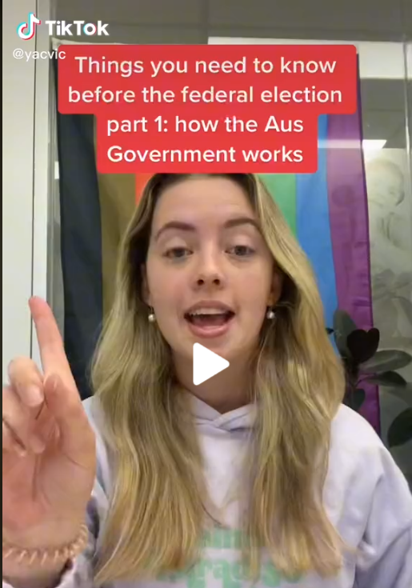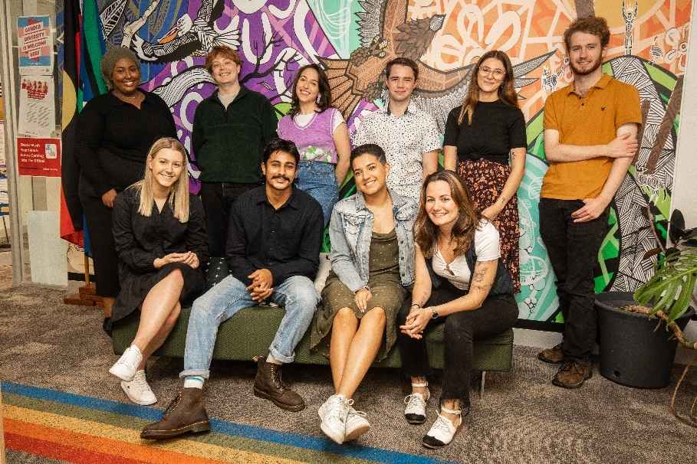
Young people are underrepresented in all levels of government, and seldom have resources to learn about how elections work.
With the 2022 Federal Election being an important moment to shape the future of Australia, YACVic’s Policy and Communications teams worked together to develop an Election Navigator to support young people to make their own informed decisions about their vote.
We broke down the resource into different sections: understanding how governments and election systems work, enrolling to vote, deciding who to vote for, meeting your local candidates, and voting on the day.
We also provided clear information on how to find accessible voting centres, and, as this was the first election run in the context of COVID-19, how to vote if you had to isolate.
The resource was turned into easy-to-understand social media tiles, illustrations and short videos to engage young people and encourage them to learn more. We also had a student intern share her experience navigating her decision as a first-time voter. The Election Navigator was shared widely by youth services, who used it to have conversations with young people on voting.
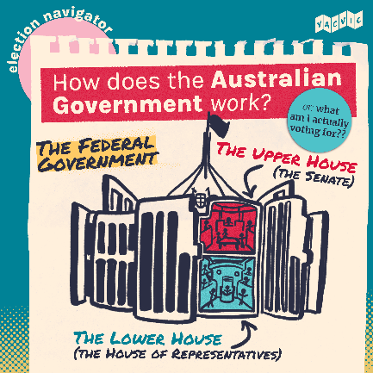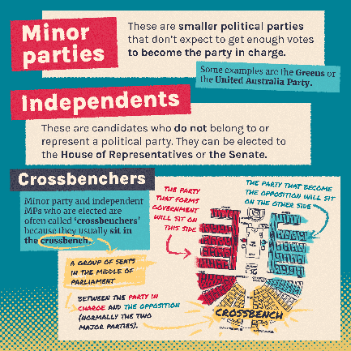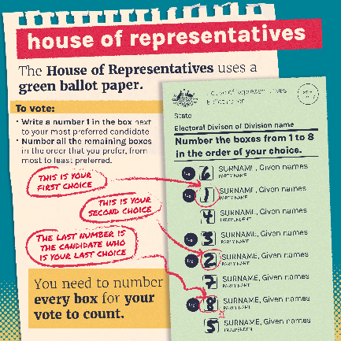
Young people deserve access to tailored resources and information on decisions that will affect them. YACVic continues to lead the way as a trusted, impartial source for young people and the youth sector.
Learn more: yacvic.org.au/election

Corporate Services
Keeping our team safe at home and in the office
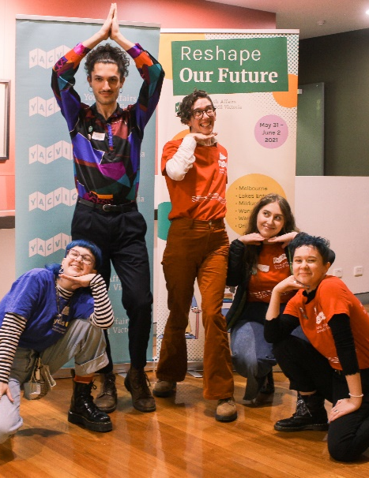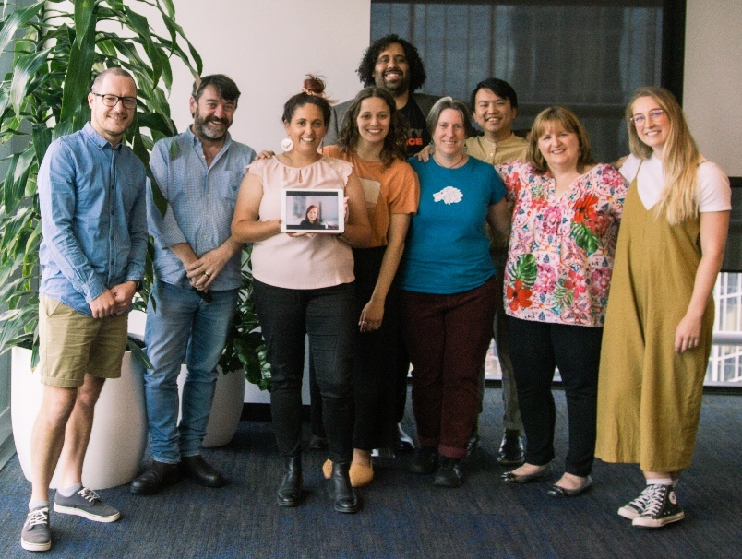
YACVic’s constant work of championing and advocating for young people’s rights and the youth sector is underpinned by a solid internal platform of systems and support, which is maintained by our small Corporate Services Team. Our focus every year is on our people, operational rigour and sustainability.
This year, many staff felt the fatigue of working through the peak COVID-19 times, with the pandemic impacting heavily on both work and home life, from many different directions.
Through all the periods of lock-down, we kept staff meeting and connecting via a variety of online tools, and welcoming pets and kids as part of the team! We also managed to squeeze in one in-person whole-of-staff team celebration and a few team gatherings in December. But there is no doubt that all staff will benefit from, and are looking forward to, having more opportunities to connect face-to-face in the coming year.
Health and safety is always on our minds. We have provided both individualised support and general well-being tips to help staff cope with being sick with, recovering from or caring for family members with COVID-19. We conducted a review of health and safety needs for all staff working from home, providing additional equipment where needed. Overall, the staff team has adapted well to hybrid working, and we will continue to support this long-term, with the majority of staff enjoying the flexibility and reporting an improved work-life balance.
We also continued to focus on robust financial management, making sure that every dollar at YACVic is spent wisely and well. This includes strong financial, risk management and compliance efforts, and looking for other values-aligned and innovative ways to increase our revenue.
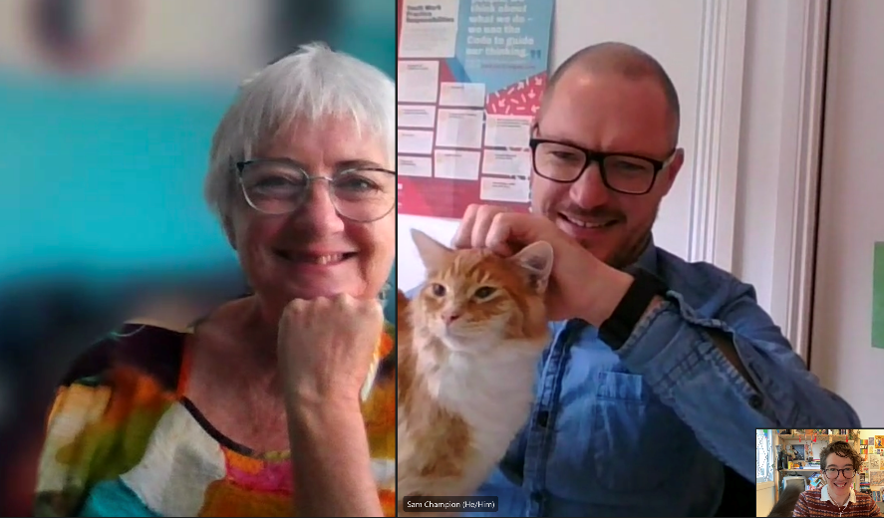

Key Stats
Of 62 staff (35.4 FTE) employed by YACVic at 30 June 2022:
- 33 joined us during the year on short-term contracts/casual hours contracts
- 11 joined us on contracts of 1 year or longer
- 53% were aged 25 years or younger

Thanks To Staff

Akshay Kumar Myadam
Alberto Giglia
Alexandra Iliopoulos
Alyce Gumley
Alyssa Grace
Anhar Al-Shameri
Annelise Moller
Ardu Cubillo
Ash Hem
Bianca Failla
Bonnie Dukakis
Briar Rolfe
Bridget Jolley
Bryce Taylor
Carla Hall
Catherine Dunn
Christopher Phung
Conor Pall
Daphne Arapakis
David Trevorrow
Derm Ryan
Douglas Briggs
Elyse Westwood
Em Dewhurst
Finnley Stirling
Fiona Macdonald
Giovanna Szalkowicz
Haley Zilberberg
Hope Kuchel
Indi Clarke
Is Hay
Jacob Gamble
Jade Maiolo
Janelle Graham
Jasmine Ryan
Jay Carnell
Jeanine Orr
Jennifer Rowan
Jessica Standish
Julia Baron
Jun Bin Lee
Karen Walsh
Katherine Ellis
Katia Pellicciotta
Kelsey McGowan
Kim Zoe Evans
Kirstine Greenwood
Kirsty Fealy
Laura Donnelly
Laura Pettenuzzo
Leyla Quartermaine
Liam Head
Lily Day
Lucia Suarez
Luke Rycken
Mac Zamani
Malika Kirby
Mark Yin
Maya Ghassali
Meg Langmaid
Mia Boonen
Mija Gwyn
Natalie James
Natalie Voermans
Nikayla Bamblett
Nuriyah Haque
Rachel Wilks
Rebecca Marquis
Reece Moir
Rhiannon Jennings
Riya Rajesh
Ruqia Mohamed
Safe Shahab
Sam Champion
Sarah Woolsey
Sebastian Antoine
Simon Green
Sneha Challa
Stacey Christie
Stephanie Brenkovich
Tara Smith
Thomas Feng
Tom Saxton
Zach Smith

Financial Report
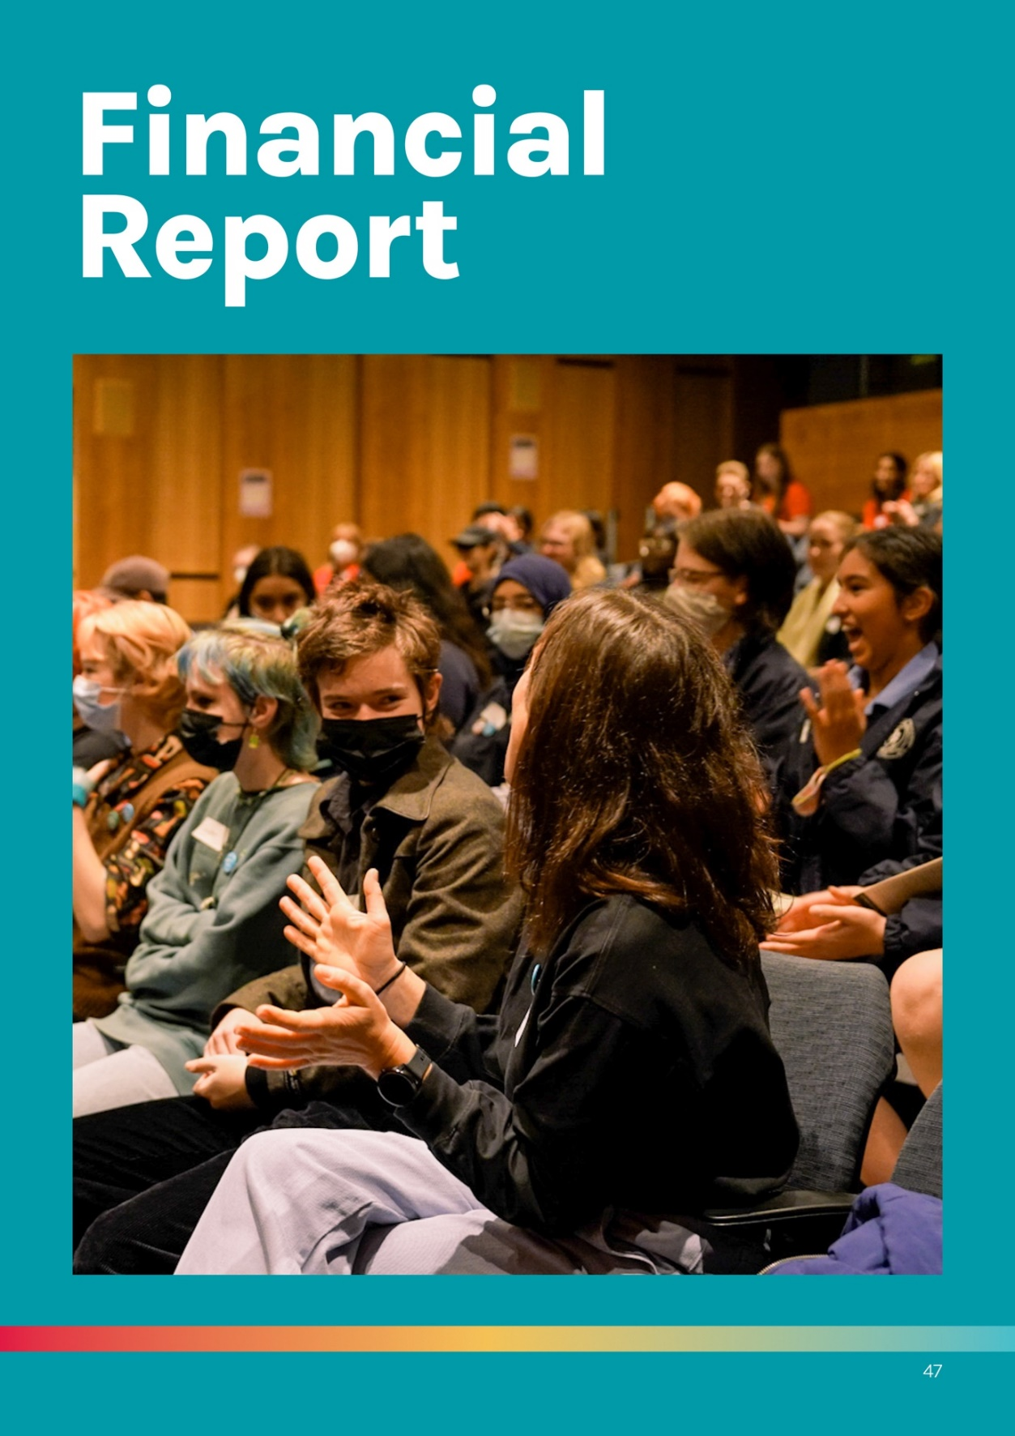

Treasurer’s Report
I am delighted to deliver the 2021/22 Treasurer's report for YACVic.
Despite the challenges imposed by COVID and limited infrastructure funding, in the 2021/22 financial year YACVic achieved many positive outcomes across its five strategic goals. With an increasing demand for YACVic in its role as a peak body for the youth sector in Victoria, rising costs and static Government core funding, YACVic continues to work with Government on additional financial support and explore alternative ways to mobilise funds through the 'fee for service' operating model and collective action partnerships.
With a strong emphasis on prudent financial management, YACVic delivered a small surplus of $300,734, which is mainly in line with last year's surplus of $332,868. The surplus has resulted from timing in receiving funds and is fully committed to the future year's projects or core activities.
YACVic’s revenue increased by $316,244 to $4,943,599 due to the recognition of grants received last year for the project activities finalised this financial year. Similarly, the expenditure increased by $348,378 to $4,642,865 due to the finalisation of grant-funded projects. Notably, in 2021/22 FY, YACVic completed the Working for Victoria project, attracting total funding of $6,972,142 to the youth sector, and the Bushfire Recovery Victoria project with total revenue of $249,650.
As of 30 June 2022, the YACVic financial position remains strong, with net assets of $1,867,166.
The cash held in the bank has increased to $9,308,436 (2020/21 FY $3,540,657), primarily due to receiving the "Future Proof: Young People, Disaster Recovery and (Re)building Communities" grant from the Federal Government just before year end. This large grant in advance is balanced by an increase in current liabilities of $7,859,697 (2020/21 FY $2,534,079) representing funds to be distributed to project partners. The "Future Proof" grant is a significant achievement for the youth sector. YACVic will administer this grant and conduct the activities in collaboration with 13 project partners over the 2022-2024 financial years.
I congratulate the Board and management for their tireless efforts toward supporting the youth sector and ensuring financial sustainability.

Galina Fidler,
YACVic Treasurer

Statement of Comprehensive Income

For the year ended 30 June 2022

Income
- Conferences: 2022, $70,653. 2021, not applicable.
- Member subscriptions: 2022, $25,606. 2021, $38,306.
- Government grants: 2022, $4,302,969. 2021, $4,042, 809.
- Other grants: 2022, $115,715. 2021, $84,600.
- Interest received: 2022, $1,111. 2021, $2,337.
- Other income: 2022, $427, 545. 2021, $264,203.
- Covid-19 Government Stimulus: 2022, not applicable. 2021, $195,100.
Total: 2022, $4,943,599. 2021, 4,627,355.

Expenditure
- Depreciation and amortisation expense: 2022, $263,323. 2021, $234,788.
- Finance costs: 2022, $13,671. 2021, $13,835.
- Employee costs: 2022, $3,589,109. 2021, $3,407,726.
- Accommodation expenses: 2022, $35,112. 2021, $90,534.
- Administration expenses: 2022, $279,117. 2021, $90,534.
- Communication expenses: 2022, $41,035. 2021, $37,802.
- Publication and printing: 2022, $9,988. 2021, $12,691.
- Project costs: 2022, $411,510. 2021, $222,445.
Total: 2022, $4,642,865. 2021, $4,294,487.

Other comprehensive income for the year: 2022, not applicable. 2021, not applicable.

Total comprehensive income for the year: 2022, $300, 374. 2021, $332,868.

Statement of Financial Position

As At 30 June 2022

Assets

Current assets
- Cash and cash equivalents: 2022, $9,308,436. 2021, $3,540,657.
- Trade and other receivables: 2022, $90,398. 2021, $236,842.
- Prepayments: 2022, $43,695. 2021, $62,931.

Total current assets: 2022, $9,442,529. 2021, $3,840,430.

Non-current assets
- Plant and equipment: 2022, $109,191. 2021, $180,051.
- Right-of-use assets: 2022, $239,542. 2021, $335,234.

Total non-current assets: 2022, $348,733. 2021, $515,285.

Total assets: 2022, $9,791,262. 2021, $4,355,715.

Liabilities

Current liabilities
- Trade and other payables: 2022, $1,307,547. 2021, $301,716.
- Employee benefits: 2022, $357,140. 2021, $286,160.
- Other liabilities: 2022, $5,940,337. 2021, $1,796,262.
- Lease liabilities: 2022, $254,673. 2021, $149,941.
- Total current liabilities: 2022, $7,859,697. 2021, $2,534,079.

Non-current liabilities
- Lease liabilities: 2022, $10,737. 2021, $215,805.
- Employee benefits: 2022, $53,662. 2021, $39,399.
- Total non-current liabilities: 2022, $64,399. 2021, $255,204.
Total liabilities: 2022, $7,924,096. 2021, $2,789,283.
Net assets: 2022, $1,867,166. 2021, $1,566,432.

Members’ funds
- Retained surplus: 2022, $1,867,166. 2021, $1,566,432.
Total members’ funds: 2022, $1,867,166. 2021, $1,566,432.

Statement of Changes of Equity

For the year ended 30 June 2022

2022
- Balance at 1 July 2021: Retained surplus, $ 1,566,432. Total $1,566,432.
- Surplus for the year: Retained surplus, $300,734. Total $300,734.
- Balance at 30 June 2022: Retained surplus, $1,867,166. Total $1,867,166.

2021
- Balance at 1 July 2020: Retained surplus, $1,233,564. VicSRC retained surplus, $256,133. Total $1,489.697.
- Surplus for the year: Retained surplus, $332,868. VicSRC retained surplus, not applicable. Total $332,868.
- Ending of auspice: Retained surplus, not applicable. VicSRC retained surplus, a negative balance of $256,133. Total, a negative balance of $256,133.
- Balance at 30 June 2021: Retained surplus, $1,566,432. VicSRC retained surplus, not applicable. Total $1,566,432.
Note: The financial summary provides an overview of YACVic’s financial affairs. The statutory financial statements which include our accounting policies and audit report are available as a PDF at YACVic.org.au/about-YACVic. If you would like those transcribed in an accessible or list format like this document, please let us know at communications@yacvic.org.au.
—signed, Accru Melbourne

Wurundjeri Country
Level 2, 235 Queen Street
Melbourne, Victoria, 3000
www.yacvic.org.au
info@yacvic.org.au

November 2022

