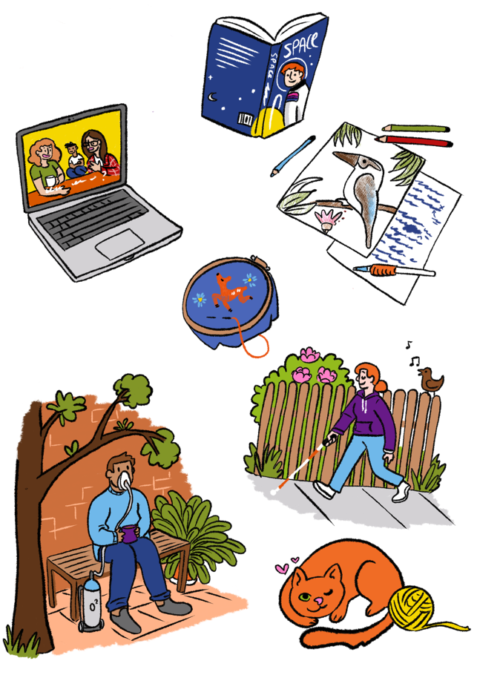

Online hub project advisory group

Youth Disability Advocacy Service

About this book
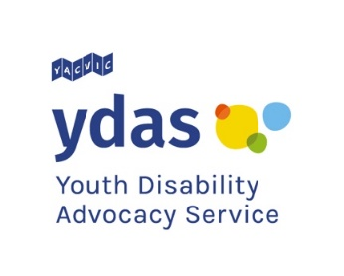 | This book is from Youth Disability Advocacy Service or YDAS.
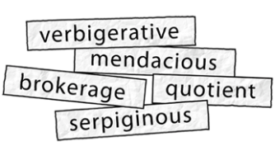 | This book has some hard words.
 | Hard words are bold.
 | We tell you what hard words mean.
You can ask someone to help you read
this book.
 | This book is about our online hub project advisory group.
 | The online hub will help disabled young people
 | - learn how to speak up about problems with NDIS service providers
 | - understand their rights.

Rights are things that everyone should be
able to
- get
- have
- do.
For example you have the right to feel safe with your service providers.
The online hub will also teach disabled young people how to make a complaint about NDIS.
A complaint means you speak up when something is not right.

Project advisory group
The project advisory group or PAG will help us make the hub.
We want 10 disabled young people to be part of the PAG.

 | You can be in the group if you
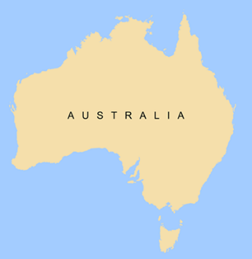 | - live in Australia
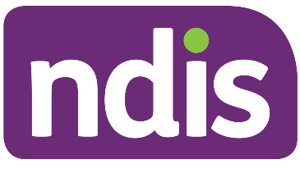 | - are on the NDIS
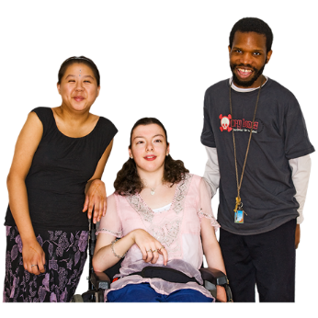 | - are 12 to 25 years old.
 | If you join the PAG we will pay you 50 dollars for every hour you work.
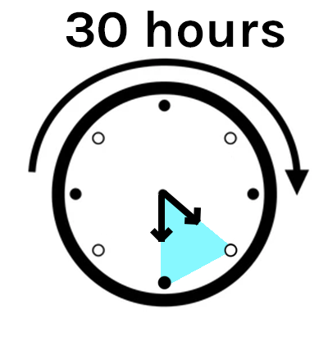 | You can work up to 30 hours.

When will the PAG meet?
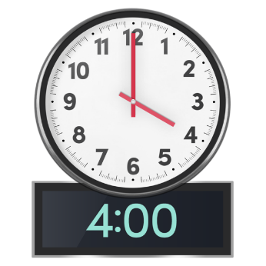 | The meetings will all be at 4pm  Melbourne time.
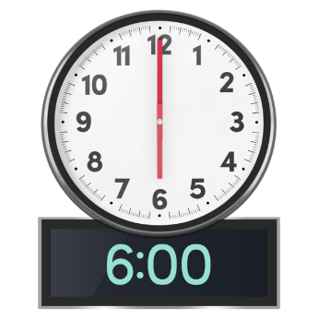 | The meetings will finish at 6pm  Melbourne time.
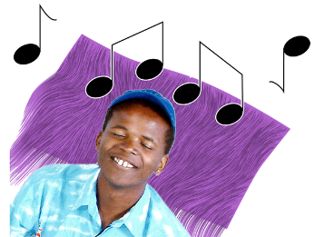 | We will have breaks in the meetings.
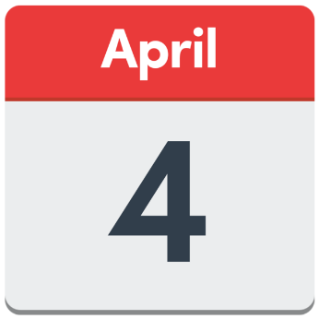 | Thursday April 4
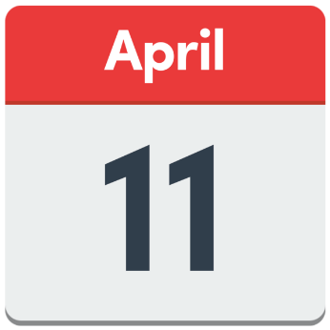 | Thursday April 11
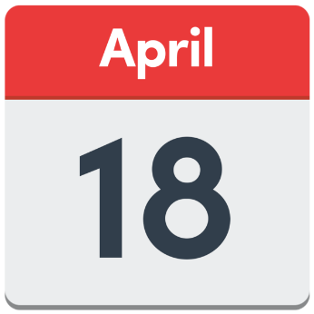 | Thursday April 18
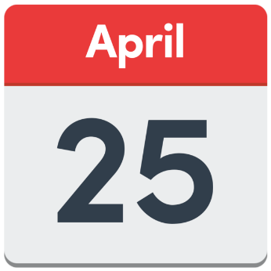 | Thursday April 25
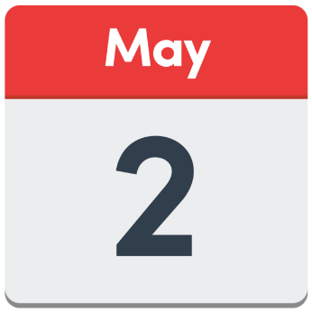 | Thursday May 2

What the PAG will do
The PAG will talk about how to share
information with
 | - disabled young people
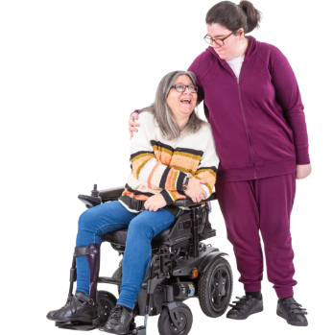 | - family members and carers
 | - NDIS service providers.

From May to July the PAG will make
- videos
- podcasts
- blog posts
- something else.
What you make will be part of the online hub.

If you want to be in the PAG
Fill in a form to tell us why you want to be in
the PAG.
 | The form is on our website.
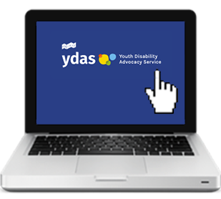 | Click here to see the form.
You must fill in the form by 9am
Monday 11 March.

 | This is Jun.
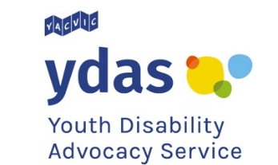 | Jun works at YDAS.
 | Jun can help if you
 | - have questions about the PAG
 | - need help with the form.

More information
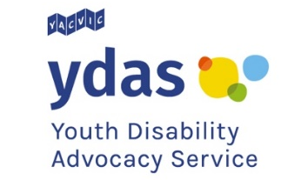 | For more information contact YDAS.
 | Call or text 0457 453 784
 | Email jlee@ydas.org.au
Website
yacvic.org.au/ydas/get-involved/

Pictures by Photosymbols.

