Sick/Sovereign

Re-imagining COVID-19 through disabled First Nations storytelling

Darcy H., Mo, H.G. Manchini, E.R., Patrick Mercer, Chantell Nicholls, Aiesha Saunders

Contents

Foreword – Darcy H. 3

Untitled – Mo 5

Four – H.G. Mancini 6

Exhausted – E.R. 11

Three Admissions – Patrick Mercer 13

Untitled – Chantell Nicholls 16

HCUO – Aiesha Saunders 17

# Foreword – Darcy H.

As I write this, I struggle to recall the last time I left the house for reasons beyond taking out the bins, checking the mail, attending an appointment, or going to the pharmacy. I struggle to recall the last time I socially engaged with friends. I don’t even bother trying to remember the last time I felt safe in a social setting.

It’s hard to imagine that there was ever a time when being around people didn’t involve constant assessment and re-assessment of risk, asking myself the same question over and over and over: “is this worth risking my life for?”

I question the validity of my identity more than ever before. Physical presence and connection is an integral part of culture, of fostering and maintaining community and kinship. Am I really even mob if that’s something I can’t do? Do I have any right to claim Blakness at this distance? The divide between myself and everything around me feels bigger each day.

COVID would likely be a death sentence for me. Isolation is a safety mechanism I use to keep myself alive. But it is not a choice. It is a product of existing within structures of colonialism, capitalism and white supremacy that position people like me as better off dead.

But neglecting, ignoring, and even sacrificing oppressed communities during a crisis while positioning their illness and death as inevitable, even a relief? That is a choice. That is a deliberate and calculated choice. It is a choice that communities rendered insignificant and undesirable are forced to witness being made, again and again, every single day.

This is a snippet of what existing at the intersection of Blakness and disability amidst a global pandemic means for me. What it means for me, though, is not the same as what it means for the next disabled Blackfulla, or the one after that, or after that. There is, of course, no one, all-encompassing disabled Blak experience. Our perspectives are broad, complex, diverse, messy, undefinable, and distinct. And yet...we rarely see any disabled First Nations experiences represented at all, let alone in all their nuanced glory.

This is why I wanted to create Sick/Sovereign. Because disabled First Nations perspectives deserve and need visibility. Multiply marginalised people continue to be sidelined in discussions around and responses to COVID. We are still finding ways to express how we fit into the pandemic world.

We deserve for our expressions to be informed by our communities, not just the dominant colonial, capitalist, white supremacist perspectives that reduce us to a deficit, a nuisance, a problem to be solved. We deserve access to understandings of the world that have been shaped by lived experiences like our own. In these expressions, we can find solidarity, connection, shared experiences, and language and representations to identify with.

Sick/Sovereign exists to create a space that we have been denied. It is a collection of stories from young, disabled, First Nations people situating themselves in relation to COVID and vaccination. It is not an attempt to position any single perspective as factually or morally superior or correct. There is no wrong or right way to experience a global crisis. These stories encapsulate experiences of pain, struggle, loss, isolation, joy, abundance, strength, uncertainty, confusion, excitement, apathy, numbness, regret, and so much more. They are unedited, unabridged, undiluted accounts of just some of the limitless possibilities of what it means to be young, Blak and disabled in a global pandemic.

It is a great privilege to share this powerful collection of stories. I am endlessly grateful for everyone who made it happen. In particular, I would like to thank Jun and Laura for their tireless work and faith in me. And most importantly, thank you to each of the contributors for trusting me with your stories. Sick/Sovereign exists because of and in honour of you.

Darcy H. (they/them) is a 23-year-old Blak, mad, neurodivergent crip living on Wurundjeri Woi-wurrung Country.

Instagram: [@wetdirt2008](http://instagram.com/wetdirt2008)

# Untitled – Mo

Growing through my early teenage years in the pandemic was a very strange experience, as I felt a sense of uncertainty in almost everything that happened: when was the first case going to arrive? How many more lockdowns would there be? How long would they last? When would I be able to get the vaccine? When would things reopen?

It caused me to feel isolated from the greater world, like I had nothing to look forward to after all this was over.

2020 and 2021 feel like a blur, I struggle to remember the exact dates of what things happened, and what year of the two they happened in.

Is that my fault for not writing down what happened each day? Is it just a by-product of not being able to go out and do unique things consistently, therefore falling into the same routines and patterns for weeks at a time?

The lockdowns contributed to this a lot, even when I had something to look forward to doing each week, a fixed event that added some sort of continuity to my year, it would regularly get put on hold or moved to being online, which took a lot out of me.

I had finally gotten a good group of friends that accepted me for who I was, who helped me feel better when I was feeling my worst, and it never seemed certain what would happen.

Especially during early 2021, I felt the worst I have felt in my life so far. The lockdowns took a lot out of me and I’m sure a lot of other people.

Getting a vaccination felt strange at the time. What would I feel like after? How long would it last?

(I felt fine afterwards)

Overall, the COVID-19 pandemic very much disrupted mine and many other lives, and it’s unclear what will happen in relation to it, and the world.

Mo (he/they) is a 14-year-old Biripi and Dunghutti person living on Wadawurrung Country.

# Four – H.G. Mancini

Hello, hello, can you hear me?

I would like to tell you a story, you see

A tale of things that have to be said

For all of you to understand the things in my head

I have a problem, a problem with me

A problem so hard it’s not I, but we

There’s not just me living inside my head

It’s me, my friends and the dark instead

Not one or two, but three of four

Other Me’s hiding from the light on the floor

The floor where there’s a stage to make quite clear

Which one of us is going to be here

If it’s bright and there’s light, it might be me

But if it’s dark and in shadow, it’ll be Two or Three

They’re not so bad, but then there is Four

The most terrifying and saddest ever seen before

Four is lonely, Four is small

Four is dark and Four is tall

Four’s name is not mine, in fact it’s long

Four doesn’t have my name, it’s too strong

Four’s name is Weakness or Sorrow or Strife

I think it’s all three that it has in its plight

As he comes only during the time of the night

When One, Two and Three have turned off the lights

Four only appears when One has been bad

When One is lonely or tired or sad

Because, unlike his friends Two and Three

One does not ever fall asleep you see

One stays awake in the dead of night

When it’s dark out and he’s turned off the lights

He’s so tired, so tired, but can’t close his eyes

For fear of just where Four lies

For Four will whisper, come and play with me

And One cannot never give in, you see

Once One gives in and turns on the light

Four will come out in a terrifying sight

Four is angry, Four is mad

Four is uncontrollable and always bad

He makes One do things that he’ll regret

He makes One do things he won’t soon forget

But there is one thing that makes One sad

It’s that Four is not always, truly mad

Four is the problem that no one understands

Till someone sees it with their own eyes and hands

Four is an excuse used by very much all

Who want to be rude and make many tears fall

These people do not truly know just what Four really does

But I do, I do a lot after all this fuss

Four is a problem, a problem of mine

But I can see why you would deny that saying in time

Too much, too much running around

Can make someone distrustful of information found

I’ve got Four stuck in my head

Instead of helping, he makes a mess instead

I realize this now while Four is gone

But I don’t think this will last for long

I must ask that you take a moment at hand

And ask that you try and understand

That though the insomnia and anxiety

Are not all I’ve really always had

In these years of fear and strife

Of sickness and masks and fancy of flight

I’m got autism and allergies as well to be had

Why, because I can’t compromise, I’m really not that bad

I’m not as mad as you make out you see

I’m only One, not Four, Two or Three

I can’t help the way I was made

I can’t help the way I will stay

I cannot help that I am always sick

I cannot help that I become that rather quick

So things I must wear and precautions I must take

In a braver world that within, I strive to be great

You can nasty and sneer all the more

But I must do what I do and something even more

For I do not wish for death you see

For there are people needing and loving me

So while I avoid everything galore

While you shout and rant and rave at my door

There are so many other things to be had

And to reiterate, I’m really not that bad

My experience with having COVID, being a First Nation person and being disabled hasn’t been a pleasant one, hence why I decided to write my feelings down in this poem.

It was unpleasant and hurtful, as my DID kicked in and there wasn’t just one person, but 7 people sick at the same time in one place, which caused a lot of confusion and terror, leading to meltdowns, several uncontrollable personality switches and dissociation, including memory loss.

It’s also been a lot worse for myself and my roommates (as I call them) due to the host, being me, not physically being able to be vaccinated and berated for that particular fact, leading to feelings of shame that I thought I had rid myself of years ago when I accepted my culture.

It also exacerbated my inability to use my motor skills, causing a ramp-up in seizure activity and leaving me unable to drive my electric wheelchair and unable to move entirely on the worst days.

Sadly, no one except maybe a few people knows what it’s like to be trapped in your own head with no way out. A maze with no prize that slowly gets longer and longer without you knowing.

Four symbolises exactly what was going on at the time, when personalities were shoving each other out of the way to be heard and myself fighting through the strife ensuring from the pandemic and other factors to come out the other side in one piece despite my roommates also fighting me.

I hope we can all take a lesson from this text, even if we can’t relate to it, that not all people are bad because of circumstances that affect them. That’s the true message of this at large.

H.G. Mancini (she/they) is a 25-year-old Wiradjuri, Darug and Gundungurra person living in Meanjin/Brisbane.

Instagram: [@lookylookyabookybooky](http://instagram.com/lookylookyabookybooky)

# Exhausted – E.R.

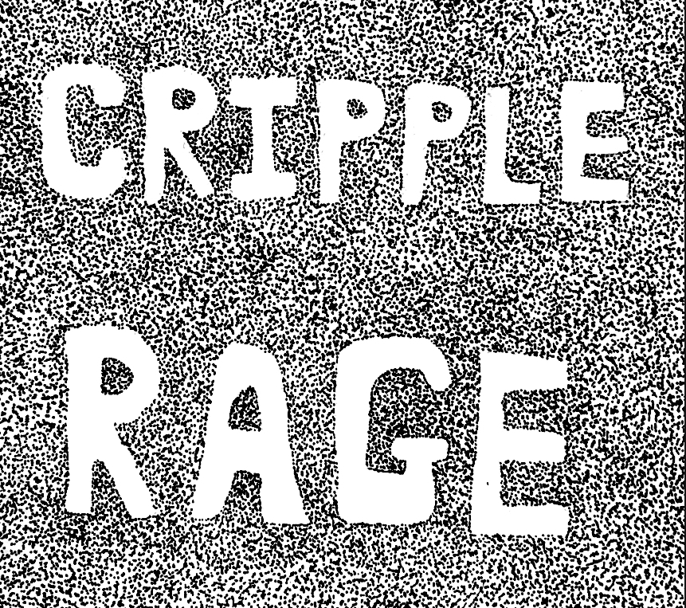

Sovereignty is a connection all Blackfellas share, tying us together like string.

Sovereignty is multifaceted, much like disability.

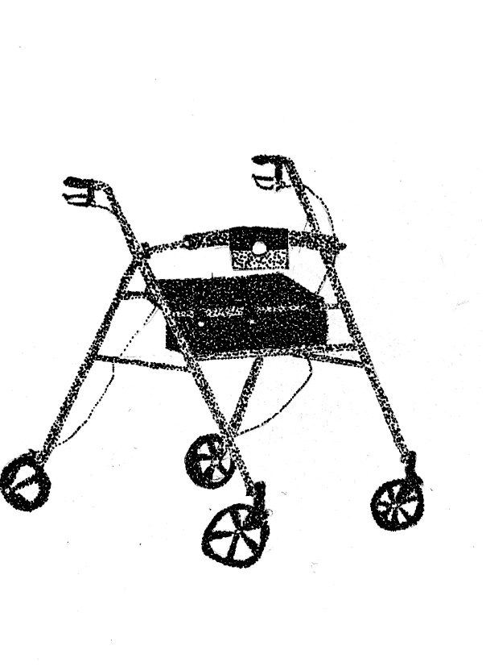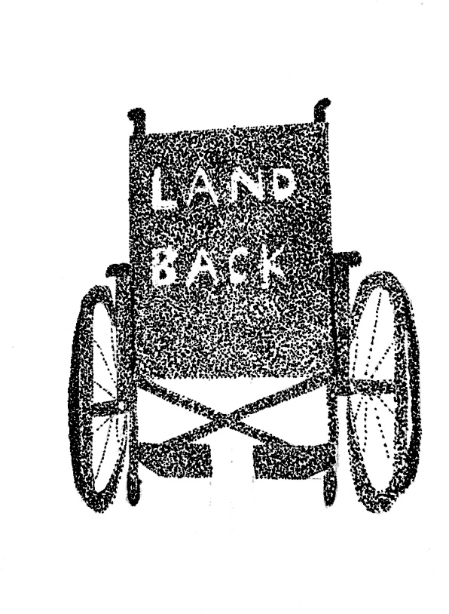

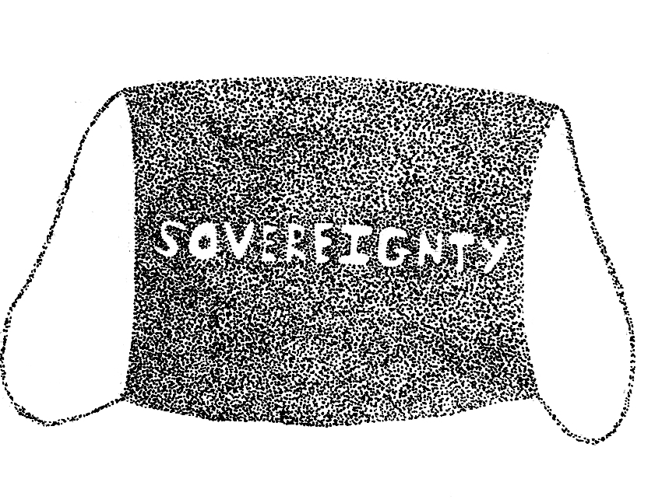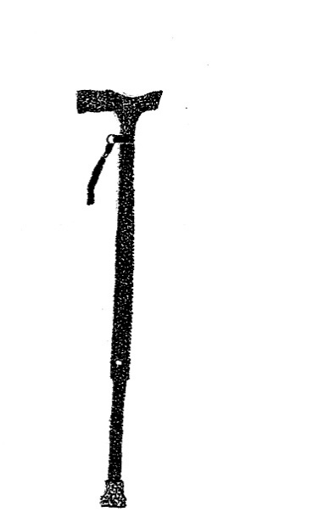

The struggle for the ownership of our bodies has been continuous since 1788. Fighting multiple colonial systems, which duplicates when disabled. We will continue to fight the way our Ancestors have. Feet, walkers, canes, white canes, wheelchairs and face masks.

We demand the right to live.

We demand sovereignty over our bodies.

E.R.

Instagram: [@lavendermould](http://instagram.com/lavendermould)

Disclaimer: My art is not ‘dot painting.’ Whilst being Aboriginal, ‘dot painting’ belongs to specific mobs and songlines, none of which I belong to. My art is pointwork, using lots of tiny dots to create art.

# Three Admissions – Patrick Mercer

The first admission she was by my side –

To the emergency room at least

Gas! Gas!

Masks on, it was early -

Ensnared by fear before the numbness.

Nurses cold and distant,

More Ratchet than Nightingale

Royal Melbourne Hospital in the maw,

Short and curt and tired

She sat with me as we ubered home

My tongue panting out the window

Sucking in Flemington Road smog.

I think about the prisoners on Rottnest Island

Leprous, syphilitic experiments

Bored eugenicists yawn as another

Soul drops off Country,

Absorbed by the sandstone.

My second admission she would not take me.

Hexed to my deathbed

On a pull-out sofa.

The smell of vomit and sweat sweet and rich,

Good for the roses –

Less so the carpet.

We would love to play domestic

Till it was bin night,

*Didn’t we Darling?*

Ballarat Base Hospital – not a place to wait alone

The clerk triages me, then my race

*Is this a mistake?* She asks,

looking at my file.

*You don’t look aborigine!*

My Irish doctor feigns interest, at least,

*What’re ye studyin’? What’s this tattoo there?*

*We’re the aborigines of Europe!* He claims,

They send me home before I’m well

Another polite Koori

Given the bare minimum

Not worth the bed beneath me

A third admission-

Alkaline blood; electrolytes missing:

Potassium, lithium, phosphate.

I’d lingered in bed stubborn days and nights

*I can’t. I won’t. They’ll send me home like last time.*

Another sick Koori

*Probably started with too many drinks, ey?*

*Maybe something a little harder?*

Knowing smirks dismiss my answer.

Skin and muscle hang loose on a frame

Melted wax couldn’t fix wings so close to the sun.

*Bloody diabetics can’t look after themselves!*

An uncle roars,

Too cut on vino, intoxicated by opinion.

We were vampire victims once.

Wasted away to nothingness

Consumed by sickly sweet, drowned in treacle.

We didn’t bring the sugar

The gin

The yarndi

*Dulce et decorum est*

How sweet it is,

A diabetic in a plague.

Patrick Mercer (he/they) is a 25-year-old Wadawurrung Kulin person living split between their Country and Woiwurrung Country. Patrick was lucky to grow up on Bunurong, Wiradjuri and Gadigal lands. He lives with Type 1 Diabetes and other complications and enjoys the support of the diabetes community in so-called Victoria.

Patrick’s passions lie in poetry, creative non-fiction, music, decolonisation, protecting heritage and healing Country.

Instagram: [@le.diabetique](http://instagram.com/le.diabetique)

Twitter: [@lediabetique1](http://twitter.com/lediabetique1)

# Untitled – Chantell Nicholls

2020 and 2021 were hard year for me because Covid. In 2020 I had to do year 12 online it was really hard. I felt like my whole life was turned upside down I had to Isolate from the world, friends, family, community and school. The more I isolated the more my mental health went bad. I was in out for hospital because for lockdown. I got diagnos with bpd.

I away had really bad mental health issues from the age for 12. Growing up was really hard at a really young age I got diagnosed with autism and a intellectual disability at a young age. I had some much trouble To interact with kids my age for that I got bullied a lot. I never felt normal.

The old I got the more I Realized not be normal is good my mind just work different to other people. So during lockdown my mind find it so hard with all the changes. I didn’t know what to do I miss seeing my friends and socialize. So I had to find ways to cope. This is when I find my love for playing the guitar and keyboard.

Music is a big escape for me for when my mental health is getting bad. After when we stop going in out for lockdown I join the misfit Project. Since join them my life has change so much in a good way. I have find a place where I feel like I belong growing up I never had a place were I can be myself.

Then we went back into lockdown but this time around I had a better support network. I was still feeling really isolated but a couple time a week they will online program with misfit it was good to still see friends on zoom.

When I found out there was a vaccinations for Covid. I was really Nervous but it felt good if we get it we wont be in lockdown. So once I got both needles I was aloud to go back to normal life. Since being out lockdown I have been on stage 2 times and in the middle for rehearsing for 2 more shows so I’m really excited.

Chantell Nicholls is a 20-year-old proud Aboriginal non-binary person based in Warburton.

HCUO – Aiesha Saunders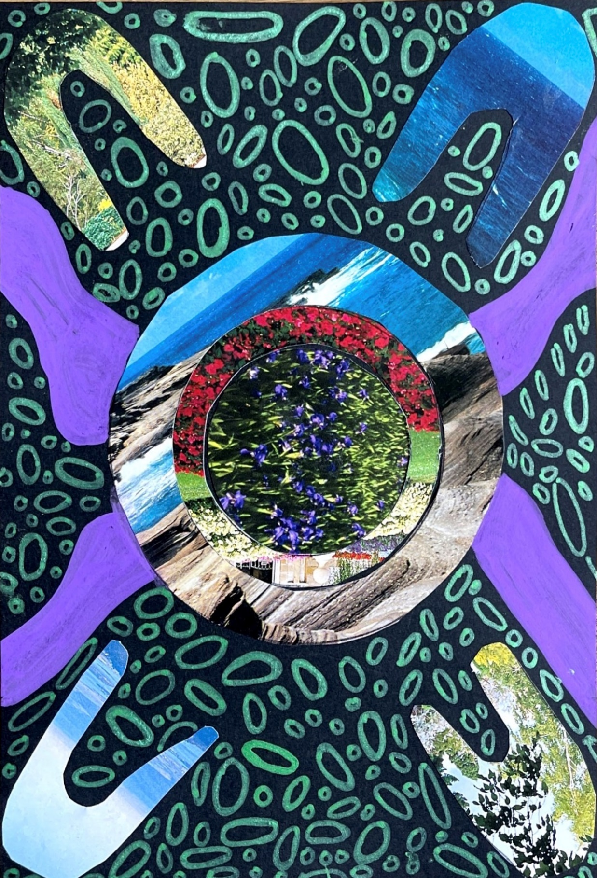

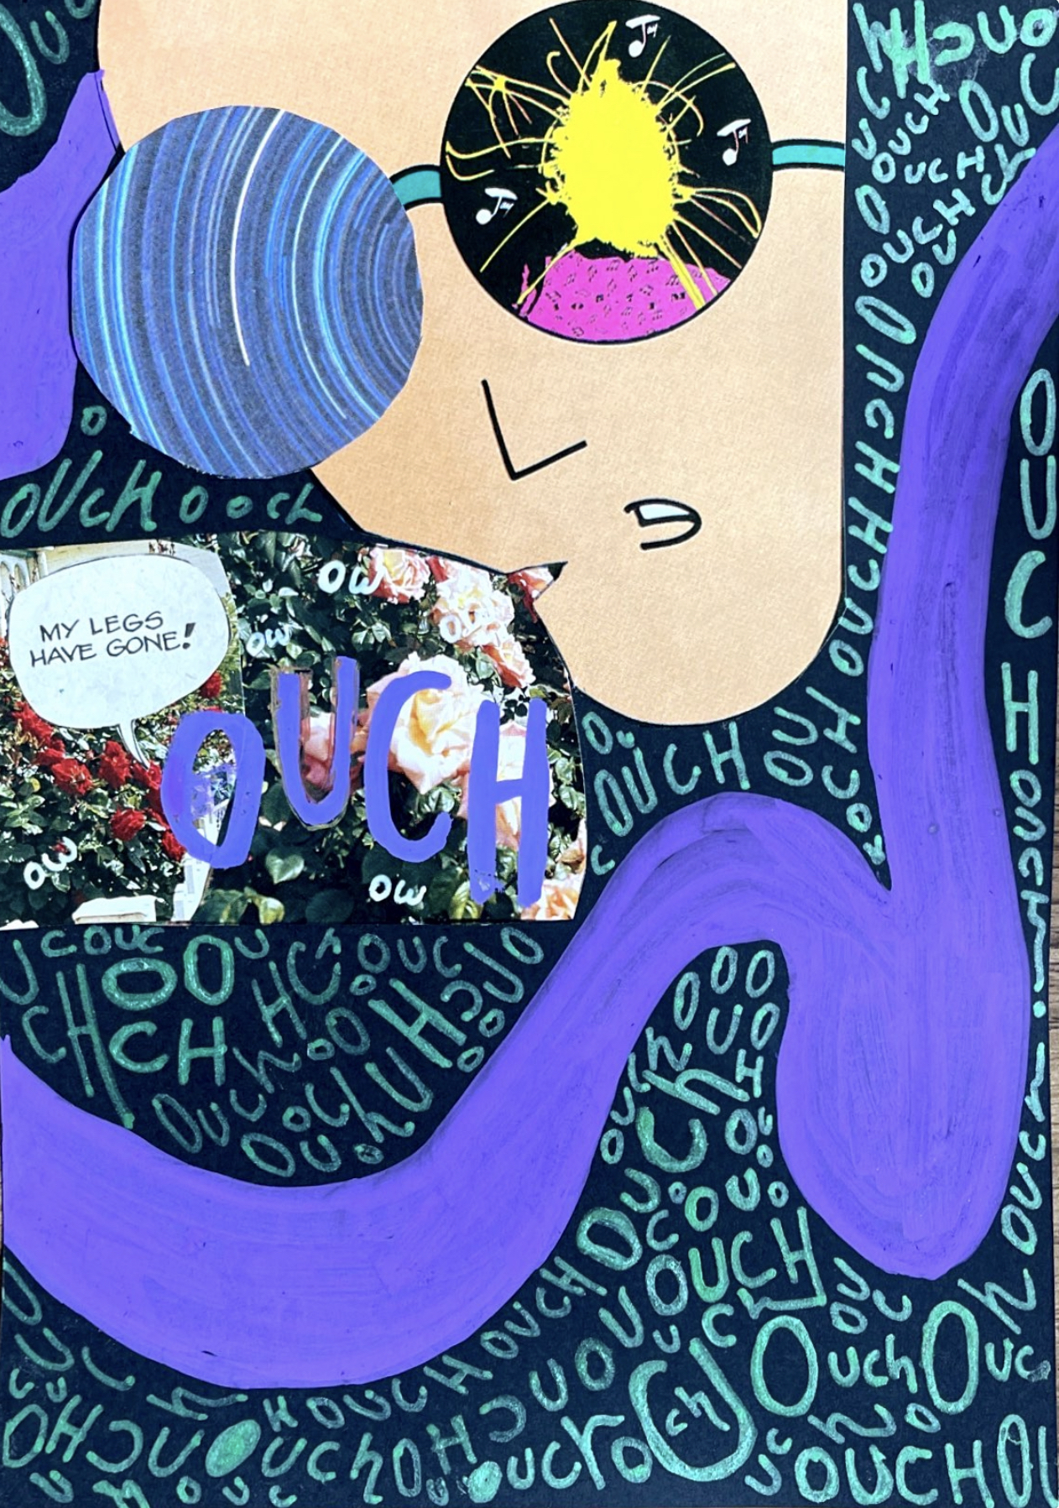

This piece is a combination of paper collage and Posca markers on black board.

The piece is a visual representation of how my partner, family, culture and nature keep me safe and grounded despite living with constant chronic pain.

I wanted to highlight the parts of me that make me whole despite the constant pain I feel every day.

Aiesha Saunders (she/her) is a Birpi woman living on unceded Gadigal lands.

Instagram: [@aiesha_may](http://instagram.com/aiesha_may)

Sick/Sovereign was created as part of the YDAS COVID Vaccination Disability Leaders campaign.

To view more projects from this campaign, scan the QR code below.

[](https://www.yacvic.org.au/ydas/policy-and-news/policy/covid-19/resources)

Printed on Wurundjeri Woi-wurrung Country

August 2022