**YACVic Access Key**

This is an Access Key for the YACVic office. An Access Key gives all the information you need to know about the building, location and all of the accessibility requirements it meets.

If you have any other questions about access and YACVic, please reach out to anyone at the organisation, we are so happy to help. Is Hay ([ihay@ydas.org.au](mailto:ihay@ydas.org.au)) created this document and can answer any questions.

**You can read this whole document, or just click on the name of the topic you need information on and you will be brought to that part of the document.**

The topics we cover in this access key are:

* Where is the YACVic office?
* How do I get to the YACVic office?
  + Car
  + Bus
  + Train
  + Tram
  + Walking
* Entering the building
  + Smoking
  + Signs
  + Building front door
  + Lobby
  + Elevators
  + Level 2
* In the office
  + Layout of the office
  + Kitchen
  + Bathrooms
  + Lighting
  + Noise
  + First aid
  + Fire
* Making the space inclusive
* Other things to know

**Where is the YACVic Office?**

The YACVic office is located on Level 2, 235 Queen Street, Melbourne, 3000. The YACVic office is located on stolen Aboriginal land. We want to pay our respects to Elders past and present and affirm that this always was and always will be Aboriginal land.

**How do I get to the YACVic Office?**

Car

There is some street parking along Queen Street and Lonsdale Street, though that is only available for short visits, and is likely to be busy during work hours.

There are 2 indoor car parks near to the office.

The first parking bay is directly opposite the office, 200 Queen Street, and is accessible through 222 Queen Street. This image is of this parking bay.

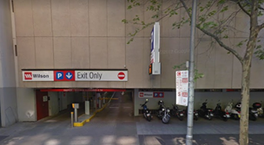

The second parking bay is further away from the office and is located at 460 Lonsdale Street. This image is of this parking bay.

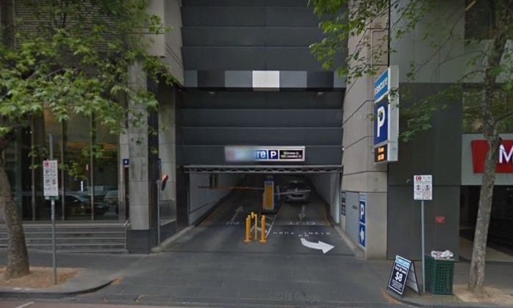

Bus

There are lots of bus stops near the YACVic office.

There is a bus stop on Lonsdale Street, outside the entrance of the building. This bus stop has a rain shelter but no seats.

* The numbers of the buses that stop there are: 216, 219, 220, 232, 234, 235, 236, 237

There is another bus stop on Little Bourke Street, which is across the road from the building.

* The numbers of the buses that stop there are: 200, 207, 250, 251, 303, 309, 350

There is another bus stop on Hardware lane, which you can reach by walking down Lonsdale Street.

* The numbers of the buses that stop there are: 200, 207, 250, 251, 302, 303, 304, 305, 309, 318, 350, 905, 906, 907, 908

Train

The closest train stations to the YACVic office are Flagstaff Station and Melbourne Central Station.

Melbourne Central Station is 450 metres from the YACVic office. It is around a 7 minute walk to the YACVic office from Melbourne Central Station. Note that there is an upward hill from Melbourne Central Station to the YACVic office. This is a picture of a map of how to get to the YACVic office from Melbourne Central Station.



Map from Melbourne Central Station to Office building.

Flagstaff Station is 500 metres from the YACVic office. It is around a 7 minute walk to the YACVic office from Flagstaff Station. Note that there is a downward hill from Melbourne Central Station to the YACVic office. This is a picture of a map of how to get to the YACVic office from Flagstaff Station.

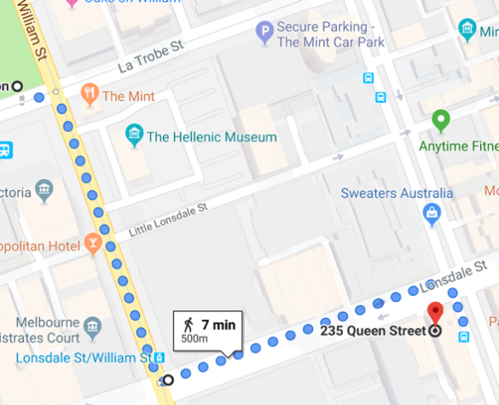

Trams

There are lots of options of tram stops near the YACVic office. All of the ones we have listed below are wheelchair accessible.

The first tram stop option is located at Queen Street/Bourke Street. You would continue walking down Queen Street from this stop until you reach the office.

The trams at this stop are:

* Route 86 – Bundoora RMIT to Waterfront City Docklands
* Route 96 – Brunswick East to St Kilda Beach

Another tram stop option is located at William Street/Bourke Street. It is a downhill walk from this stop to the office. You would walk along Bourke Street and then turn left when you reach Queen Street.

The trams at this stop are:

* Route 58 – West Coburg to Toorak.

Other tram stop options are along Swanston Street. They are the Bourke Street Mall stop and the Melbourne Central Station stop. Both are similar distances to the office. It is an uphill walk from these stops to the office. You would walk along Elizabeth Street, turn right at Lonsdale Street and then cross at the traffic lights when you reach Queen Street.

The trams at this stop are:

* Route 19 – North Coburg to Flinders Street Station
* Route 57 – West Maribyrnong to Flinders Street Station
* Route 59 – Airport West to Flinders Street Station

Walking

You can walk from various parts of the city to the YACVic office. As it is in the CBD, all streets have footpaths, and all traffic light stops have curb ramps.

It is generally a good idea to avoid lanes or streets that start with ‘Little’ (for example ‘Little Bourke Street’) as they are often far more narrow than main streets.

**Entering the Building**

Smoking

Smoking is not allowed inside the building. A smoking area is located outside the building to the right of the entrance, across from the bus stop.

Signs

There are no signs directly above the footpath next to the office. Above the door to enter the building are signs that say “VIT Victorian Institute of Technology” and “ECU Edith Cowan University”.

Building front door

There are no steps in front of the door.

The door opens to be 1 metre wide.

The doors are automatic glass doors, where the glass in front of the right side of the door slides behind the left side. You can only enter on the left side.

The doors have a sticker on them that says “235 Queen Street”.

If the door doesn’t open automatically, contact the person you are visiting and they can come and let you in.

Lobby

Please keep in mind that there is an automatic fragrance machine in the lobby of the building that cannot be turned off. There is a slight floral scent outside the building and in the lobby and elevators for this reason.

The lobby has tiled floor with a black mat in front of the doors. There are fake plants and a long seat located on the right side of the office. There is a TV on the right side of the lobby that displays information about which offices are located on each floor.

There is a hand sanitizer machine located on the left wall next to the elevators. The hand sanitizer has a strong smell.

There are 3 elevators on the left side of the lobby, which are all controlled by one single button located on the wall between the first and second elevators.

Elevators

There is a slight floral fragrance in the elevators.

You should take one of the 3 elevators to level 2 to get to the YACVic office. The elevators are 1.5 metres by 1.5 metres.

To use the elevators, click the up arrow button located on the wall between the first and second elevators. When you enter the elevator, you should click the button that says ‘2’ on it. The buttons in the elevators all have braille on them.

You will then be brought up to level 2 where the office is located.

Level 2

When you exit the elevators you will be facing the YACVic office. The YACVic office is the only office located on level 2. There is an automatic sliding door, which also has a handle that opens to the office. This door opens to 91 centimetres.

To the right of the elevators is a set of stairs behind a heavy door. These are the stairs that will be used in case of a fire.

If you walk left after leaving the elevator there are 3 bathrooms. More details about the bathrooms are further down in the access key.

**In the office**

Layout of the office

The floor in the office is made of carpet, except for the kitchen, which is vinyl.

Here is a description of the layout of the office. You can also look at the picture below this description to understand it in more detail.

As YACVic, YDAS and KYC have changed our working conditions since the pandemic, the office doesn’t have any set seats. There will be people sitting at different desks dotted around the office. There are desks all throughout the office, with some behind reception, then continuing along the right half of the office, and some behind a slight wall in the back half.

The front desk/reception is to the right when coming in.

The board room, which is across from the reception desk has two 87cm wide nonautomated doors. One is on the left of the entrance door, the other is before the entry way to the kitchen. This room can be split into two for smaller meetings, but that isn’t often done. There is a large table in the board room, with chairs around it. They can be rearranged as needed. There are large TVs with webcams located at each side of the board room.

If you walk straight through the office, at the very end is the CEO’s office. On either side of the CEO’s office are 2 meeting rooms, and one office. The room to the left of the CEO’s office is another office. On the far left and far right are 2 meeting rooms. These rooms are accessible through 91cm wide nonautomated doors. They can be sometimes hard to move around in once inside due to desks taking up some of the space. These spaces have a glass wall facing into the building and have a window facing outward. The meeting room glass walls have images along the middle section, which means they can be used for confidential and child safe meetings, as they cover the faces and identifications of anyone in the rooms.

There is a kitchen space behind the board room. You can enter the kitchen by walking past the right side of the board room, turning left and then walking through an entry way. Along the left side of the kitchen are cupboards and a fridge. Along the right side of the kitchen are several small tables that combine to make one long table. There are chairs next to the tables, with the entire right side of the wall being built in seating. More information about the kitchen is further down in this access key. The entrance into the kitchen is about 146cm wide but be wary that there is a pole in the middle of the entryway about 10cm thick. This has been painted yellow to help with visibility.

The entry way to the kitchen has 6 locked tall cabinets that go along the left wall. Along the right side of the entry way is a large printer and copier. There is also a large desk along the rest of the right wall which has cupboards below. There is a pole in the middle of the entryway which is about 10cm thick. This has been painted yellow to help with visibility.

Behind the wall along the entry way to the kitchen are several desks. One of these desks is wheelchair accessible. If you continue along the left side of the office, opposite these desks there is a door that leads to stairs to be used in case of an emergency.

At the very back of the office in the back left corner, there is a space with lockers against one wall. There is a small circular desk with chairs around it. Along the far left wall there is a cushioned seat with pillows, and a library of books and magazines. This can be used as a quiet space.

Kitchen

Food and drink are allowed in the building excluding alcoholic beverages. The kitchen provides a fridge, microwave, toaster, tea/coffee, appliances, sink, recycling and rubbish bins.

The tap on the sink has been moved so that people of short stature or in a wheelchair can reach. There is a boiling water tap that has a safety lock on it.

At the very end of the kitchen there is a container of straws and tea that are easy to reach. You can use the straws if you need them to drink, but if you don’t need them, please don’t use them.

Bathrooms

All toilets at the YACVic office are gender neutral.

Please note the locks on the toilet doors can be a bit confusing. Avoid pushing the door when turning and turn about 180 degrees until you hear the clicking noise. The toilets are not scent free and have had air fresheners placed in.

The restroom closest to the elevators is an accessible bathroom. The door is non-automatic 90cm wide and has a handle to open from the inside. The tiling is less slippery than in the hallway. The accessible bathroom has a shower, toilet, change table and sink. The toilet has handrails next to it to help with mobility.

There are 2 single toilet rooms that are located in the middle of the hallways with the toilets. They have no urinals. They have sanitary bins.

The last bathroom down the hallway has 2 urinals and 3 cubicles and does not have any sanitary bins.

Lighting

The lighting throughout the building is fluorescent, but we can turn off the lights to the office. We have lamps in the office which we can use to provide softer lighting if requested.

Noise

The office is relatively quiet, though there are some noises to keep in mind. There are the noises of phones ringing, printer being run, doors being opened and closed, and the elevator dinging. There are also noises from the street that sometimes make it up to the office.

First Aid

The First Aid kit is located in the last cupboard on the right side of the entry way to the kitchen. We have Ventolin and an Epi-pen.

Fire

Steph Brenkovich and Jess Standish are YACVic office’s fire wardens. In case of a fire, they will direct you as to what to do. They wear red helmets. There are fire stairs located to the right of the elevators and along the left wall of the kitchen. There is enough room to fit one electric wheelchair behind each door closed. There are fire hoses and fire extinguishers next to the fire doors.

**Making the space inclusive**

We understand that no space can be completely safe and inclusive for everyone, but we aim to do everything we possibly can to ensure that everyone has the best time possible at the YACVic office.

Behaviour that will not be tolerated in the YACVic office includes: racism, sexism, body-shaming/fatphobia, transphobia, homophobia/biphobia/queerphobia, class based discrimination, ableism, anti-sex work discrimination and non-consensual behaviour.

**Other things to know**

* There are various power points located around the office that can be used to charge phones, communication devices, mobility devices and other technology.
* There is no dedicated prayer room, but we can clear out one of the meeting rooms for you to use it if you need.
* We can do other things to make this space accessible for you, please contact the person who invited you to the office to request what things you need.