YACVic Online Workshop Access Key

This is an Access Key for YACVic’s online workshops. It contains an overview what to expect before and during a workshop with us. There are also some details around using Zoom and an overview of our workshop content.

If you have any other questions about access during one of our workshops, please reach out to [FStirling@YACVic.org.au](mailto:FStirling@YACVic.org.au). We are happy to support.

## Before the workshop

[Download Zoom](https://zoom.us/download) onto your phone, laptop or other device. It will be easiest to use on a devise bigger than a phone.

Ensure you have good wifi connection in the location where you will be joining the training.

You will have received Humanitix tickets that contain a Zoom link. Double check that this is in your inbox.

## Logging on

We use Zoom to deliver our workshops. Since you will be joining as a participant, you do not need to create a Zoom account. If you already have a Zoom account, feel free to log into it.

To join our workshop, click on the Zoom link provided on your ticket, in your confirmation email or in a calendar invite that you can download when purchasing a ticket.

If you are having trouble logging on, please reach out to [FStirling@YACVic.org.au](mailto:FStirling@YACVic.org.au) and we can support you to do so.

Once you click the Zoom link, you will see this pop-up:

Internet browser displaying for Zoom, displaying the Zoom logo on the top left. A blue button reading 'Launch Meeting' is in the bottom middle. 

A pop-up is in the upper middle of the screen, reading 'This site is trying to open Zoom Meetings'. There are options to 'Open' in a grey box, and 'Cancel' in a blue box 

Click on ‘Open’, and ‘Launch Meeting’.

You will then see a screen that looks like this:

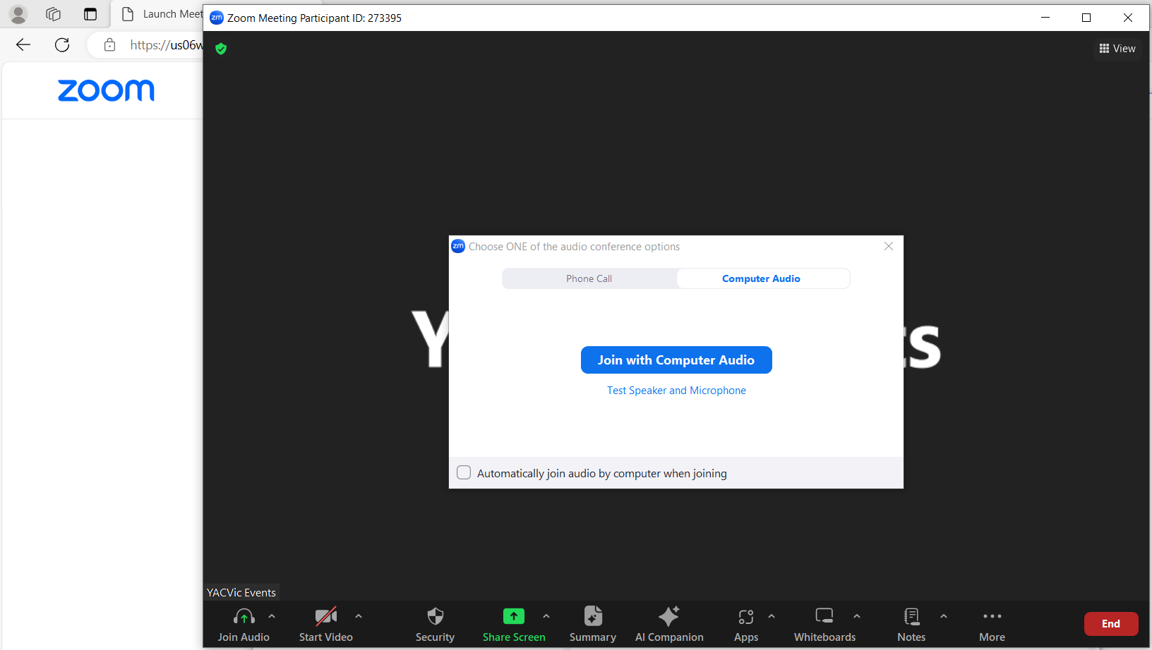

Click on ‘Join with Computer Audio’.

## During the workshop

### Zoom functions for YACVic Workshops

There are a few common functions you might use on Zoom during our workshop.

At the bottom of your screen, you will see a bar with many icons. There are icons for your microphone and video. There is also an icon to see the list of participants in the workshop. The chat icon allows you to see the chatroom. The show captions icon allows you to see captions. The reactions icon allows you to display emoji reactions – including ‘Raise/Lower Hand’, ‘Clapping Hands’, ‘Thumbs Up’, and ‘Heart’.

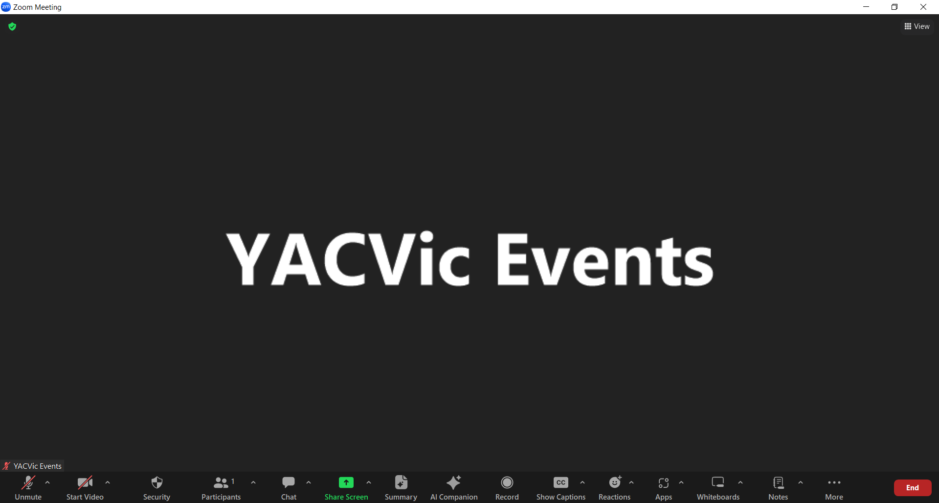

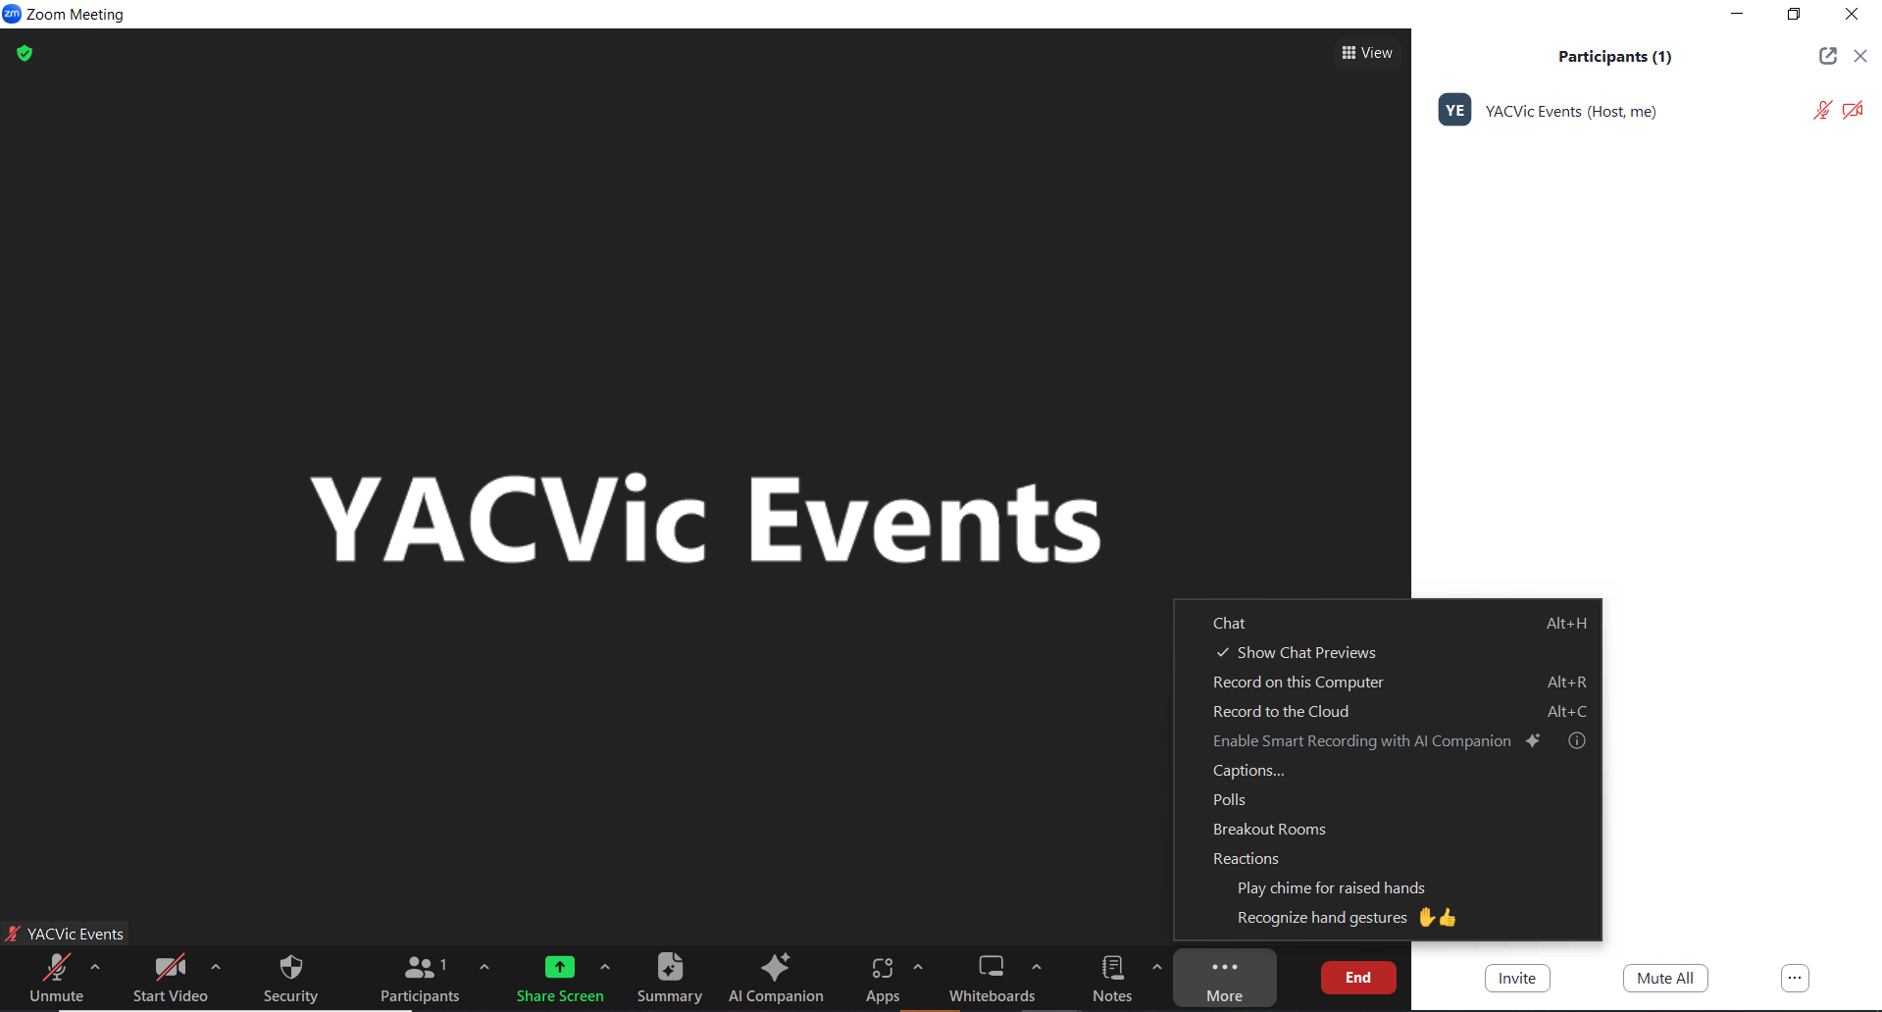

**Re-naming**

Before a workshop begins, you might want to change your Zoom display name. You can do this by hovering your mouse over your name, clicking the three dots and clicking your name. A pop-up box will appear, enter your name here.

If you are comfortable doing so, you can also add the pronouns you use and the Aboriginal land you are joining from.

**Breaks**

At YACVic, we generally take a 10-minute break every hour, unless someone has requested more frequent break times as an access need. If you would like to take a break from the workshop at any time, you are free to do so. Please let one of our facilitators know before you do by messaging them individually in the chat.

**Cameras**

We prefer for participants to leave their cameras on for the workshop, as part of ensuring that everyone is in a safe space and is engaged. However, we understand this might not be comfortable or accessible for everyone, so you can let us know if you would prefer to interact through the chat function and leave your camera off.

You might also want to turn your camera off for part of the workshop. Please let one of our facilitators know if you’d like to do so.

**Automatic captioning**

Participants can use the ‘CC’ button on the bottom panel of their Zoom browser to show captions.

**Pinning a participant**

Usually on Zoom, the person speaking in your meeting will be displayed in the largest video icon on your screen. By pinning someone, you can choose who you would like to be displayed on your screen. To pin a participant hover over their video icon and click on the three dots. Then, click ‘Pin’.

**Gallery View**

You might prefer to see all participants at once on your screen. To do this, click on ‘View’ at the top right corner of the screen. This will open options for ‘Speaker’, ‘Gallery’, ‘Multi-speaker’ or ‘Immersive. Click on “Gallery’ to see all participants at once on yuor screen.

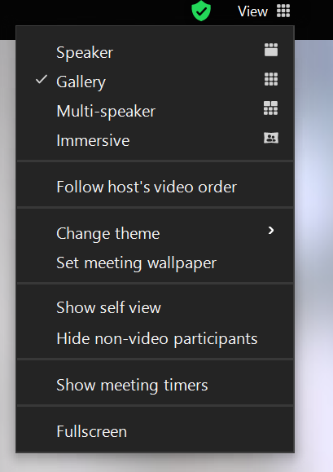

### Workshop Content

The workshop will be led by two facilitators. To learn more about our facilitators, visit the [YACVic website](https://www.yacvic.org.au/training-and-services/what-we-offer/#TOC-9).

A workshop is usually held for around 5 to 15 participants. If you would like to know how many participants are joining, please reach out to [FStirling@YACVic.org.au](mailto:FStirling@YACVic.org.au) prior to the workshop.

Your facilitators will welcome you and other participants into the workshop space. They might take a few minutes to wait for everyone to join, and will offer you the chance to get a drink or a bite to eat while doing so.

Your facilitators will be using a PowerPoint presentation as part of the workshop. This will be screenshared into Zoom, so you should be able to see your facilitators and the PowerPoint on the same screen.

Once everyone has joined and is settled in, your facilitators will start the workshop. They will begin by doing an Acknowledgement of Country and welcoming everyone. An Acknowledgement of Country is a way for everyone to show respect to the Traditional Owners of the land they are joining from, as well as to the enduring connection of First Nations peoples to Country. The facilitators will then introduce themselves and the workshop.

**Workshop Content**

If you would like more detailed information about the workshop content before you log in, please contact [FStirling@YACVic.org.au](mailto:FStirling@YACVic.org.au). We may be able to provide you with a detailed agenda.

**Workshop Closing**

The facilitators will wrap up the workshop by summarising the content covered and give you the chance to ask questions.

The facilitators will ask you to complete a feedback survey by putting a link in the Zoom chat or scanning a QR code with your phone. This survey is optional, but we appreciate if you would take the time to complete it.

The facilitators will show a few more slides about staying connected with YACVic and then will finish the training.

The facilitators might stay online in the Zoom meeting to answer any questions you have; you can stay to ask a question or log off.

To exit the meeting, click the ‘leave meeting’ button on the right corner of the screen.